FOR IMMEDIATE RELEASE
JANUARY 11, 2022

NEW YORK’S PRINCE OF DRILL BIZZY BANKS KICKS OFF THE NEW YEAR WITH HIS NEW SINGLE “OK OK OK”
ACCOMPANIED BY A COMPANION VISUAL AVAILABLE FOR STREAMING NOW
SINGLE IS SUPPORTED BY UPCOMING PERFORMANCE AT THE
GRAMERCY THEATER ON JANUARY 25TH
FOLLOW-UP TO THE PREVIOUSLY RELEASED “2016” SINGLE
STREAM/DOWNLOAD “OK OK OK”
WATCH/SHARE “OK OK OK”
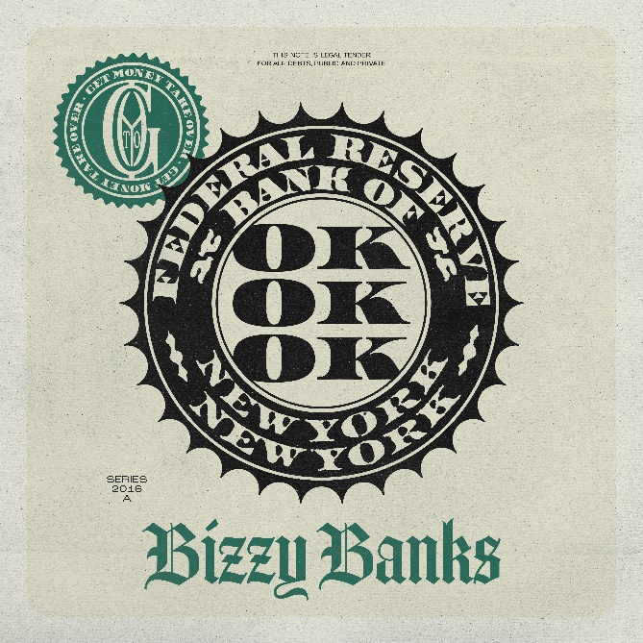
DOWNLOAD HI-RES ARTWORK

New York’s prince of drill, Bizzy Banks, kicks off the new year with his new single, “Ok Ok Ok.” The single is accompanied by a companion visual available for streaming now. Bizzy says of the track: “I was freestyling in the studio and I kept being interrupted while I was writing. Every time, I kept saying, 'Ok Ok Ok' so I didn't lose focus. That gave me the inspiration for this song." “Ok Ok Ok” was produced by Yozora, Elvis Beatz, and Flossy Draco while the visual is directed by 20K. The single is supported by Bizzy’s upcoming show with Shawny Binladen at the Gramercy Theatre on January 25th. “Ok Ok Ok” comes on the heels of his previously released single “2016” available for streaming now via YouTube.

"Nobody can take me off track. I'm staying focused and blocking out all the noise."
– BIZZY BANKS

Bizzy’s previously released single “No Passes,” proved that the young star has no signs of slowing down. Premiered by DJ Whoo Kidd on his Shade 45 radio show and accompanied by Bizzy’s basketball clinic for fans, Bizzy continues his return to the front of Brooklyn drill scene. “I Can’t” marked the first official single since Bizzy’s release and was accompanied by not only the visual but also his On The Radar freestyle that is now at over 451K views. “Don’t Know How To Act” was the long-anticipated follow-up to last year’s stand-out mixtape, SAME ENERGY, available now at all DSPs and streaming services HERE. SAME ENERGY includes such singles as “Bandemic,” “My Shit,” “Azul,” “Driftin’,” “City Hot,” and “Adore You (Feat. PnB Rock),” all accompanied by official music videos streaming now at YouTube HERE. Produced by D.A. Got That Dope (Megan Thee Stallion, Da Baby), “Adore You,” featuring the late PnB Rock, was met with praise from such outlets as XXL, which raved, “Bizzy can jump from flow to flow, plus his references are clever…The slow groove puts the rhymer in a prime position to keep evolving.” “Some of the best music he's released yet,” enthused Brooklyn Vegan. “(Bizzy) seems poised to be one of New York drill's biggest breakouts since the untimely death of Pop Smoke.”

SAME ENERGY is currently boasting over 54.4 million global streams and was first heralded with the acclaimed single, “Bandemic,” which received praise from a range of national publications, including LA Weekly, which wrote, “Banks holds nothing back on the new tune…it’s representative of the material he’s currently working on.” An official video – shot and edited by Useless Films – has earned over 2.2M views via YouTube alone HERE. The mixtape also peaked at #13 on the Apple Music Top Hip Hop Albums and #20 on the overall chart.

In the short time since Bizzy emerged on the New York drill scene, he has racked up co-signs from some of the most notable names like NY heavyweights like Lil Tjay and Pop Smoke before his passing. His feature on Pop Smoke’s FAITH album, “30”, was touted by Brooklyn Vegan as the “best collab on the album” and received critical acclaim while sitting on the OCC for its 62nd week. Pitchfork named “Top 5”, a release from Bizzy’s 2020 label-debut mixtape “G.M.T.O. Vol. 1 (Get Money Take Over)” as one of “The 36 best rap songs of 2020” and is currently sitting at 5.3 million views. His single “Don’t Start Pt. 2” is a certified hit boasting over 8.1 million views on YouTube. The finesse and astute lyricism showcased on his debut mixtape won Bizzy a nomination for the XXL 2021 Freshman class as well as the #10 spot on Rolling Stone’s “Breakthrough 25” highlighting the fastest rising artists. Since the start of 2022, Bizzy has released three singles to add to his burgeoning catalog, “Don’t Know How To Act,” “I Can’t,” and “No Passes.” Bizzy was also brought out on J.I.’s “Young and Restless” Tour in September 2022.

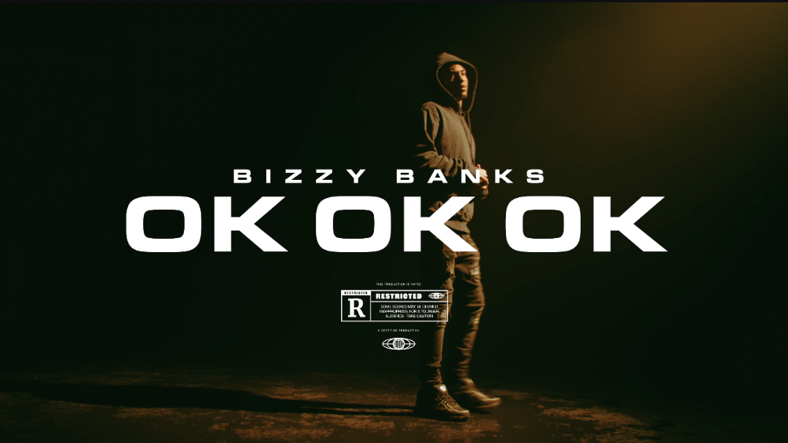

# # #

CONNECT WITH BIZZY BANKS
INSTAGRAM | TWITTER | YOUTUBE

FOR ALL INQUIRIES, CONTACT
ARIANA.WHITE@ATLANTICRECORDS.COM

