DAISY JONES & THE SIX ANNOUNCE DEBUT ALBUM AURORA – FEATURING MUSIC FROM THE HIGHLY-ANTICIPATED ADAPTATION OF NEW YORK TIMES BESTSELLING LITERARY PHENOMENON

GROUNDBREAKING LIMITED SERIES DAISY JONES & THE SIX – PRODUCED BY AMAZON STUDIOS AND HELLO SUNSHINE – PREMIERES MARCH 3 ON PRIME VIDEO
STARRING RILEY KEOUGH, SAM CLAFLIN, SUKI WATERHOUSE + MORE

AURORA SET FOR DIGITAL + VINYL RELEASE MARCH 3 VIA ATLANTIC RECORDS – LEAD SINGLE “REGRET ME” OUT NOW

WRITTEN & PRODUCED BY GRAMMY® AWARD WINNER BLAKE MILLS WITH ACCLAIMED, STAR-STUDDED LINEUP OF COLLABORATORS INCLUDING PHOEBE BRIDGERS, MARCUS MUMFORD, JACKSON BROWNE, TAYLOR GOLDSMITH, MADISON CUNNINGHAM, CHRIS WEISMAN, JAMES VALENTINE + MORE

BUY/STREAM “REGRET ME” HERE
PRE-ORDER AURORA ON VINYL HERE
PRE-SAVE AURORA HERE
WATCH DAISY JONES & THE SIX TEASER HERE

“We finally have Aurora. A stunning, nostalgic, timeless album that captures the drama, pathos, and yearning of the band’s zenith and nadir all in one. A snapshot of time, intoxicating and dangerous. That delicious moment that you know can’t last… Daisy Jones and The Six are real. And they are better than my wildest dreams.” – TAYLOR JENKINS REID [author of Daisy Jones & The Six]

“In the early 1970s, a group of kids with stars in their eyes and talent to spare formed a band called Daisy Jones and The Six. They would go on to become one of music’s biggest success stories despite – or perhaps because of – their own interpersonal demons. Theirs was a love story: the love of a particular sound, the love of family, the love of your life, and the love you can’t have but also maybe can't live without… Aurora represents the pinnacle of a short-lived recording career. It also serves as proof – for both the fictional band and the real one who dreamed this up together – that pouring your heart and soul into something you believe in can have a profound effect on the rest of your life.” – SCOTT NEUSTADTER [Oscar-nominated series co-creator and executive producer]

“I can confidently predict that on March 3rd you’ll find me on my couch, pressing play and dying to know how the songs I grew to love on paper actually sound.” – GQ

“Sure to be filled with incredible original music… Daisy Jones & The Six promises a 70’s-tinged dream…” – PASTE

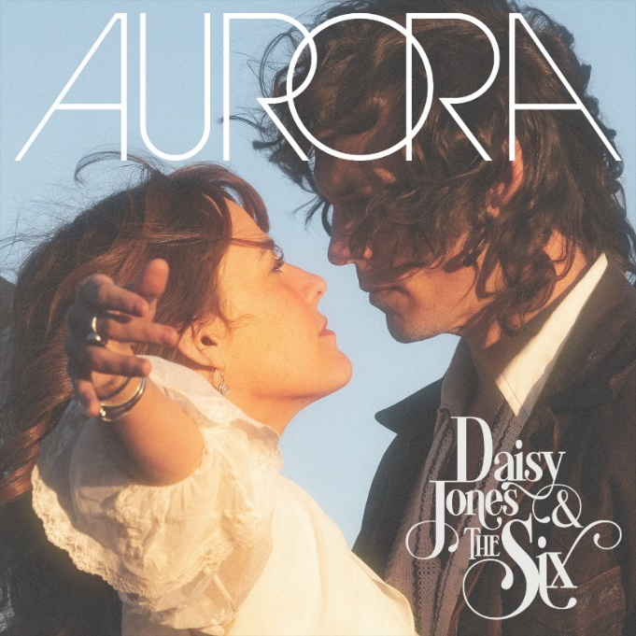
download hi-res album artwork here

Atlantic Records is proud to announce Aurora, the timeless debut album from Daisy Jones & The Six. The forthcoming 11-song LP from the titular band of Taylor Jenkins Reid’s beloved, New York Times bestselling 2019 novel arrives Friday, March 3rd on vinyl and across all DSPs (pre-order on vinyl here + pre-save here). Show-stopping lead single “Regret Me” is out everywhere today (buy/stream here).

Also on March 3rd, the groundbreaking limited series adaption ‘Daisy Jones & The Six’ will premiere on Prime Video, with new episodes released every Friday through March 24th, starring Riley Keough, Sam Claflin, Suki Waterhouse, and more (watch teaser here).

The highly-anticipated series arrives via Amazon Studios and Reese Witherspoon’s media company Hello Sunshine, who optioned Reid’s work in 2018 – before Daisy Jones & The Six ever even hit bookshelves. Upon the novel’s release in early 2019, it received coveted recognition as a ‘Reese’s Book Club Pick.’

Today’s release – “Regret Me” – is a title that readers will recognize immediately as one of the many emotionally-charged hits that characters Daisy Jones (Keough) and Billy Dunne (Claflin) co-wrote in the 1970s for Aurora and released via fictional label Ellemar Records. Viewers of the show will similarly recognize the Aurora album artwork as having been lifted directly from the limited series.

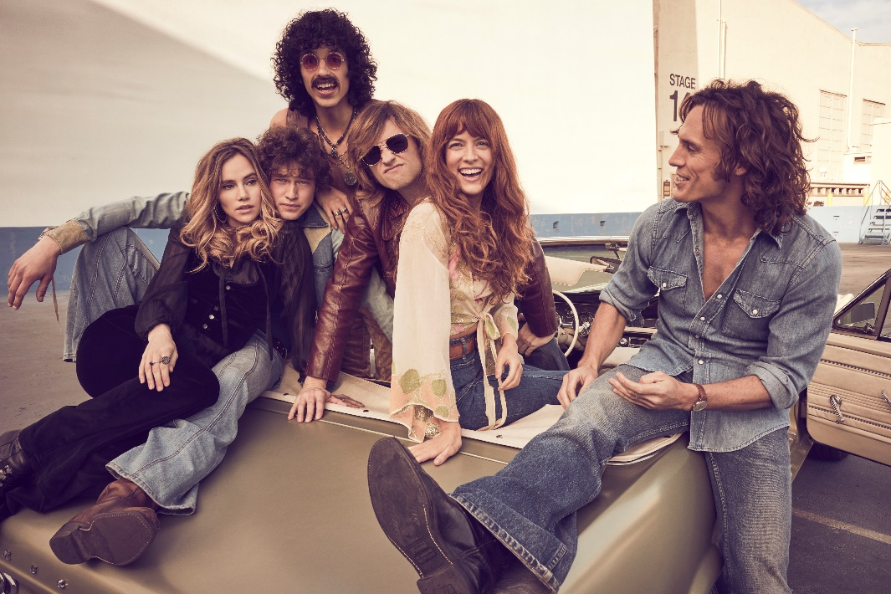
download hi-res photo here

Now, in 2023, Aurora has been brought to life by the cast, with Keough in her role as Jones and Claflin, Waterhouse, Will Harrison, Josh Whitehouse and Sebastian Chacon rounding out The Six. The group became a band both on-screen and off – with some of the multi-hyphenates learning their character’s instrument for the very first time during production, and Keough and Claflin lending their vocals to each track.

Helmed by acclaimed GRAMMY®-winning songwriter, producer, and multi-instrumentalist Blake Mills (Bob Dylan, Fiona Apple, Alabama Shakes, John Legend, Perfume Genius), Aurora and other music from throughout the show boasts co-writing credits that include some of today’s biggest names in music, such as: Marcus Mumford, Phoebe Bridgers and Jackson Browne, with additional production from renowned record producer Tony Berg (Phoebe Bridgers, Andrew Bird), alongside instrumentalists from Rilo Kiley, The Who, Nine Inch Nails, Pearl Jam, David Bowie, Elton John, Jeff Beck, The Wallflowers, and more.

Mills – who also executive produced the music from the series – recorded the entirety of Aurora with Keough, Claflin, and the above collaborators at Sound City Studios. The iconic Van Nuys, CA space – now jointly run by Mills, Berg, and filmmaker-producer Jordan Tappis – also serves as the backdrop in both the book and limited series for the creation of the album.

On the process of bringing this soundtrack to life, Blake Mills shares:

Creating the library of music for Daisy Jones and The Six was an experience I’ll never forget. I am grateful that, among other things, it afforded me an opportunity to collaborate with so many of my peers, and also some of my heroes.

Of today’s announcement, Atlantic Records’ West Coast President Kevin Weaver shares:

We couldn’t be more excited to partner with Amazon Studios and Hello Sunshine on the music releases for Daisy Jones and The Six. The series takes the viewer on a musical journey that was ripe to be realized into brand new music representing the iconic songs first conceptualized by Taylor Jenkins Reid in her critically acclaimed novel. We can’t wait for the world to finally experience this music out loud for the first time.

***

DAISY JONES & THE SIX – AURORA TRACKLIST:
- Aurora
- Let Me Down Easy
- Kill You To Try
- Two Against Three
- Look At Us Now (Honeycomb)
- Regret Me
- You Were Gone
- More Fun To Miss
- Please
- The River
- No Words

ABOUT DAISY JONES & THE SIX – THE LIMITED SERIES:
Based on the best-selling novel by Taylor Jenkins Reid, Daisy Jones & The Six is a limited musical-drama series detailing the rise and precipitous fall of a renowned rock band. In 1977, Daisy Jones & The Six were on top of the world. Fronted by two charismatic lead singers—Daisy Jones (Riley Keough) and Billy Dunne (Sam Claflin)—the band had risen from obscurity to fame. And then, after a sold-out show at Chicago's Soldier Field, they called it quits. Now, decades later, the band members finally agree to reveal the truth. This is the story of how an iconic band imploded at the height of its powers.

The series stars Riley Keough as Daisy Jones, Sam Claflin as Billy Dunne, Camila Morrone as Camila Dunne, Will Harrison as Graham Dunne, Suki Waterhouse as Karen Sirko, Josh Whitehouse as Eddie Roundtree, Sebastian Chacon as Warren Rhodes, Nabiyah Be as Simone Jackson, and Tom Wright as Teddy Price, with a special guest appearance by Timothy Olyphant as Rod Reyes.

From Amazon Studios and Hello Sunshine, Daisy Jones & The Six is executive produced by Reese Witherspoon and Lauren Neustadter for Hello Sunshine and Brad Mendelsohn for Circle of Confusion. Scott Neustadter and Michael H. Weber created the series based on the novel by Taylor Jenkins Reid, who also produces. Scott Neustadter is executive producing and co-showrunning with Will Graham, who also serves as an executive producer. James Ponsoldt directed the first five episodes and serves as an executive producer, Nzingha Stewart directed four of the remaining episodes, and Graham directed one.

Daisy Jones & The Six premieres March 3, with new episodes released every Friday through March 24, exclusively on Prime Video in more than 240 countries and territories worldwide. For more information, visit the Amazon Studios Press Site.

***

CONNECT WITH DAISY JONES & THE SIX
WEBSITE | FACEBOOK | TWITTER | INSTAGRAM | YOUTUBE | TIKTOK

***

Atlantic Records Press Contact:
Libby Kober | Libby.Kober@atlanticrecords.com

Prime Video Press Contacts:
Melissa Armstrong | Melissa.Armstrong@amazonstudios.com
Kevin McAlpine | Kevin.McAlpine@amazonstudios.com
Reegan Smyth | Reegan.Smyth@amazonstudios.com

Hello Sunshine Press Contact:
Matthew Avento | Matthew.Avento@ledecompany.com

