FOR IMMEDIATE RELEASE
JANUARY 23, 2023

RISING ALT POP STAR DANIEL LEGGS SHARES HEARTFELT NEW SINGLE
“last one standing”

TENDER NEW BALLAD MARKS EIGHTH INSTALLMENT IN ONGOING SERIES OF NEW SONGS RELEASED ON THE 22ND OF EACH MONTH

LISTEN HERE

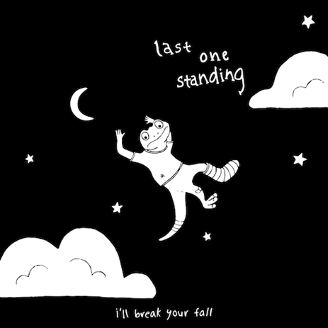
DOWNLOAD HI-RES ARTWORK

Rising alt-pop singer-songwriter-producer Daniel Leggs has shared his latest single, “last one standing,” available now via Overall Recordings/Atlantic Records at all DSPs and streaming services.

The eighth installment in an ongoing series of new songs released on the 22nd of each month, “last one standing” marks Leggs’ most tender track to date, a classic ballad destined to serve as first wedding dance for countless couples to come.

"For me, ‘last one standing’ is about love in the most positive way possible,” says Leggs. “I’ve always wanted to write an old-school, cheesy love song from a more modern perspective and I think this is a good reflection of that. The whole idea of glorifying love as something that keeps us going and gives us purpose is very uplifting. In this age of comparing ourselves and feeling like we’re constantly falling short, sometimes all we need is a little love."

In a world of emotional uncertainty, music is the only thing Daniel Leggs is sure of. Growing up as a concert-trained pianist too shy to express himself in daily life beyond gratitude and kindness, the 23-year-old tunesmith has found himself via an ongoing series of warm-hearted tracks such as “gatsby,” “ticket home” (co-written with 6x RIAA platinum-certified singer-songwriter Garrett Nash), and the recent viral favorite, “crutches,” the latter of which is joined by a whimsical animated music video streaming HERE. Written, recorded, mixed, and mastered in a central Rhode Island basement studio, Leggs’ budgeted studio model produces a distinctive sound that combines relatable lyrics with experimental imperfections to manifest something beautiful and all his own. With new music arriving monthly, Daniel Leggs is telling the runaway story of his daydreams, one perfect pop song at a time.

# # #

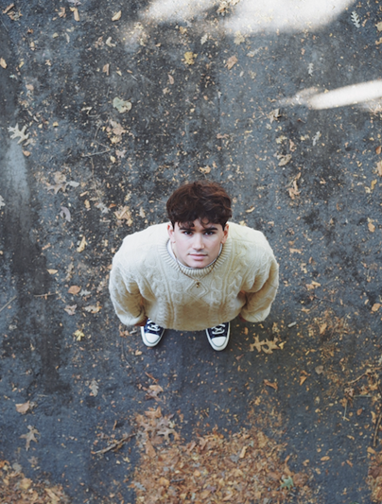
DOWNLOAD HI-RES PRESS PHOTOS
PHOTO CREDIT: AUDREY BERGERON
CONNECT WITH DANIEL LEGGS
OFFICIAL | INSTAGRAM | SOUNDCLOUD | TIKTOK | TWITTER | YOUTUBE

For press inquiries, please contact:
Jessica Nall // Jessica.Nall@atlanticrecords.com
N”

N”

