FOR IMMEDIATE RELEASE
JANUARY 13, 2023

Daniel Seavey releases “I Tried”
New single AVAILABLE NOW OFF FORTHCOMING DEBUT EP, Dancing IN The Light
Sold out Introducing Daniel Seavey headline Tour continues through January
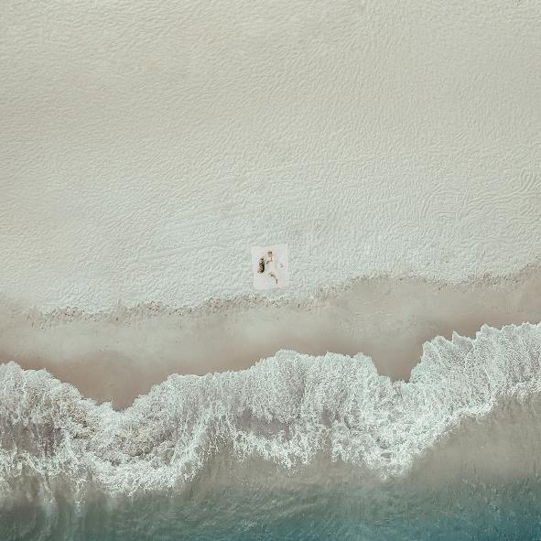
DOWNLOAD HIGH-RES ART/IMAGES
STREAM “I TRIED”: LINK

“Daniel Seavey is ready to showcase his impeccable production skills, stellar vocals, and personal artistry in his music as a solo artist” – ROLLING STONE

“Armed with a lifetime's worth of experiences traveling the world as well as his keen ear for melodies spread across over 20 instruments, Seavey is ready to emancipate himself as he embarks on a solo career.” – PAPER

“… this solo leg of his musical journey is to be one overflowing with potential.” – WONDERLAND

“With Seavey on his own, it’s clear he’s overflowing with ideas — and wasting no time exploring them all at once” – BILLBOARD

“Music came naturally for Daniel Seavey — so there was no denying what his true calling was.” – PEOPLE

Multi-platinum singer/songwriter, multi-instrumentalist and producer Daniel Seavey showcases another side of his sonic evolution with new single “I Tried” – available now via Atlantic Records. With hypnotizing guitar plucks and a celestially catchy refrain, Seavey strips back for a beautifully raw continuation of his solo journey. The single arrives ahead of Seavey’s forthcoming debut EP release, Dancing In The Light.

“’I Tried’ was a tough song to write. The melody came easy, but the self-admittance of failure in the lyrics was something that took me quite a bit of soul searching and time. I realize you can’t fix something you broke, but I believe honesty helps.” – DANIEL SEAVEY

Embarking on a new chapter of his career, the Why Don’t We co-founder made his solo debut in late 2022 with “Can We Pretend That We’re Good?” and “Runaway” – a pair of explosive self-penned/produced singles deemed “punchy and experimental” by Billboard, while Rolling Stone praised Seavey for his “impeccable production skills, stellar vocals, and personal artistry” and PAPER echoed his “keen ear for melodies.” The former track has tallied over 16 million global streams since release, further highlighted by four alternate versions showcasing the artist’s versatile musicality across over 20 instruments.

Following his December sold-out live solo debut show at The Troubadour in Los Angeles, Seavey announced his highly anticipated 2023 Introducing Daniel Seavey headline tour. Quickly following suit, the 17-show run sold out in minutes with venue upgrades due to overwhelming demand. Opening last week in San Diego, CA, the skilled set featured a mix of new tracks and dynamic covers produced live in real time for fans. For full routing, please visit danielseavey.com.

In 2016, Seavey co-founded Why Don’t We and embarked upon an unbelievable six-year journey highlighted by over 4 billion global career streams, two RIAA Platinum-certified singles, five RIAA Gold-certified singles, two Top 10 albums on the Billboard 200 chart, and sold out tours with multiple stops at legendary venues such as Radio City Music Hall and more. On the road, he often penned and produced nascent ideas that would eventually become the foundation of his own unique sound. In 2022, he hunkered down in his home studio and wrote and recorded what would become his debut. He not only sang and produced, but he also played every instrument, infusing a piece of himself upon each facet.

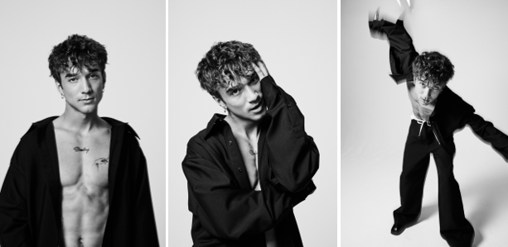
DOWNLOAD HIGH-RES ART/IMAGES (credit: Jimmy Fontaine)

CONNECT:
Instagram | TikTok | Twitter | YouTube | SoundCloud | Press Assets

CONTACT:
Ted Sullivan (Atlantic Records) | ted.sullivan@atlanticrecords.com

