FOR IMMEDIATE RELEASE
DECEMBER 9, 2022

Daniel Seavey wants to “Runaway”

New single from Multi-platinum singer/songwriter, multi-instrumentalist,
producer & Why Don’t We co-founder available now

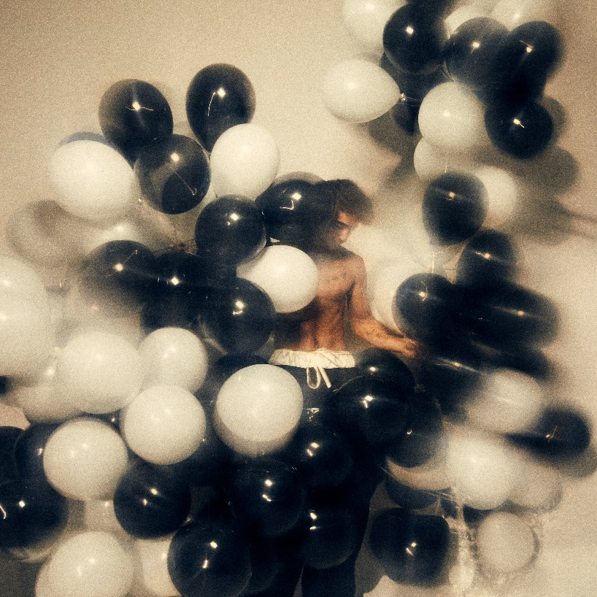
DOWNLOAD HIGH-RES ART/IMAGES

WATCH “RUNAWAY” VIDEO: LINK | STREAM “RUNAWAY”: LINK

“Daniel Seavey is ready to showcase his impeccable production skills, stellar vocals, and personal artistry in his music as a solo artist” – ROLLING STONE

“Armed with a lifetime's worth of experiences traveling the world as well as his keen ear for melodies spread across over 20 instruments, Seavey is ready to emancipate himself as he embarks on a solo career.” – PAPER

“… this solo leg of his musical journey is to be one overflowing with potential.” – WONDERLAND

“… new era for Why Don’t We co-founder Daniel Seavey: his solo chapter. Blending hits roots of rock, pop and alternative with enticingly sharp and experimental production…” – BILLBOARD

“Music came naturally for Daniel Seavey — so there was no denying what his true calling was.” – PEOPLE

Multi-platinum singer/songwriter, multi-instrumentalist, and producer Daniel Seavey continues his solo journey with new single “Runaway” – available now via Atlantic Records alongside a music video companion directed by Éli Sokhn. The blissfully gauzy track glides towards an entrancing escapist refrain underlined by a cinematic and mounting production.

“I believe the world around us affects us so much. What we surround ourselves with, we become. Sometimes our surroundings help us, other times they hurt us. ‘Runaway’ is about the reoccurring thought I have that, if we’re just able to detach ourselves from the darkness that surrounds us, we may find true peace.” – Daniel Seavey

Embarking on a new chapter of his career, the Why Don’t We co-founder made his solo debut in September with “Can We Pretend That We’re Good?” – an explosive self-penned/produced single that quickly amassed over 10 million streams worldwide. The track was deemed “enticingly sharp and experimental” by Billboard, while Rolling Stone praised Seavey for his “impeccable production skills, stellar vocals, and personal artistry” and PAPER echoed his “keen ear for melodies.” Further highlighted by four alternate acoustic versions, a tell-all appearance on The Zach Sang Show & more, Seavey continues to make waves with the music he was always destined to create.

Earlier this week, Seavey made his live solo debut at The Troubadour in Los Angeles after selling out the show in just two minutes last month. The skilled set featured a mix of new tracks and dynamic covers, produced live in real time and giving his most diehard fans a taste of what is to come in 2023.

In 2016, Seavey co-founded Why Don’t We and embarked upon an unbelievable six-year journey highlighted by over 4 billion global career streams, two RIAA Platinum-certified singles, five RIAA Gold-certified singles, two Top 10 albums on the Billboard 200 chart, and sold out tours with multiple stops at legendary venues such as Radio City Music Hall and more. On the road, he often penned and produced nascent ideas that would eventually become the foundation of his own unique sound. In 2022, he hunkered down in his home studio and wrote and recorded what would become his debut, led by “Can We Pretend That We’re Good?” He not only sang and produced, but he also played every instrument, infusing a piece of himself upon each facet.

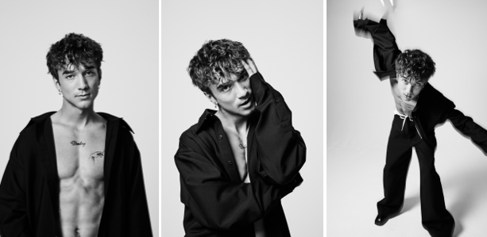
DOWNLOAD HIGH-RES ART/IMAGES (credit: Jimmy Fontaine)

CONNECT:
Instagram | TikTok | Twitter | YouTube | SoundCloud | Press Assets

CONTACT:
Ted Sullivan (Atlantic Records) | ted.sullivan@atlanticrecords.com

