MUSIC THE LABEL/ATLANTIC RECORDS SIGNEE JEVEN RELIFORD SPREADS HOLIDAY CHEER WITH NEW COVER
“THIS CHRISTMAS” VISUAL STREAMING NOW
FOLLOW-UP TO LONG-ANTICIPATED SINGLE “SAY DAT THEN (FEAT. ANN MARIE)”
WATCH/SHARE “THIS CHRISTMAS”

# # #

ABOUT JEVEN RELIFORD
When Jeven Reliford sings, you’ll instantly recognize him. He projects his vocals in alternating bursts of emotion and power, dipping into grooves and taking flight on the hooks. He ultimately infuses his music with personality, bringing no shortage of charisma, clarity, and confidence to R&B and pop. It’s why he’s quietly generated hundreds of millions of views. It’s why he’s attracted a fervent audience of millions of followers. It’s why he’s tipped for a breakthrough. The Georgia native recognized his voice as a kid. Mom and dad often heard him humming from his car seat. Listening to the likes of Chris Brown, Bruno Mars, and Justin Bieber, he often practiced their songs until he could replicate the high notes. Simultaneously, he excelled as an athlete, studying Brazilian jiu-jitsu, wrestling, and running track at a D1 level. He also quietly honed his vocals, showing off in the car until a friend encouraged him to post on TikTok. He reluctantly uploaded a 12-second cover of “Goodbyes” by Post Malone and Young Thug. It caught fire on the platform, inspiring him to continue to post. By his twelfth video, he had eclipsed a quarter-of-a-billion views and 37 million “likes” with labels flying him to meetings across the country. He eventually went on to catch the attention of Anthony “T.A.” Tate. After a number of meetings, he signed to Music The Label in partnership with Atlantic Records in 2020. He spent the next two years not only shaping his sound with tracks such as “Butterflies,” but also growing up. Now, there’s no mistaking him for anybody else on his debut for Music The Label/Atlantic Records with “Say Dat Then (Feat. Ann Marie).”

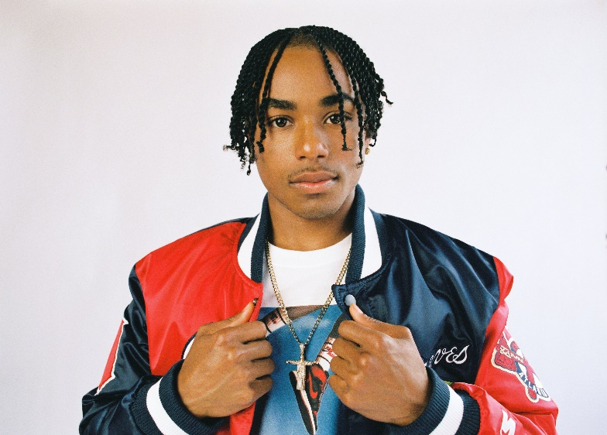
DOWNLOAD HI-RES PRESS PHOTOS

FOR PRESS INQUIRIES CONTACT:
SYDNEY MARGETSON
SYDNEY.MARGETSON@ATLANTICRECORDS.COM

CONNECT WITH JEVEN:
INSTAGRAM | TWITTER | FACEBOOK | TIK TOK

