FOR IMMEDIATE RELEASE
AUGUST 5, 2022

JOE P RELEASES HIGHLY ANTICIPATED SINGLE “ALL DAY I DREAM ABOUT,”
WITH CINEMATIC OFFICIAL MUSIC VIDEO

SONG ALREADY HAS OVER 4M VIEWS

WATCH HERE | LISTEN HERE

SOLD OUT NORTH AMERICAN TOUR SUPPORTING SPACEY JANE
BEGINS OCTOBER 10 IN TORONTO

BREAKTHROUGH SINGLE, “OFF MY MIND,” SET TO IMPACT
AT TRIPLE A RADIO OUTLETS NATIONWIDE

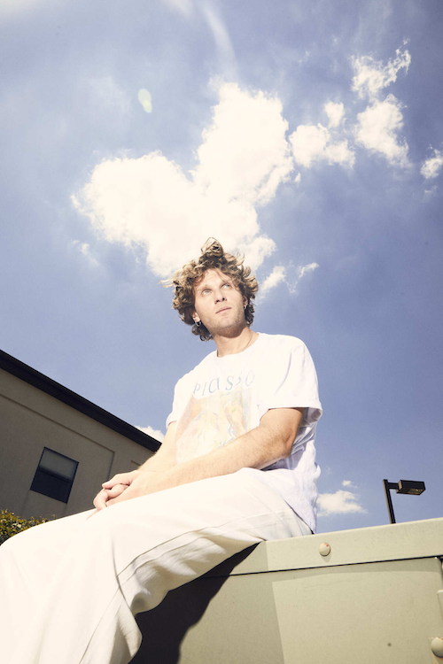
DOWNLOAD HI-RES IMAGE // PHOTO CREDIT: JIMMY FONTAINE

Rising alternative singer/songwriter joe p is back with his eagerly awaited new single, “All Day I Dream About,” available now via Neon Gold/Atlantic Records HERE. The cinematic music video, also out today HERE, was co-written by joe p and frequent collaborator Anthony Yebra and stars joe in several vintage-style film trailers.

“All Day I Dream About” has already proven a viral fan favorite, with over 14K pre-saves fueled by a long series of hugely popular TikTok teasers in which joe p shared its writing and production. The new single follows the continuing ascent of the Asbury Park, NJ-based artist’s breakthrough single, “Off My Mind,” available now at all DSPs and streaming services HERE. Currently set to impact at Triple A radio outlets nationwide later this month, the track is accompanied by an official music video, streaming now HERE. In addition, joe p recently joined forces with chart-topping pop singer-songwriter GAYLE for an official live performance of “Off My Mind,” filmed earlier this year backstage at New York City’s legendary Mercury Lounge and streaming now HERE.

Joe p has spent much of the past year on the road traveling with such like-minded artists as GAYLE, Middle Kids, and Joywave. His epic live schedule resumes with this fall with a North American tour alongside Spacey Jane, set to get underway October 10 with a sold out show at The Axis Club in Toronto, ON and then traveling into early November. Most dates – including an eagerly awaited two-night stand at New York City’s Bowery Ballroom (October 12-13), as well as shows in Boston, Washington, DC, Chicago, Vancouver, and Los Angeles – are already sold out. For updates and remaining ticket availability, please visit joepthehyena.com/showsfull.

When the onset of the pandemic brought about the dissolution of the band he’d fronted since eighth grade, joe p found himself in isolation with time to step out and experiment on his own. From the refuge of his New Jersey basement studio, he threw himself into writing, recording and producing his most personal material to date. Posting homegrown ideas to TikTok, joe p watched as his raw acoustic videos drew millions of views and over 300K followers in just a few months. Among those new fans was Apple Music’s Zane Lowe, who kicked joe’s career into hyperdrive by duetting alongside his self-made “Fighting In The Car” video (streaming HERE). A deal with Neon Gold/Atlantic was quickly followed by the acclaimed release of joe p’s acclaimed debut EP, Emily Can’t Sing, highlighted by such singles as “Leaves,” “Fighting In My Car,” and “Off My Mind,” all joined by high-concept, low-budget music videos streaming now at the official joe p YouTube channel HERE.

joe p
NORTH AMERICAN TOUR 2022

OCTOBER
10 – Toronto, ON – The Axis Club (SOLD OUT)
12 – New York, NY – Bowery Ballroom (SOLD OUT)
13 – New York, NY – Bowery Ballroom (SOLD OUT)
14 – Boston, MA – Brighton Music Hall (SOLD OUT)
15 – Philadelphia, PA – Union Transfer
16 – Washington, DC – Black Cat (SOLD OUT)
18 – Chicago, IL – Lincoln Hall (SOLD OUT)
19 – Minneapolis, MN – Fine Line Music Cafe
20 – Omaha, NE – Reverb Lounge
22 – Denver, CO – Gothic Theatre
23 – Salt Lake City, UT – Metro Music Hall
25 – Seattle, WA – Neumos
26 – Vancouver, BC – Rickshaw Theatre (SOLD OUT)
27 – Portland, OR – Doug Fir Lounge
29 – San Francisco, CA – The Chapel
30 – Los Angeles, CA – Teragram Ballroom (SOLD OUT)
31 – Santa Ana, CA – Constellation Room (SOLD OUT)

NOVEMBER
1 – Solana Beach, CA – Belly Up Tavern
2 – Phoenix, AZ – Crescent Ballroom
4 – Dallas, TX – The Studio at the Factory
5 – Austin, TX – Parish
6 – Houston, TX – Warehouse Live (SOLD OUT)
8 – Nashville, TN – The Basement East
9 – Atlanta, GA – Terminal West

ALL DATES w/SPACEY JANE

# # #
CONNECT WITH JOE P
WEBSITE | FACEBOOK | INSTAGRAM | SOUNDCLOUD | SPOTIFY | TIKTOK | TWITTER | YOUTUBE

PRESS CONTACTS
corey.brewer@atlanticrecords.com
gabrielle.reese@atlanticrecords.com

