KSI RELEASES BRAND NEW SINGLE “VOICES” FT. OLIVER TREE

“VOICES” OFFICIAL MUSIC VIDEO PREMIERES TODAY
WATCH HERE

AVAILABLE EVERYWHERE NOW VIA ATLANTIC RECORDS
LISTEN HERE

NEW PRIME VIDEO DOCUMENTARY KSI: IN REAL LIFE FEATURES “VOICES”
WATCH THE TRAILER HERE

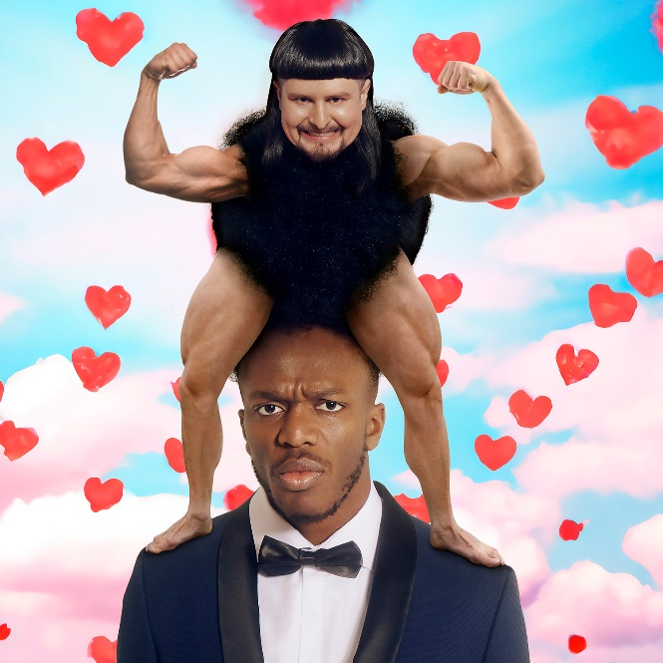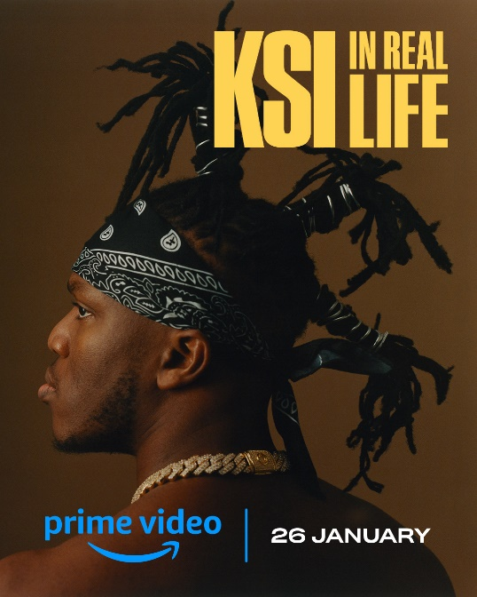
DL art here

(JANUARY 27, 2023) KSI, one of the decade’s most successful breakthrough artists, today drops a brand-new single, “Voices” featuring genre-bending Oliver Tree, the brainchild behind the 2022 global smash, “Miss You” with GRAMMY® Award-nominated producer Robin Schulz. KSI’s silky vocals and effortless flow combined with Tree’s definitive rockstar qualities deliver “Voices”, a pop rock soul-searching smash destined for commercial success. Listen HERE and watch the music video from 4pm GMT HERE.

It follows KSI’s previously released singles “Not Over Yet” featuring Ivor-Novello nominated Tom Grennan, an instant #1 on the UK Big Top 40 and “Summer Is Over” as KSI gears up to release his third album on Atlantic Records. Co-written with Conor Blake Manning, Sara Boe, Mustafa Omer, and James Murray and co-produced by Mojam and Digital Farm Animals (whose combined credits include the likes of Sam Smith, Mabel and Dua Lipa) the song is a double entendre for KSI’s mental health and his turbulent breakup with his ex-girlfriend.

Recorded at Abbey Road Studios, KSI says, “Voices is a song I worked on during my weird phase mentally. This is a big song for me because it marked a big chapter in my life. After my breakup, I thought I was fine, but I had these voices in my head telling me I wasn’t as happy as I thought I was.”

Oliver Tree says: “The song is about the pain we experience in the aftermath of a breakup. Lying to ourselves as we try to replace the void with a fling or waking up in your cold empty bed alone. That person can haunt our head for months, even years after. Wondering if we will ever escape the memories of the person, we once loved who’s now a stranger.”

The accompanying music video for “Voices” is directed by Oliver Tree and set in a busy restaurant. KSI is seen on a date with his girlfriend whose attempt at sharing a piece of spaghetti goes horribly wrong, causing an argument ending in a breakup. While KSI lays in bed alone, Tree matches with KSI’s ex-girlfriend online, and they go on the exact same date, which ends in a similar way, leaving both Tree and KSI both visibly upset and heartbroken. Later, their ex is on a date at the same restaurant with YouTube creative Chunkz. KSI is sat across the room with another girl whilst Oliver impersonates a waiter, both now looking over at their ex-girlfriend. Oliver trips and drops a towering pile of plates with the video ending in complete disarray.

The song also appears in KSI’s highly anticipated documentary KSI: In Real Life, which launched this week exclusively on Prime Video in over 240 countries and territories worldwide. “It was awesome to create this song with one of my friends Oliver Tree and it being included in the Prime Video doc is super cool too,” KSI continues.

KSI: In Real Life, executive produced by Louis Theroux and Mindhouse Productions dives into the origin story of this online icon, his beginnings in Watford and his early adoption of YouTube. Olajide Olatunji (JJ to his friends) has defied the odds and scored a series of unexpected victories in the business, music, and boxing worlds. But success has come at a price. With unique and unfiltered access to the global megastar, the film confronts questions about family, fame, the internet, and overcoming trauma. It is both a revealing portrait of the rise and rise of the ultimate influencer and a warts-and-all look at a young man working out who he is while the whole world watches.

His second album, summer 2021’s All Over the Place entered the charts at #1, an emphatic follow-up to the previous year’s debut, Dissimulation, a #2 hit which was the biggest selling debut album of 2020. In rapid succession there’s been a flurry of hits, on his own merits (making him the British Breakthrough Artist of 2020) and with others (Don’t Play with Anne-Marie, Lighter with Nathan Dawe), making for eight Top Ten singles in total. As prolific as he is innovative, KSI was the only artist to be nominated twice in the Song of the Year category at the 2022 Brit Awards.

ABOUT KSI
A pioneering, YouTuber (fourth most followed channel for a British artist behind Ed Sheeran, One Direction and Adele) approaching 20 billion cumulative views, his 40.8 million subscribers know him as a creator, an artist, a mate who brings the passion (and the jokes) to whatever he does. He’s a businessman with a portfolio of interests, from owning his own music label, The Online Takeover and his own boxing promotions company, Misfits Boxing to one of the fastest growing beverages, his Prime Hydration drink is set to surpass $140 million in revenue in its first year. As a performer and all-round entertainer, he can light up stages (Reading, TRNSMT, a Wembley headline) and screen: an upcoming documentary for Prime Video, produced by Louis Theroux, promises to lift the lid on the extraordinary life of the 29-year-old from Watford. And as a boxer, the amateur-turned-professional fighter is undefeated.

ABOUT OLIVER TREE
With more than 4B global streams to date, 1B+ YouTube views, 14.7M+ TikTok followers, and an overall social reach of 20M+, Oliver Tree is an internet-based vocalist, producer, writer, director and performance artist whose work explores the sonic intersection where pop and alternative meet and where art and entertainment visually collide. From comedy to action sports, mock reality TV drama to WWE wrestling, the world of Oliver Tree is unlike any artist who has come before him.

Featured on Jimmy Kimmel Live!, Rolling Stone, Billboard, Vice, Complex, NYLON, Entertainment Weekly, UPROXX, AltPress, and more, Tree has cemented himself as one of the most popular- and most provocative- artists of the Gen Z era. His latest release- Cowboy Tears Drown the World in a Swimming Pool of Sorrow- is an expanded deluxe edition of his acclaimed sophomore LP and has amassed over 200M streams worldwide in its first month. With 400M global streams after debuting at #10 on the Billboard Hot Dance/Electronic Songs Chart, “Miss You” with Robin Schulz marks the latest chart entry from Oliver.

Oliver’s unpredictable debut album Ugly is Beautiful, rocketed to #1 on Billboard’s “Top Rock Albums” and “Top Alternative Albums” charts upon its 2020 release while also debuting among the top 15 on the overall SoundScan/Billboard 200. Now boasting more than 2B worldwide streams, the album – which features an array of hit singles including the RIAA platinum certified “Alien Boy” and RIAA gold certified “Hurt” – was later joined by a deluxe version highlighted by “Life Goes On,” a full-fledged, RIAA gold certified global hit now with 1B+ streams, 275M video views, 25M+ TikTok creates, and 30M+ TikTok video views.

Oliver has also written two feature length screenplays and has been perfecting his craft as a director, writer and producer through his big budget music videos which he prefers to call short films. Whether you’re here for the shimmering hooks, high-art aesthetic, personal reckonings or just a healthy dose of social commentary, you’ve come to the right place.

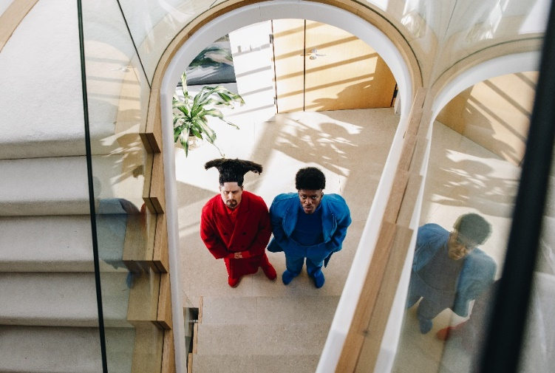
DOWNLOAD PRESS PHOTO HERE

CONNECT WITH KSI
INSTAGRAM | TWITTER | SPOTIFY | YOUTUBE | WEBSITE

CONNECT WITH OLIVER TREE
INSTAGRAM | TIK TOK | TWITTER | FACEBOOK | SPOTIFY |YOUTUBE

FOR MORE INFORMATION:
Paige.Rosoff@atlanticrecords.com
Atlantic Records | Big Beat Records

