FOR IMMEDIATE RELEASE
JANUARY 13, 2023

MAY-A EMBARKS ON NEW ERA WITH “SWEAT YOU OUT MY SYSTEM”

SULTRY AND PUNCHY TRACK JOINED BY OFFICIAL MUSIC VIDEO

LISTEN TO “SWEAT YOU OUT MY SYSTEM” | WATCH OFFICIAL MUSIC VIDEO

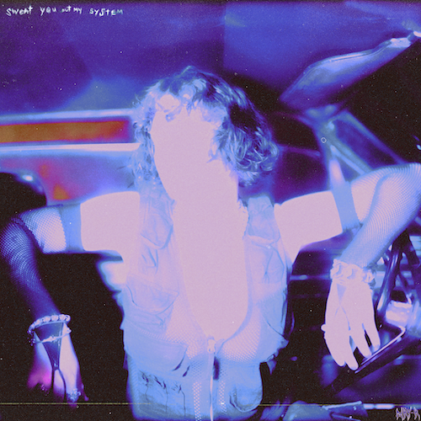
DOWNLOAD HI-RES ARTWORK

“MAY-A is moving full force into the future to make sure that her spotlight doesn’t run out anytime soon.” – PAPER

“MAY-A’s turned the heads of critics and tastemakers around the globe with her effortless and honest observations of everyday life and love…” – BILLBOARD

“MAY-A’s already-impressive multi-faceted world already extends across music, illustration, film, and video.” – ROLLING STONE

Rising pop singer-songwriter MAY-A embarks on a visionary new era with today’s release of her explosive new single, “Sweat You Out My System,” available now via Atlantic Records HERE. The track heralds a new era for MAY-A that sees her exploring and experimenting with new sounds and experiences.

“Writing ‘Sweat You Out My System’ felt like it opened so many doors in my brain to other types of music I’m excited to make,” MAY-A says. “A structured collage of rap-style moments, guitar riffs, yelling and hooks. SYOMS is pretty up-front lyrically, it plays on the idea of being completely addicted to someone ‘Missing you like a little kid/waiting for you to get back/I wish for you in my veins/so addicted it’s insane.’ The whole song stays on theme of the feeling of trying to ‘quit’ someone (hence- sweating them out like drugs), because fuck going back!”

“Sweat You Out My System” follows an incredibly successful 2022 for MAY-A, which included her ARIA Award-nominated collaboration with Australian electronic superstar Flume, “Say Nothing (Feat. MAY-A).” MAY-A joined Flume for performances of “Say Nothing” during show-stopping sets at last year’s Coachella and Governors Ball as well as on his sold-out US and Australian headline tours. The worldwide smash reached #12 on Billboard’s “Hot Dance/Electronic Songs” chart amidst a storm of high-profile media attention from Billboard, Complex and more. MAY-A also unveiled her own unique rendition, “Say Nothing (MAY-A’s Version),” hailed by NME as “a total tone shift from the duo’s original, stripping out the song’s driving beat and Flume’s electronic elements. Instead, MAY-A opts for hauntingly hazy vocals, acoustic guitar and spacious, lo-fi production, letting the vulnerability of the song’s lyrics shine through.”

MAY-A – who supported 5 Seconds of Summer on their recent Australian headline tour – is currently serving as special guest alongside Wallows on the UK/EU leg of their landmark Tell Me That It’s Over World Tour. For updates, please visit www.may-amusic.com/tour.

Nominated for Rolling Stone Australia’s “Best New Artist” award and hailed by Billboard as “a master class in indie pop,” MAY-A made her extraordinary debut with 2021’s acclaimed Don’t Kiss Ur Friends, available now at all DSPs and streaming services HERE. The EP – which received a prestigious ARIA Award nomination for “Breakthrough Artist – Release” in MAY-A’s home country of Australia – includes such inventive and self-assured tracks as “Swing Of Things,” “Time I Love To Waste,” “Apricots,” “Green,” and “Central Station.”

DOWNLOAD PRESS PHOTO HERE
CREDIT: SARAH EISEMAN
CONNECT WITH MAY-A
WEBSITE | FACEBOOK | INSTAGRAM | TWITTER | TIKTOK | YOUTUBE

For more information, please contact:
Kelly McWilliam // Kelly.McWilliam@atlanticrecords.com
”

