FOR IMMEDIATE RELEASE
JANUARY 13, 2023

GENEVIEVE STOKES SHARES SELF-SOOTHING “17”

ALT-POP SONGSTRESS DELIVERS CATHARTIC SINGLE
FROM NEW CATCHING RABBITS EP ARRIVING THIS SPRING

LISTEN TO “17” | WATCH OFFICIAL VISUALIZER
PRE-SAVE CATCHING RABBITS

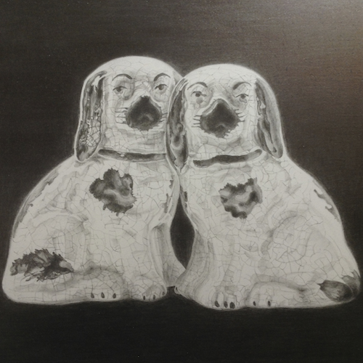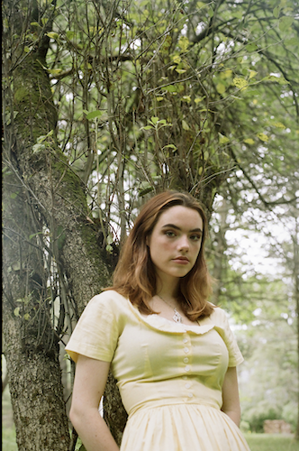
DOWNLOAD HI-RES ARTWORK + DOWNLOAD PRESS PHOTOS (CREDIT: ABBIE PITRE)

Acclaimed alt-pop singer-songwriter-pianist Genevieve Stokes is kicking off the new year with the latest song released from her forthcoming EP, Catching Rabbits, arriving this spring. The evocative and lullabylike “17” is available today at all DSPs and streaming services with an official visualizer streaming HERE.

"I wrote 17 as a self-soothing lullaby,” says Genevieve. “I wanted to pierce through my heavy, dark emotions by writing something hopeful.”

“17” follows this fall’s release of the emotionally charged “Can I” which arrived alongside Rolling Stone’s exclusive announcement of the multi-talented musician’s eagerly awaited new EP. Written by Stokes featuring production from superstar producer Tony Berg (Phoebe Bridgers, Paul McCartney, Taylor Swift), “Can I” is joined by a beautiful visualizer streaming HERE.

Catching Rabbits will also feature lead single “Habits” which now boasts nearly 40M global streams after earning more than 50M views across a series of TikTok teases prior to release. The fan favorite track has recently seen yet another viral wave on TikTok with the sped-up sound garnering over 42K creates. A fantastical Alice’s Adventures in Wonderland-inspired music video – directed by Abbie Pitre and Roman Spataro and hailed by TEEN VOGUE as “the woodland fairy fantasy of your dreams” – is streaming now at YouTube HERE. In addition, a gorgeous live performance of “Habits” – filmed in Stokes’ beloved hometown of Portland, ME – is streaming now HERE.

Hailed by PAPER for her “gut wrenching ballads,” Stokes spent much of the past year touring alongside artists including Noah Kahan, Briston Maroney, Sarah Kinsley and Charlie Burg. Additional live dates will be announced soon, and updates can be found at genevievestokes.com/tour.

Genevieve taught herself piano at the age of eight, spending her teen years developing her own unique sound, inspired by iconic female musicians like Fiona Apple and Regina Spektor but infused with her deeply personal experience and perspective. All before releasing her debut EP, Stokes drew attention and applause for her intimate yet lush approach to alternative pop, amassing over 7M streams independently, ascending esteemed playlists and garnering support from Complex, EARMILK, Ones to Watch and more.

Named by Alternative Press as a “New Artist You Need To Hear,” Stokes made a striking major label debut with her angsty yet nostalgic 2021 EP, Swimming Lessons, highlighted by standout tracks, “Surface Tension,” “Parking Lot,” and “Running Away.” Recorded in a cabin just a stone’s throw from the 21-year-old artist’s childhood home, the critically acclaimed project went on to earn over 16M streams worldwide while receiving praise from publications including Flaunt, NYLON, Billboard, Refinery29, FLOOD, and more.

CONNECT WITH GENEVIEVE STOKES
OFFICIAL | INSTAGRAM | TWITTER | YOUTUBE | FACEBOOK | TIKTOK | PRESS ASSETS

PRESS CONTACT:
ANDREW.GEORGE@ATLANTICRECORDS.COM

