FOR IMMEDIATE RELEASE

JANUARY 13, 2023

NOA KIREL IS ANYTHING BUT “GONE”

GLOBAL POP STAR KICKS OFF 2023 WITH FIERCE NEW SINGLE AND VIDEO

SET TO COMPETE IN 2023 EUROVISION SONG CONTEST

LISTEN TO “GONE” HERE | WATCH OFFICIAL VIDEO HERE

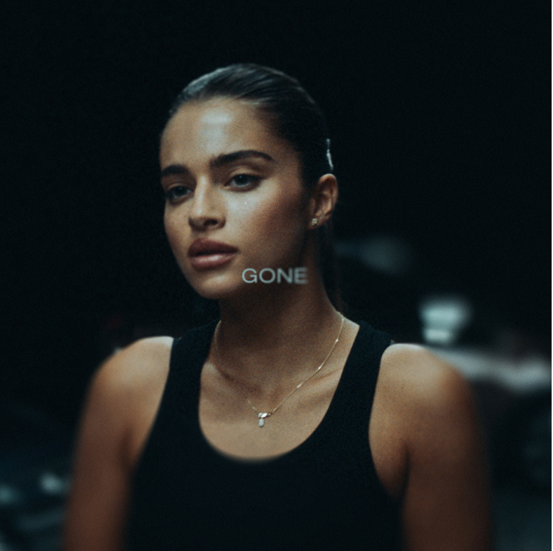
DOWNLOAD HI-RES ART + PRESS PHOTO HERE // CREDIT: Stanislaw Prokopczuk

Global pop sensation Noa Kirel is back with her new single, “Gone,” available now at all DSPs and streaming services. Produced and written by Monsters & Strangerz (Katy Perry, Camila Cabello, Rihanna) with additional co-writers, Michael Pollack (Justin Bieber, Lizzo) and Casey Smith (Olivia Rodrigo, Jonas Brothers), the dark yet empowering pop anthem chronicles Noa’s journey to freedom from a toxic relationship. Watch the official music video, which showcases the dynamic dancer’s fierce independence, on YouTube HERE.

“I’m excited to share a song that hopefully a lot of people who have struggled in toxic relationships can relate to,” shared Noa. “It makes me feel empowered and I hope it helps people channel their independence and freedom. Here’s to no more toxic relationships and negative energy in 2023!”

Kirel – who recently earned a record-setting sixth consecutive MTV EMA for “Best Israeli Act” and will represent her home country competing in this year’s Eurovision Song Contest in Liverpool, England – made her breakthrough English-language debut with the acclaimed 2021 single, “Please Don’t Suck,” co-written by Noa and produced by multi-platinum production duo The Monarch (Justin Bieber, Kelly Clarkson). The eye-popping official music video, directed by Jake Wilson (Cher, Lizzo) with choreography by the legendary Sean Bankhead (Beyoncé, Britney Spears, Miley Cyrus), has amassed over 26M views via YouTube HERE while praise for the starlet poured in from Variety, Flaunt, E! News, UPROXX, Ones To Watch, and more.

“Gone” follows additional English-language releases including the hypnotic “Thought About That,” which arrived alongside a gleaming, sci-fi-inspired music video streaming HERE, and the infectious “Bad Little Thing,” which Noa performed live as she opened the 70th annual MISS UNIVERSE®, first broadcast live on FOX from Eilat, Israel and streaming now HERE. An electrifying live act, Noa has performed on countless stages around the globe, with recent highlights including a sold-out headline stadium show at Tel Aviv’s Hayarkon Park and show-stealing sets at Pride festivals in New York City and Miami.

Since making her English-language debut, Noa has stunned on the covers of Galore, VULKAN Mag, and Photobook Magazine, while garnering critical applause from PAPER, People Magazine, which named her among their list of “Talented Emerging Artists Making Their Mark in 2022”, and Rolling Stone, which premiered her first-ever Spanish-language collaboration, “Dale Promo” with Metro The Savage.

ABOUT NOA KIREL
As a showstopping vocalist, clever lyricist, dynamic dancer, and scene-stealing actress, Israeli pop superstar Noa Kirel presents a different kind of story for popular music and culture. Cited by The Hollywood Reporter as “Israel’s biggest pop star,” she has emerged as an influential and inspirational force. Growing up in a suburb of Tel Aviv, Noa was born with one kidney, developing a will to endure at a young age. She gravitated towards dance at just three years old, taking classes and studying the artform, and soon began penning music of her own inspired by such multi-hyphenate stars as Beyoncé and Jennifer Lopez. At 14, she unveiled her debut single “Medabrim” (“Talking”) and exploded as a phenomenon in Israel with Hebrew-language smashes including the chart-topping “Million Dollar,” “Pouch,” “BLING BLING,” and more. In 2018, her explosive popular success earned her a spot on the panel of Israel’s Got Talent, making history as she became the show’s youngest judge anywhere in the world. By 2020, Noa impressively landed a global deal with Atlantic Records as well as a feature film produced by Picturestart. At the same time, she has continued to grow her brand across the board as the face of Samsung, Fila, Mac, and Keff in Israel, in addition to unleashing her own signature perfume and hair lines.

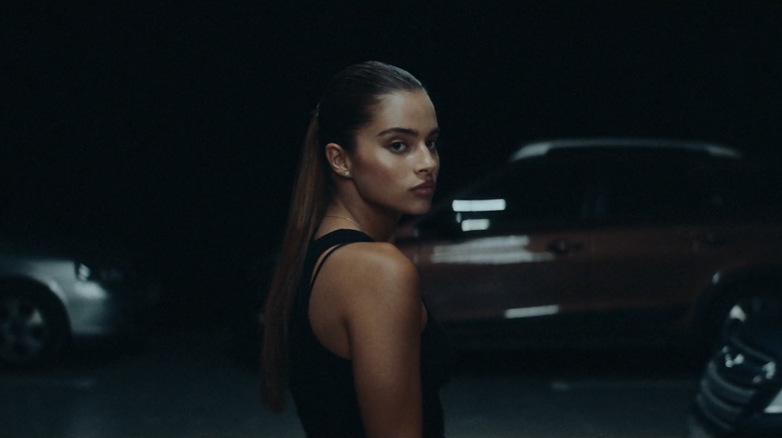
DOWNLOAD HI-RES VIDEO STILL

CONNECT WITH NOA KIREL:
WEBSITE | SPOTIFY | INSTAGRAM | TWITTER | FACEBOOK | YOUTUBE | TIKTOK | PRESS ASSETS

PRESS CONTACT:
ANDREW GEORGE | ANDREW.GEORGE@ATLANTICRECORDS.COM

