FOR IMMEDIATE RELEASE
JANUARY 27, 2023

SARA KAYS COVERS OWL CITY’S “FIREFLIES”

ACCLAIMED SINGER-SONGWRITER SHARES FAN FAVORITE COVER FIRST PERFORMED ON TOUR

LISTEN TO “FIREFLIES” | WATCH OFFICIAL VISUALIZER

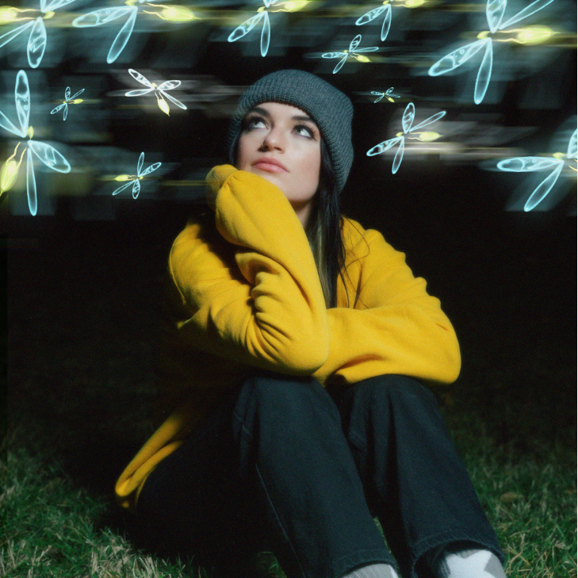
DOWNLOAD HI-RES PRESS PHOTOS + ART
CREDIT: CHASE DENTON

RIAA gold-certified singer-songwriter Sara Kays has officially shared her beautiful cover of Owl City’s classic “Fireflies,” which became a fan favorite last year as she performed on tour across North America opening for Alec Benjamin and MAX. Listen HERE and watch the official visualizer at YouTube HERE.

“I spent almost half of 2022 on tour, and at most of the shows I would sing ‘fireflies’ by owl city in the middle of my set,” shared Sara. “It was always such a fun moment in the show because everyone and their mother loves that song. I figured after singing it at least 50 times last year, I should release my own version of it! It was super fun to make and I’m excited to have it out in the world :-)"

Having cultivated an intensely engaged and supportive audience on TikTok nearing 2M followers, Sara is disarmingly raw about everything from body image to mental health as proven on her 2021 Struck By Lightning EP. Observations, thoughts, and truths straight from the Notes app on her phone inform diary-style stories spotlighted by gentle acoustic guitar, soft ukulele, and a keyboard murmur. With over 500M global streams, her authenticity shines through in her powerful lyricism and expressive voice, which connect to audiences all over the globe and have cemented her as one of the most prominent pop artists on the rise.

The Nashville-based musician initially teased the EP’s arrival with “Backseat Rider,” “Traffic Lights,” “Future Kids,” and “Picture Of You”. In addition to her collaboration with Cavetown on the title track, the EP is highlighted by her RIAA gold-certified, viral breakup anthem, “Remember That Night?” which she made her national late night TV debut performing on The Late Show with Stephen Colbert. Last year, Sara followed her Struck By Lightning EP with singles including “Math,” “When You Look At Me,” and most recently, "Watching TV." Profiled for Billboard’s “Emerging Artists Spotlight” and named among People’s “Talented Emerging Artists” list, Sara is readying new music to be released in 2023.

WHAT CRITICS ARE SAYING:

“Sara Kays’ music has something to offer for everyone.” – PEOPLE

“Sara Kays knows what it takes to craft heartfelt lyrics spun with velvet, tight-knit arrangements that simply elevate the already high-flying material.” – AMERICAN SONGWRITER

“Normalizing life’s struggles that often seem easier to avoid, Sara has carved out a unique space…quickly creating a community through her message.” – FLAUNT

“Sara Kays has cultivated a devoted following by wearing her heart on her sleeve. The rapidly rising artist's growing fanbase is a testament to her understated gift for empathetic songwriting.” – ONES TO WATCH

“One Of Pop Music’s Breakout Stars” – HUFFPOST

CONNECT WITH SARA KAYS:
TIKTOK | TWITTER | INSTAGRAM | facebook | YOUTUBE | PRESS ASSETS

PRESS CONTACT:
ANDREW.GEORGE@ATLANTICRECORDS.COM

