R&B SONGSTRESS RAICHE GIFTS FANS WITH NEW VISUAL
“NEW YORK, NEW YORK”
“NEW YORK, NEW YORK” IS PART ONE OF HER HOLIDAY VISUAL TALE
PART TWO, “I HATE CHRISTMAS,” WILL RELEASE ON CHRISTMAS DAY
FOLLOW-UP TO RAICHE’S YEAR-LONG SINGLE RUN
WATCH/SHARE “NEW YORK, NEW YORK”
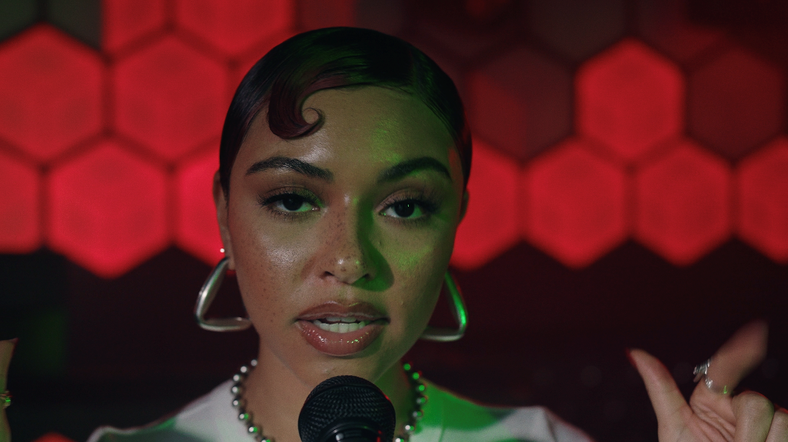

ABOUT RAICHE

Named one of Billboard’s “15 Hip-Hop & R&B Artists to Watch in 2021” as well as an ESSENCE “Rising Star,” YouTube “Artist on the Rise,” and iHeartRadio “On The Verge Artist,” Raiche has quickly proven to be a creative sensation and breath of fresh air in contemporary R&B. The gifted young artist fuses soulful roots with modern pop to concoct a genuinely distinctive new sound all her own, lit up with confidence, consistency, and positivity. Born and raised in Pittsfield, MA, just two hours outside of Boston, Raiche devoted her energies towards music from an early age, uploading cover videos to YouTube that almost immediately earned her online applause. Her musical dreams almost came to a halt following high school graduation but some encouraging words from her beloved Nana eventually led her to Boston, where she met DJ Knock Out. The local legend soon introduced Raiche to her GDE production team as well as to superstar songwriter Prince Charlez (Rihanna, Beyoncé, Usher), who promptly signed the talented vocalist to his recently launched Island Prolific imprint at Atlantic Records.

Now boasting over 19.1M worldwide streams across her growing body of work, Raiche made her national debut with 2018’s “Money Pies,” streaming HERE; a colorful official video – directed by the all-female Verluxe collective – can be viewed HERE. Raiche’s acclaimed debut EP, DRIVE, followed the next year, highlighted by “Complicated” and the powerful title track, “Drive,” featured in Netflix’s Self Made: Inspired by the Life of Madam C.J. Walker. To date, Raiche has released a string of singles across 2022 including: “Complicated,” “Fool,” and “Feelings.” Her single run was ignited by her first performance at the legendary Essence Music Fest this past summer.

# # #

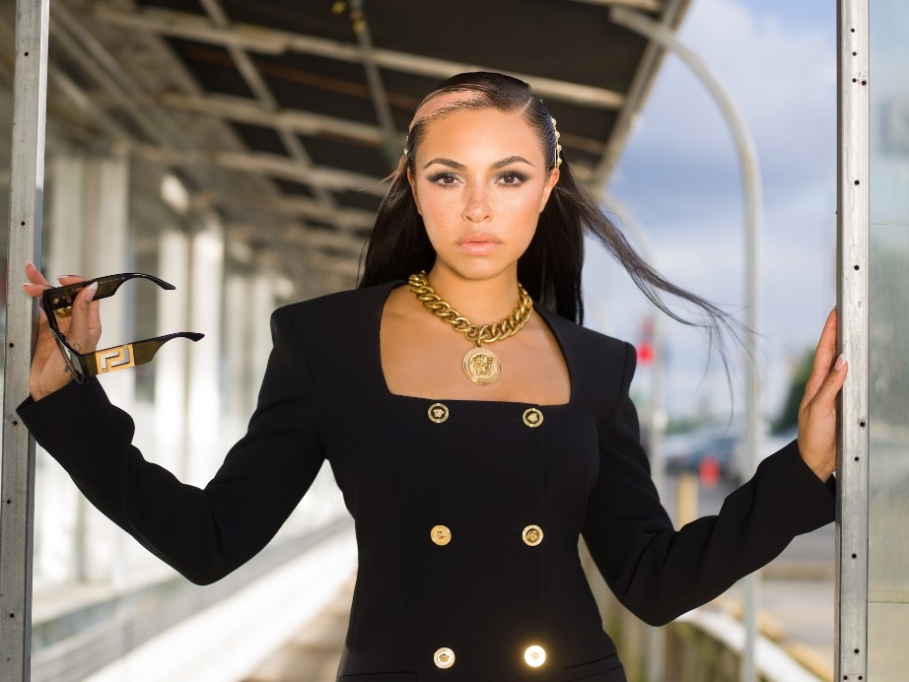

CONNECT WITH RAICHE
MYNAMEISRAICHE.COM | FACEBOOK | TWITTER | YOUTUBE | INSTAGRAM | SPOTIFY | SOUNDCLOUD
FOR PRESS INQUIRIES CONTACT:
SYDNEY.MARGETSON@ATLANTICRECORDS.COM

