FOR IMMEDIATE RELEASE
DECEMBER 22, 2022

R&B GENERAL TANK RELEASES NEW VISUAL FOR “NO LIMIT (FEAT. ALEX ISLEY)”
LAST & FINAL ALBUM "R&B MONEY” OUT NOW
GEARING UP FOR THE NEW EDITION “LEGACY TOUR” IN 2023
WATCH/SHARE “NO LIMIT”
STREAM/DOWNLOAD R&B MONEY
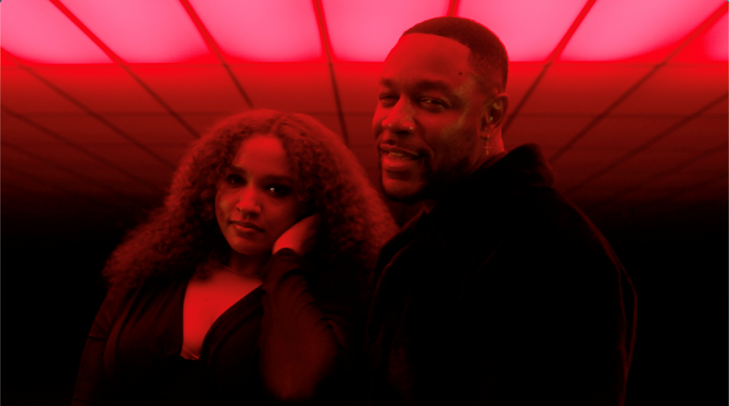
R&B superstar Tank couldn’t leave his fans for the holidays without giving them a gift before the end of 2022. Today, Tank releases the visual for “No Limit” featuring Alex Isley off his tenth and final album, R&B MONEY, out now via his label R&B MONEY/Atlantic Records. Directed by Jonathan Hernandez and choreographed by Francisco "Cisco” Ruelas, the "No Limit” video is quintessential Tank; Sexy, intense, and will leave you wanting more. “No Limit” is the follow-up to Tank’s #1 hit single, “Slow,” featuring J. Valentine, which they performed at 2022 BET Soul Train Awards (click here).
Released in August, the R&B Money album in total produced three #1 hit singles, “Can’t Let It Show,” “I Deserve,” and the aforementioned “Slow,” officially garnering Tank seven #1 R&B hit songs since the release of his album SAVAGE (2017), which produced the 2x-platinum-selling hit "When We.”
In addition to the release of R&B Money, Tank enjoyed many highlights for 2022, including the successful launch of the "R&B Money Podcast,” hosting the "Soul Train Awards Red Carpet Special,” hosting "Urban One Honors,” and announcing going on tour with New Edition on the "Legacy Tour” kicking off March 9 to April 30 performing at arenas across North America.
FOLLOW TANK:
IG: @therealtank
TW: @therealtank
FB: @therealtank
FOR PRESS INQUIRIES
SYDNEY.MARGETSON@ATLANTICRECORDS.COM
TASHA@STRONGARMMEDIA.COM

