SKRILLEX CONTINUES HOT STREAK WITH MORE NEW MUSIC AND SOLD OUT POP-UP PERFORMANCES

REVERED PRODUCER DROPS “LEAVE ME LIKE THIS” FEATURING BOBBY RAPS

LISTEN TO THE NEW TRACK HERE.

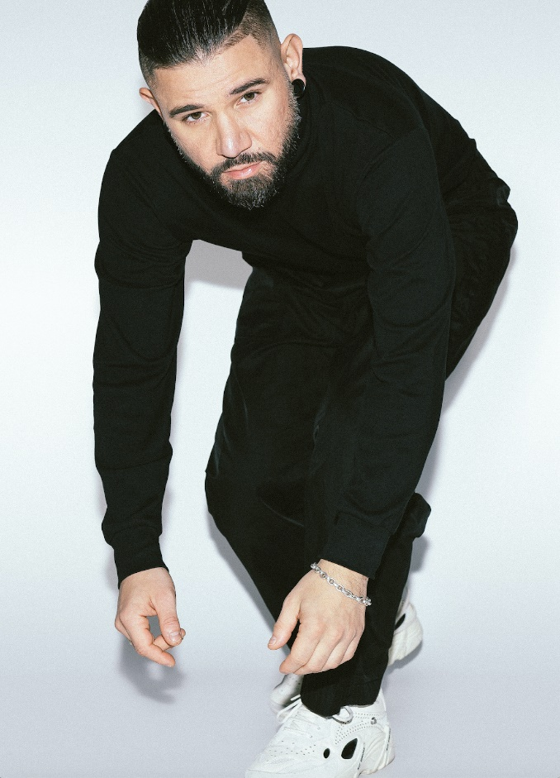
Photo Credit: Marilyn Hue

Following the release of his two previous singles and selling out his London pop-up performances with Fred again.. and Four Tet, Skrillex continues to excite his fans with additional music. His new single “Leave Me Like This” featuring rapper, singer, and producer Bobby Raps comes as the third song released this month as Skrillex shows no signs of stopping anytime soon. His recent shows, along with the release of new music, has had his fans roaring with excitement throughout social media. With both previous songs having garnered great reception from notable music sources such as Billboard and Pitchfork, along with making Uproxx’s best new music of the week roundups, this new track continues on the same path of excitement and innovation that Skrillex fans have come to love.

Listen to his new single “Leave Me Like This” here.

