**VISIONARY PSYCHEDELIC POP ACT ARLIE RELEASES NEW SINGLE “findaway” BUY/STREAM** [**HERE**](https://arlie.lnk.to/findaway)

**CURRENTLY ON US HEADLINE TOUR**

**TICKETS ON SALE** [**HERE**](https://www.arlie.band/tour/)

**SLATED FOR ATLANTA’S SHAKY KNEES MUSIC FESTIVAL ON MAY 5**

**DEBUT ALBUM *BREAK THE CURSE* OUT NOW**

**BUY/STREAM** [**HERE**](https://arlie.lnk.to/BREAKTHECURSEPR)

*“The indie-pop song expands upon the band’s saturated sound heard on ‘WAIT,’ taking them to a groovier and more upbeat level.”*– **V MAGAZINE**

*“Arlie’s return once again bursts with colorful melodies and irresistible indie pop grooves, but also cultivates a more vulnerable side...”* – **UNDER THE RADAR**

*“As you wind your way through BREAK THE CURSE’s eleven tracks – which frequently recall the lively, day-glo pop of the sixties filtered through the bold electronics of today* – *the ebullient, sumptuous melodies get their hooks into you. It becomes impossible not to listen again. And again. And again.”*

– **METRO**

*download hi-res artwork* [*here*](https://warnermusicgroup.app.box.com/s/bb12wx18lh967y5j436mxuesc6u8xk75/file/1133071831829)*; photo credit: Gracie Heart*

Today, visionary psychedelic Nashville-based pop act **Arlie** releases new single “**findaway**” (buy/stream [here](https://arlie.lnk.to/findaway)), a high-energy track that fans have already been enjoying live during the early February dates of the band’s current **US headline tour**. Fresh off a packed **NYC** show at **Bowery Ballroom** last week, Arlie will make stops in **Los Angeles**, **San Francisco**, **Chicago**, and **Denver** – among many other cities – before capping off their current run in **Dallas**, **TX** on **March 9**.

Of “findaway,” singer-songwriter and multi-instrumentalist **Nathaniel Banks** shares:

*“This song is about the power of desire as a source of fuel for creative problem solving, for better or for worse. I’m into exploring duality and dialectics in art. This one could be understood as both a celebration of persistence and determination, and at the same time, a lament about the unconscious forces that drive behavioral patterns.”*

Co-written and co-produced by Banks, “findaway” follows the recent release of acoustic versions of “**big fat mouth**” and “**crashing down**” (buy/stream [here](https://arlie.lnk.to/acoustic)) – two fan favorite tracks from the ever-growing Arlie catalog. **Nuance** hailed that acoustic pairing as *“stripped down to their delicate cores… highlighting Banks’ vocal abilities.”*

Arlie’s current headline tour is in continued support of their impressive first full-length, ***BREAK THE CURSE***, which debuted to critical acclaim in the summer of 2022. On **Friday**, **May 5**, the band will join the stacked lineup for the 10-year anniversary edition of **Atlanta**’s **Shaky Knees**. [Full routing enclosed below.]

Arlie spent last fall on the road supporting LA natives and fellow indie pop band **The Wrecks** on US dates from San Diego to Rhode Island. Earlier in 2022 marked the band’s debut headline US run with the *BREAK THE CURSE* tour – a run which was almost entirely **sold out**, including in NY, LA, Chicago, Austin, and Denver.

*BREAK THE CURSE* – Arlie’s highly-anticipated, first LP – marked the follow-up to 2018’s debut EP ***WAIT***, and was met with critical acclaim from outlets including **Ones to Watch** and **V Magazine** (*“The indie-pop song ‘landline’ expands upon the band’s saturated sound heard on ‘WAIT,’ taking them to a groovier and more upbeat level.”*)

*“A true collage of everything from pop to alternative, pulled together with a squelching kaleidoscopic flare… beaming with lyrical savviness that exudes alternative infatuation.” –* **ONES TO WATCH**

“…*fusing a sound both futuristic and vintage… Arlie flirts with an aroma of nostalgic youth, like a mix between a 1984 Testarossa and The Jetsons’ hovercraft.”* – **FLAUNT**

*“Arriving in the wake of the band’s 2018 EP, WAIT, and a string of stellar singles, the record found lead singer/songwriter and multi-instrumentalist Nathaniel Banks returning to music after taking an extended hiatus for his mental health. His return once again burst with colorful melodies and irresistible indie pop grooves, but also cultivated a more vulnerable side, with Banks reflecting on ‘breaking the curse’ of societal and generational trauma.”* – **UNDER THE RADAR**

*“‘break the curse,’ among other songs on the album, pushes the band away from the constraints of any one genre, allowing them to explore their signature sound at the intersection of pop, rock, and alternative music.”* **– EUPHORIA**

*“As you wind your way through BREAK THE CURSE’s eleven tracks – which frequently recall the lively, day-glo pop of the sixties filtered through the bold electronics of today* – *the ebullient, sumptuous melodies get their hooks into you. It becomes impossible not to listen again. And again. And again.”*– **METRO WEEKLY**

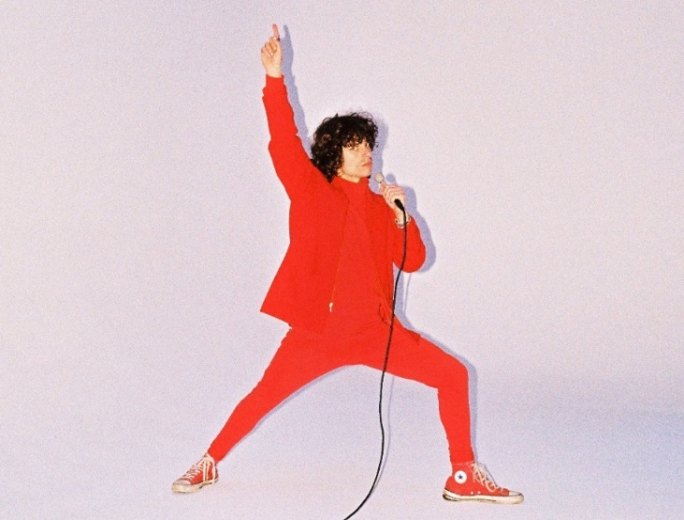

*download hi-res press photo* [*here*](https://warnermusicgroup.box.com/s/08vyw5znad35o8x24c2uoeaqxpkog97d)*; credit: Gabe Drechsler*

With over **110M** worldwide streams and counting, Arlie first began in the summer of 2015 as a solo bedroom project for Banks, eventually evolving to a full-band live act by 2017 and growing a fervent fan following in their hometown of Nashville and beyond.

Hailed for its striking synthesis of classic pop melodies with wildly creative modern production, Arlie’s 2018 [***WAIT***](https://lnk.to/WaitEP) EP included such hit singles as “**[didya think](https://www.youtube.com/watch?v=3__Y4biq_gI)**” and “[**big fat mouth**](https://www.youtube.com/watch?v=XH8ALhYeLLk).” The project immediately drew acclaim for its invigorating songcraft, meticulous production, and playful, summertime energy.

*****

**UPCOMING LIVE DATES:**

**FEBRUARY 17** – Chicago, IL – SUBTERRANEAN*

**FEBRUARY 18** – St. Louis, MO – Blueberry Hill Duck Room*

**FEBRUARY 19** – Kansas City, MO – Record Bar*

**FEBRUARY 21** – Denver, CO – Larimer Lounge*

**FEBRUARY 23** – Salt Lake City, UT – Soundwell*

**FEBRUARY 24** – Boise, ID – The Shredder*

**FEBRUARY 25** – Seattle, WA – Vera Project*

**FEBRUARY 26** – Portland, OR – White Eagle Saloon*

**FEBRUARY 28** – San Francisco, CA – Bottom of the Hill*

**MARCH 2** – Los Angeles, CA – Teragram Ballroom*

**MARCH 4** – San Diego, CA – House of Blues: Voodoo Room*

**MARCH 5** – Phoenix, AZ – The Rebel Lounge*

**MARCH 8** – Austin, TX – 3TEN*

**MARCH 9** – Dallas, TX – Club Dada*

**APRIL 29** – Columbia, MO – Nacho Fest

**MAY 5** – Atlanta, GA – Shaky Knees Music Festival

*w/ special guests Whitehall & The Sewing Club

# # #

**CONNECT WITH ARLIE:**

[OFFICIAL](https://www.arlie.band/) | [INSTAGRAM](https://www.instagram.com/arlieband/?hl=en) | [FACEBOOK](https://www.facebook.com/arliemusic) | [YOUTUBE](https://www.youtube.com/channel/UCBthy0lYQKjIbDCr1jyVrpA) | [TWITTER](https://twitter.com/arlieband)

**FOR ALL PRESS INQUIRIES, PLEASE CONTACT:**

Libby Kober | [Libby.Kober@AtlanticRecords.com](mailto:Libby.Kober@AtlanticRecords.com)

Gabby Reese | Tour/Online | [Gabrielle.Reese@AtlanticRecords.com](mailto:Gabrielle.Reese@AtlanticRecords.com)