DAISY JONES & THE SIX RELEASE “LOOK AT US NOW (HONEYCOMB)”

HIGHLY-ANTICIPATED SINGLE CO-WRITTEN BY MARCUS MUMFORD + PERFORMED BY RILEY KEOUGH & SAM CLAFLIN – STARS OF FORTHCOMING LIMITED SERIES DAISY JONES & THE SIX

DEBUT FULL-LENGTH AURORA SET FOR DIGITAL + VINYL RELEASE MARCH 3 VIA ATLANTIC RECORDS

WRITTEN & PRODUCED BY GRAMMY® AWARD WINNER BLAKE MILLS WITH STAR-STUDDED LINEUP OF COLLABORATORS INCLUDING MARCUS MUMFORD, JACKSON BROWNE, TAYLOR GOLDSMITH, CHRIS WEISMAN, JAMES VALENTINE, ETHAN GRUSKA + MORE

GROUNDBREAKING ADAPTATION OF NEW YORK TIMES BESTSELLING LITERARY PHENOMENON PREMIERES MARCH 3 ON PRIME VIDEO – PRODUCED BY AMAZON STUDIOS AND HELLO SUNSHINE

BUY/STREAM “LOOK AT US NOW (HONEYCOMB)” HERE

PRE-ORDER AURORA ON VINYL HERE
PRE-SAVE AURORA HERE
WATCH DAISY JONES & THE SIX OFFICIAL TRAILER HERE

“Move over Rumours, Aurora is here… Based on the songs first conceived in the novel and framed as an oral history, Aurora is an unprecedented project for a book-to-screen adaptation and musical storytelling on television. Thunder may only happen when it’s raining, but we’re already shook by the idea that we’ll actually get to hear Aurora. In the meantime, we can drop the metaphorical needle, don our best caftans, and play ‘Regret Me’ on repeat.” – ENTERTAINMENT WEEKLY

“Moving from the pages to the recording booth, ‘Regret Me’ takes new form as a fiery duet between the band’s two lead vocalists. Producer Blake Mills, who helmed the creation of Aurora as both writer and producer, reimagined the song through the lens of its fictional 1970s origins with the lyrics flipped into an emotional battlefield.” – ROLLING STONE

“If ‘Regret Me’ is already stuck in your head, well, welcome to the Daisy Jones & The Six fan club… the latest footage – including music soundbites and a sneak peek of the ambitious, no-longer-fictional Aurora record – speaks of some very Stevie Nicks-esque things to come.” – ELLE

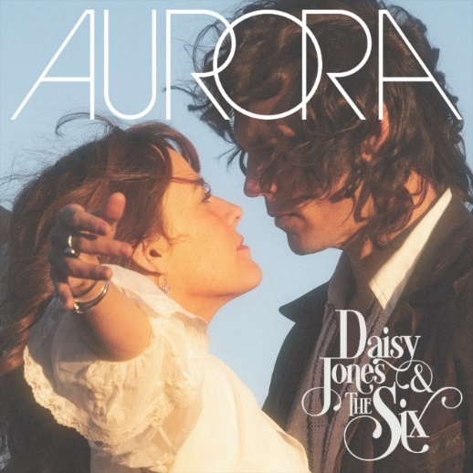
download hi-res album artwork here

Atlantic Records is proud to share the latest single from Daisy Jones & The Six – “Look At Us Now (Honeycomb)” – out everywhere today (buy/stream here).

Co-written by Marcus Mumford with vocals from Riley Keough and Sam Claflin, the stunning duet is lifted off the forthcoming LP Aurora, the storied debut from the titular band of Taylor Jenkins Reid’s beloved, New York Times bestselling novel Daisy Jones & The Six.

Fans of the book will instantly recall the single as pivotal in both the band’s early recording sessions, and in the charged personal dynamic between lead singer Daisy Jones and frontman Billy Dunne.

Aurora arrives in full Friday, March 3rd on vinyl and across all DSPs via Atlantic Records (pre-order on vinyl here + pre-save here).

That same day, the groundbreaking limited series adaption ‘Daisy Jones & The Six’ will premiere on Prime Video, with new episodes released every Friday through March 24th, starring Riley Keough, Sam Claflin, Suki Waterhouse, and more (watch the official trailer here).

The highly-anticipated series arrives via Amazon Studios and Reese Witherspoon’s media company Hello Sunshine, who optioned Reid’s work in 2018 – before Daisy Jones & The Six ever even hit bookshelves. Upon the novel’s release in early 2019, it received coveted recognition as a ‘Reese’s Book Club Pick.’

Today’s release follows lead single “Regret Me,” another emotionally-charged duet – with an instantly-recognizable title to readers – sung by lead characters Daisy Jones (Keough) and Billy Dunne (Claflin). “Regret Me” debuted to massive critical acclaim and excitement from fans last month, with Variety praising the track as “a dreamy duet… Keough and Claflin’s voices blend together breezily over an instrumental that evokes the prime of ‘70s rock ‘n roll,” and Rolling Stone proclaiming, “‘Regret Me’ takes new form as a fiery duet between the band’s two lead vocalists. Producer Blake Mills reimagined the song through the lens of its fictional 1970s origins with the lyrics flipped into an emotional battlefield.”

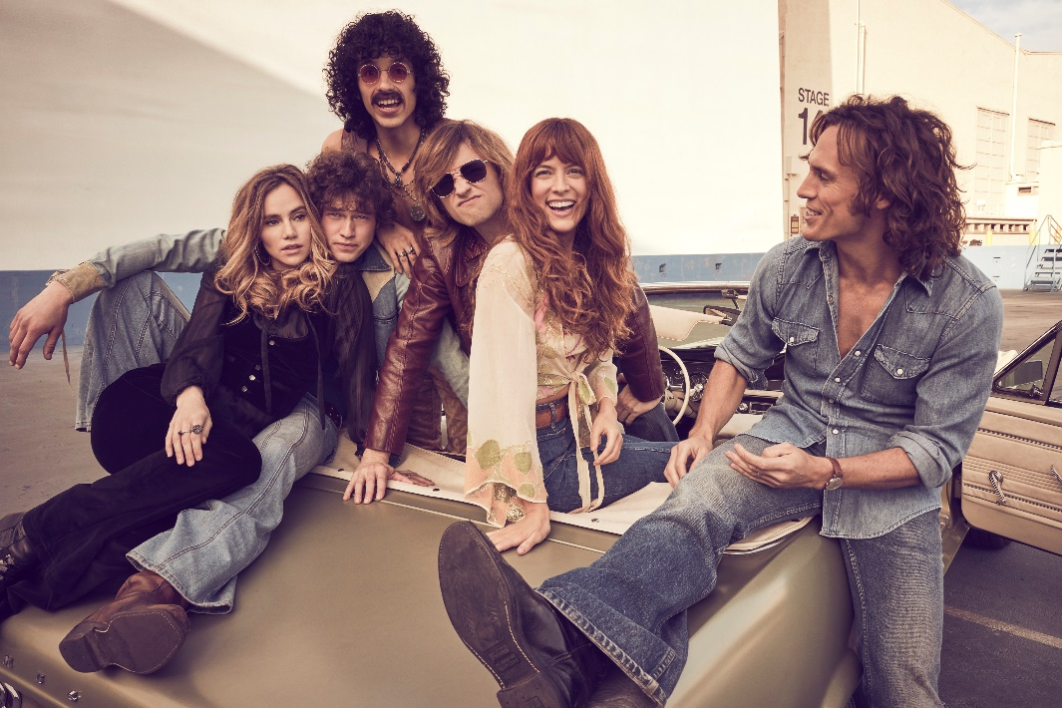
download hi-res photo here

Now, in 2023, Aurora has been brought to life by the cast, with Keough in her role as Jones and Claflin, Waterhouse, Will Harrison, Josh Whitehouse and Sebastian Chacon rounding out The Six. The group became a band both on-screen and off – with some of the multi-hyphenates learning their character’s instrument for the very first time during production, and Keough and Claflin lending their vocals to each track on the record.

Helmed by acclaimed GRAMMY®-winning songwriter, producer, and multi-instrumentalist Blake Mills (Bob Dylan, Fiona Apple, Alabama Shakes, John Legend, Perfume Genius), Aurora and other music from throughout the show boasts co-writing credits that include some of today’s biggest names in music, such as: Marcus Mumford and Jackson Browne, with additional production from renowned record producer Tony Berg (Phoebe Bridgers, Andrew Bird), alongside instrumentalists from Rilo Kiley, The Who, Nine Inch Nails, Pearl Jam, David Bowie, Elton John, Jeff Beck, The Wallflowers, and more.

Mills – who also executive produced the music from the series – recorded the entirety of Aurora with Keough, Claflin, and the above collaborators at Sound City Studios. The iconic Van Nuys, CA space – now jointly run by Mills, Berg, and filmmaker-producer Jordan Tappis – also serves as the backdrop in both the book and limited series for the creation of the album.

On the process of bringing this soundtrack to life, Blake Mills shares:

Creating the library of music for Daisy Jones and The Six was an experience I’ll never forget. I am grateful that, among other things, it afforded me an opportunity to collaborate with so many of my peers, and also some of my heroes.

While Taylor Jenkins Reid, author of Daisy Jones & The Six elaborates:

We finally have Aurora. A stunning, nostalgic, timeless album that captures the drama, pathos, and yearning of the band’s zenith and nadir all in one. A snapshot of time, intoxicating and dangerous. That delicious moment that you know can’t last… Daisy Jones and The Six are real. And they are better than my wildest dreams.

Speaking on the impact of Aurora, Oscar-nominated series co-creator and executive producer Scott Neustadter adds:

In the early 1970s, a group of kids with stars in their eyes and talent to spare formed a band called Daisy Jones and The Six. They would go on to become one of music’s biggest success stories despite – or perhaps because of – their own interpersonal demons. Theirs was a love story: the love of a particular sound, the love of family, the love of your life, and the love you can’t have but also maybe can't live without… Aurora represents the pinnacle of a short-lived recording career. It also serves as proof – for both the fictional band and the real one who dreamed this up together – that pouring your heart and soul into something you believe in can have a profound effect on the rest of your life.

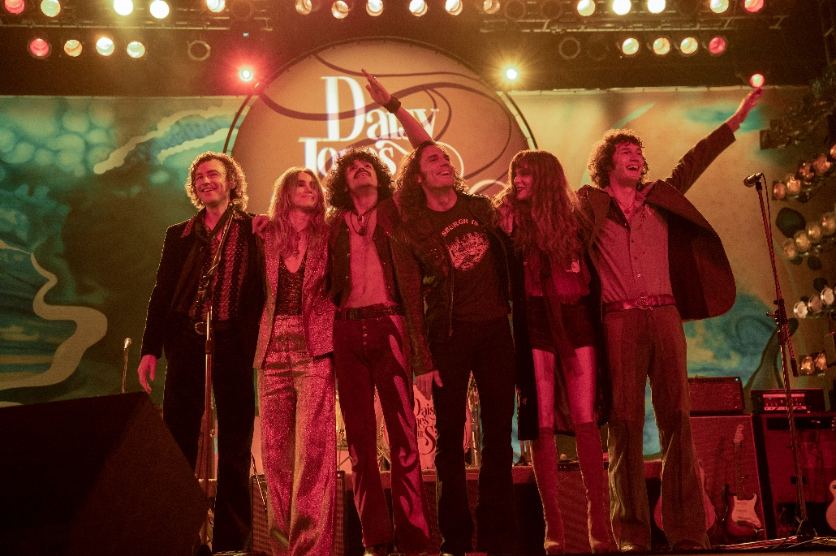
download hi-res photo here

***

DAISY JONES & THE SIX – AURORA TRACKLIST:
- Aurora
- Let Me Down Easy
- Kill You To Try
- Two Against Three
- Look At Us Now (Honeycomb)
- Regret Me
- You Were Gone
- More Fun To Miss
- Please
- The River
- No Words

ABOUT DAISY JONES & THE SIX – THE LIMITED SERIES:
Based on the best-selling novel by Taylor Jenkins Reid, Daisy Jones & The Six is a limited musical-drama series detailing the rise and precipitous fall of a renowned rock band. In 1977, Daisy Jones & The Six were on top of the world. Fronted by two charismatic lead singers—Daisy Jones (Riley Keough) and Billy Dunne (Sam Claflin)—the band had risen from obscurity to fame. And then, after a sold-out show at Chicago's Soldier Field, they called it quits. Now, decades later, the band members finally agree to reveal the truth. This is the story of how an iconic band imploded at the height of its powers.

The series stars Riley Keough as Daisy Jones, Sam Claflin as Billy Dunne, Camila Morrone as Camila Dunne, Will Harrison as Graham Dunne, Suki Waterhouse as Karen Sirko, Josh Whitehouse as Eddie Roundtree, Sebastian Chacon as Warren Rhodes, Nabiyah Be as Simone Jackson, and Tom Wright as Teddy Price, with a special guest appearance by Timothy Olyphant as Rod Reyes.

From Amazon Studios and Hello Sunshine, Daisy Jones & The Six is executive produced by Reese Witherspoon and Lauren Neustadter for Hello Sunshine and Brad Mendelsohn for Circle of Confusion. Scott Neustadter and Michael H. Weber created the series based on the novel by Taylor Jenkins Reid, who also produces. Scott Neustadter is executive producing and co-showrunning with Will Graham, who also serves as an executive producer. James Ponsoldt directed the first five episodes and serves as an executive producer, Nzingha Stewart directed four of the remaining episodes, and Graham directed one.

Daisy Jones & The Six premieres March 3, with new episodes released every Friday through March 24, exclusively on Prime Video in more than 240 countries and territories worldwide. For more information, visit the Amazon Studios Press Site.

***

CONNECT WITH DAISY JONES & THE SIX
WEBSITE | FACEBOOK | TWITTER | INSTAGRAM | YOUTUBE | TIKTOK

***

Atlantic Records Press Contact:
Libby Kober | Libby.Kober@atlanticrecords.com

Prime Video Press Contacts:
Melissa Armstrong | Melissa.Armstrong@amazonstudios.com
Kevin McAlpine | Kevin.McAlpine@amazonstudios.com
Reegan Smyth | Reegan.Smyth@amazonstudios.com

Hello Sunshine Press Contact:
Matthew Avento | Matthew.Avento@ledecompany.com

