FOR IMMEDIATE RELEASE
FEBRUARY 28, 2023

DON TOLIVER UPGRADES LOVE SICK
WITH FOUR ADDITIONAL TRACKS

DELUXE NEW EDITION INCLUDES THE BRAND NEW TRACKS,
“EMBARRASSED (FEAT. TRAVIS SCOTT),”
“LUCKILY I’M HAVING (FEAT. TEEZO TOUCHDOWN),”
THE LONG AWAITED “NO POLE”
AND MORE

LONG AWAITED NEW ALBUM ALSO INCLUDES THE RECENT SINGLES
“LEAVE THE CLUB (FEAT. LIL DURK & GLORILLA),”
“4 ME (FEAT. KALI UCHIS),”
AND “SLOW MOTION (FEAT. WIZKID)”

LOVE SICK SHORT FILM, PRESENTED BY ROTATION,
STREAMING NOW EXCLUSIVELY ON PRIME VIDEO
WATCH HERE

US ARENA DATES ALONGSIDE FUTURE’S “ONE BIG PARTY TOUR”
BEGINS MARCH 9 IN NEW ORLEANS

LOVE SICK (DELUXE) AVAILABLE NOW VIA CACTUS JACK/ATLANTIC RECORDS HERE

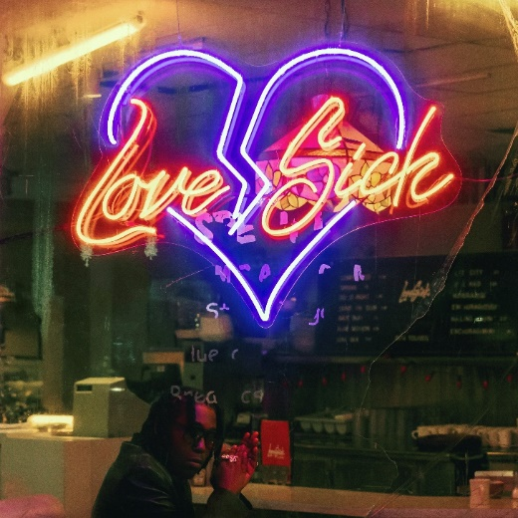
DOWNLOAD ALBUM ARTWORK

Hip-hop soul artist Don Toliver has quickly upgraded his long awaited new album, Love Sick, into an expanded deluxe edition available now via Cactus Jack/Atlantic Records. The collection now includes four additional tracks, including such brand new bangers as “Embarrassed (Feat. Travis Scott),” “Luckily I’m Having (Feat. Teezo Touchdown),” “No Pole,” and “Geronimo,” all available now for streaming and download. Expanded deluxe edition available HERE.

Love Sick includes the brand new single “Slow Motion (Feat. Wizkid)” and such scintillating new tracks as “Leave The Club (Feat. Lil Durk & GloRilla),” and “4 Me (Feat. Kali Uchis).” The album arrived last week alongside a self-written short film, Love Sick, presented by Rotation – the hip-hop and R&B brand from Amazon Music – streaming now exclusively on Prime Video. Watch Here.

Don Toliver – who recently has partnered with the Los Angeles-based Monty’s Good Burger for a Love Sick register takeover – will celebrate Love Sick with a wide-ranging US tour schedule, including direct support on Future’s star-studded “One Big Party Tour,” beginning March 9th at New Orleans, LA’s Smoothie King Center and wrapping in early April. Purchase tickets HERE. Toliver will also make a festival appearance at Inglewood, CA’s Rolling Loud California (Saturday, March 4).

Most recently, Toliver received RIAA platinum certifications for his debut album, Heaven or Hell, and its monumental singles; “No Idea” – 3x Platinum, “After Party” – 3x Platinum and “Cardigan” in addition to the now RIAA gold certified “Euphoria feat. Kaash Paige & Travis Scott” and “Had Enough feat. Quavo & Offset.” Last year saw Don Toliver earn international applause with “Do It Right.” Hailed by CLASH as “a ready-made anthem, it’s bouncy funk fueled by a sample of the S.O.S Band’s classic ‘Take Your Time (Do It Right),’” the track is joined by glitterball-powered official visual, presented by Cactus Jack and Rotation, directed by award-winning French filmmaker Alexandre Moors (Kendrick Lamar, Juice WRLD, Miley Cyrus) and now boasting close to 9M views at YouTube HERE.

In addition, Don Toliver was featured in Rihanna’s Savage X Fenty Show Vol. 4, performing a scintillating medley of “Do It Right” and “Way Bigger,” the latter of which originally appears on his critically acclaimed sophomore album, 2021’s Life of a DON. The star-studded annual fashion experience can be viewed exclusively on Prime Video HERE.

Indeed, 2022 marked a landmark year for Don Toliver, with high profile features including SZA’s “Used,” Justin Bieber’s “Honest,” Kid Cudi’s “Somewhere To Fly” and “Burrow,” Baby Keem’s “Killstreaks,” Trippie Redd’s “Ain’t Safe,” and Wizkid’s “Special,” to name just a few. Released October 2021, Life of a DON made a spectacular chart debut upon its arrival, landing at #2 on Billboard’s “Top R&B/Hip-Hop Albums” and the Billboard 200 – Toliver's second US top 10 debut on the overall chart and highest charting album to date. Life of a DON includes such hit singles as “Drugs N Hella Melodies (Feat. Kali Uchis),” “Way Bigger,” “Flocky Flocky (Feat. Travis Scott),” and the RIAA gold certified “What You Need,” all of which are joined by dramatic visuals that have earned a combined 60M+ views via the official Don Toliver YouTube channel HERE.

ABOUT DON TOLIVER:
Soul singer, songwriter, and artist Don Toliver has earned worldwide attention for a unique sound that calls out his myriad musical influences of hip-hop, smoked-out R&B, ambitious pop, and even a bit of rock ‘n’ roll, creating a genre-bending lane of his own. After the 2018 mixtape Donny Womack, the Houston, TX native assembled his full-length debut, Heaven Or Hell, which claimed spots on mid-year and year-end lists by Complex and XXL, while Rolling Stone championed him among the “10 Biggest Breakthrough Artists of 2020.” Don then joined forces with Internet Money, NAV, and Gunna for the 4x platinum banger “Lemonade,” which they also performed on NBC’s The Tonight Show Starring Jimmy Fallon. 2021 saw Don team with Lil Durk and Latto for “Fast Lane,” the lead track on Atlantic Records’ F9: The Fast Saga (Original Motion Picture Soundtrack), followed by the blockbuster release of Life of a DON, once again showcasing his fluid ability to exist in multiple soundscapes and featuring production by Mike Dean, Hit-Boy, Mustard, and more. Through it all, he has gathered billions of streams, scored platinum plaques, and received praise courtesy of everybody from such media outlets as V MAN, W Magazine, Interview, and more. 2023 now marks a spectacular new era for Don and his fans around the world as he embarks on his most exciting musical journey thus far. Stay tuned…

DON TOLIVER
ON TOUR 2023
* Festival Performance
† w/ Future “One Big Party Tour”

MARCH
4 – Inglewood, CA – Rolling Loud California *
9 – New Orleans, LA – Smoothie King Center †
12 – Dallas, TX – American Airlines Center †
17 – Fort Lauderdale, FL – FLA Live Arena †
19 – Jacksonville, FL – Vystar Arena †
24 – Philadelphia, PA – Wells Fargo Arena †
25 – Columbus, OH – Nationwide Arena †
26 – Milwaukee, WI – Fiserv Forum †

APRIL
1 – Oakland, CA – Oakland Arena †
6 – Indianapolis, IN – Gainbridge Fieldhouse †
7 – Kansas City, MO – T–Mobile Center †
8 – Minneapolis, MN – Target Center †

# # #

CONNECT WITH DON TOLIVER
OFFICIAL I INSTAGRAM| TWITTER |FACEBOOK |YOUTUBE

PRESS CONTACT:
Brittany Bell, Brittany.Bell@atlanticrecords.com

