

**PARAMORE RELEASE SIXTH STUDIO ALBUM**

[***THIS IS WHY***](https://paramore.lnk.to/thisiswhypr)

**OUT NOW VIA ATLANTIC RECORDS**

**PERFORMING ON *JIMMY KIMMEL LIVE* FEBRUARY 14**



(Credit: Zachary Gray. High Res [here](https://www.dropbox.com/s/0hy6yn8lfyjoila/PARAMORE_PRESS_6.jpg?dl=0))

*Friday February 10th, 2023*

Following a string of three energetic singles, **Paramore**’s highly anticipated sixth studio album ***This is Why*** has finally arrived via **Atlantic Records.** The title track earned the band their first #1 at Alternative Radio and was voted “Hottest Record Of The Year” by BBC *Radio One* listeners in the UK. The immaculately crafted soundscape is the beloved band’s first full length releasesince 2018. Earlier this week fans were invited to early listening parties at record stores around the world for *This Is Why* Global Listening Events and Paramore announced release day Pop Up events in Sydney, Melbourne, London and Los Angeles. The band will perform the latest single **“Running Out of Time”** on ***Jimmy Kimmel Live*** February 14.

[**LISTEN *THIS IS WHY* HERE**](https://paramore.lnk.to/thisiswhypr)

[**“RUNNING OUT OF TIME” TEASER TRAILER HERE**](https://youtube.com/shorts/1SpKkAuJkT4?feature=share)

Fresh off their headlining performance at last night’s Bud Light **Superbowl Music Festival** in Arizonaand a hometown album release show at the Opry in Nashville on Monday, Paramore will join **Taylor Swift** on the opening nights of her Eras Tour in Glendale, Arizona on March 17th and 18th.

The spring sees **Paramore** embark on their own global tour in support of ***This is Why,*** kicking off in South America in March, followed by a UK run in April, and a North American run starting in May. Support comes from **Bloc Party**, **Foals**, **The Linda Lindas** and **Genesis Owusu**. For the band’s largest headline arena shows in more than a decade they’ll make stops at some of the most iconic venues including two nights at London’s **O2 Arena**, two nights at New York’s **Madison Square Garden**, Toronto’s **Scotiabank Arena**, Austin’s **Moody Center,** two nights at Los Angeles’ **Kia Forum**, Seattle’s **Climate Pledge Arena** and more before wrapping up in St. Paul, MN at **Xcel Energy Center** on August 2nd. The band are donating a portion of their ticket sales to organizations working in areas of essential community support, including **Support & Feed** and **REVERB.**

When Paramore revealed they were recording together in January 2022 the response from music fans around the world was immediate and celebratory. In the time since the Grammy-winning, RIAA-certified multi-Platinum band released their last album, *After Laughter*  - and Hayley Williams unveiled two lauded solo albums - Paramore have become more popular than ever.  Over the last few years Paramore’s influence and popularity has snowballed, as the age of streaming organically propelled them into a position as one of the world’s biggest, most culturally compelling rock bands. For the band, who formed as teenagers in Tennessee, their 20 year trajectory has seen them grow from youthful outsiders to bone-fide pop culture icons, permeating the musical landscape by inspiring a new generation of musical talent.

[**WATCH THE VIDEO FOR “THIS IS WHY”  HERE**](https://www.youtube.com/watch?v=xIYJ7VaSxYY)

[**WATCH THE VIDEO FOR “THE NEWS”**](https://www.youtube.com/watch?v=YSFa_wOZPXg)

[**WATCH THE LYRIC VIDEO FOR “C’EST COMME ÇA”**](https://www.youtube.com/watch?v=0tGeMr5iXoA)

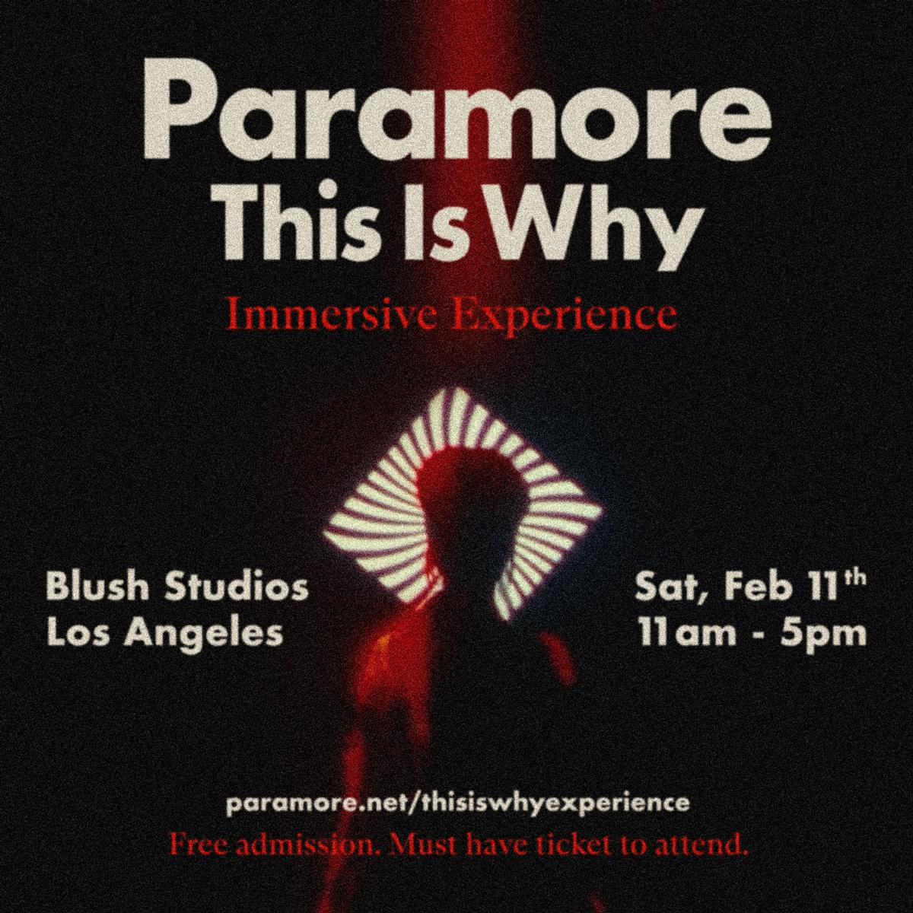

**UPCOMING PARAMORE TOUR DATES:**

Thu March 2 - Lima District, Peru - Estadio UNMSM

Sun March 5 - Santiago, Chile - Movistar Arena

Tue March 7 - Buenos Aires, Argentina - Arena Movistar

Thu March 9 - Rio De Janeiro, Brazil - Qualistage

Sat March 11 - São Paulo, Brazil - Centro Esportivo Tiete

Sun March 12 - São Paulo, Brazil - Centro Esportivo Tiete  
Tue March 14 - Bogotá, Colombia - Movistar Arena

Fri March 17 - Glendale, AZ - State Farm Stadium=

Sat March 18 - Glendale, AZ - State Farm Stadium=

Thu April 13 - Dublin, Ireland - 3Arena

Sat April 15 - Cardiff, United Kingdom - International Arena

Mon April 17 - Glasgow, United Kingdom - OVO Hydro

Tue April 18 - Manchester, United Kingdom - AO Arena

Thu April 20 - London, United Kingdom - O2 Arena

Sat April 22 - Birmingham, United Kingdom - Utilita Arena

Sun April 23 - London, United Kingdom - O2 Arena

Tue May 23 – Charlotte, NC – Spectrum Center*~

Thu May 25 – Atlanta, GA – State Farm Arena*~

Sat May 27 – Atlantic City, NJ – Adjacent Festival+

Sun May 28 - Boston, MA - Boston Calling +

Tue May 30 – New York, NY – Madison Square Garden*~

Wed May 31 – New York, NY – Madison Square Garden*~

Fri June 02 – Washington, DC – Capital One Arena*~

Sun Jun 04 – Cleveland, OH – Rocket Mortgage Fieldhouse*~

Mon Jun 05 – Indianapolis, IN – Gainbridge Fieldhouse*~

Wed Jun 07 – Detroit, MI – Little Caesars Arena*~

Thu Jun 08 – Toronto, ON – Scotiabank Arena*~

Sat Jun 10 – Columbus, OH – Schottenstein Center*~

Sun Jun 11 – Pittsburgh, PA – PPG Paint Arena*~

Tue Jun 13 – Orlando, FL – Amway Center*~

Wed Jun 14 – Hollywood, FL – Hard Rock Live*~

Sun Jun 18 - Nashville, TN - Bonnaroo +

Thu Jul 06 – New Orleans, LA – Smoothie King Center^!

Sat Jul 08 – Fort Worth, TX – Dickies Arena^!

Sun Jul 09 – Austin, TX – Moody Center^!

Tue Jul 11 – Houston, TX – Toyota Center^!

Thu Jul 13 – Denver, CO – Ball Arena^!

Sun Jul 16 – San Diego, CA – Viejas Arena^

Wed Jul 19 – Los Angeles, CA – Kia Forum^

Wed Jul 20 – Los Angeles, CA – Kia Forum^

Sat Jul 22 – San Francisco, CA – Chase Center^

Mon Jul 24 – Seattle, WA – Climate Pledge Arena^!

Tue Jul 25 – Portland, OR – Veterans Memorial Coliseum^!

Thu Jul 27 – Salt Lake City, UT – Vivint Arena^!

Sat Jul 29 – Tulsa, OK – BOK Center^!

Sun Jul 30 – St Louis, MO – Enterprise Center^!

Wed Aug 02 – St. Paul, MN – Xcel Energy Center^!

*With Support **Bloc Party**

^With Support from **Foals**

!With Support from **The Linda Lindas**

~With Support from **Genesis Owusu**

+Festival Performance

=Supporting **Taylor Swift**

[Tickets for Paramore](https://www.paramore.net/tour)

**Praise for Paramore:**

“...*in their sixth studio album, “This Is Why,” they get angrier, pricklier and funkier, all the while merging the band's past and future, levitating way beyond their icon status to something else entirely.”* ***- Associated Press***

*“One of the most influential bands of their generation”* ***- The Guardian***

*“Instrumental flourishes, funky arrangements, and theatrical vocal lines recall the art-house innovations of the Talking Heads or the absurdist approach of the B-52s. Yet the record is firmly rooted in the topical concerns of the present.” -* ***The New Yorker***

*“another bold yet sonically grounded triumph: while the production recalls the art-rock idiosyncrasies of After Laughter, Hayley Williams sneers, spins and strikes with the tenacity of her Riot! Work.”* ***- Billboard***

*“Williams sings, with biting mock-sweetness, over a backbeat and a hopping bass line. Choppy, clenched guitar chords goad her as she sneers an irritated response to a sourly divided national mood” -* ***New York Times***

***“****...it's working as a power trio here: a singer, drummer and guitarist barreling ahead at the most thrilling heights of their musicianship” -* ***NPR***

***“****Fan interaction was an integral part of the concert, and perhaps what makes Paramore shows so special — besides Williams’ never-faltering powerhouse vocals and the band’s tight musicality.” -* ***Variety***

*“With a packed setlist that spanned 20 years of hit-making, the band celebrated everything they've achieved - and proved that the best is yet to come."* ***- Rolling Stone***

*“one of the most influential alternative rock bands of their generation”* - ***The Face***

***“****It’s unmistakable musical growth” -* ***Pollstar***

***“****...transcended its pop punk beginnings to produce a genre-defying body of work that has defied the patriarchal penchant of alternative music and paved a new path for artists”* **-*BRICKS***

*“*they're unapologetically trying something new instead with the raw, political, and ultimately cathartic songs.” -***Entertainment Weekly***

**KEEP UP WITH PARAMORE:**

[**Web**](https://www.paramore.net)/ [**Instagram**](https://www.instagram.com/paramore/) **/**[**TikTok**](https://www.tiktok.com/@paramoreofficial)**/** [**Twitter**](https://twitter.com/paramore) **/**[**Facebook**](https://www.facebook.com/paramore)

**For more information on Paramore:**

**Chloë Walsh @ The Oriel Co / Anna Ross @ The Oriel Co**

[**chloe@theoriel.co**](mailto:chloe@theoriel.co)

[**anna@theoriel.co**](mailto:anna@theoriel.co)

**Tour requests:  
Alex Courides @ The Oriel Co:**

[**alex@theoriel.co**](mailto:alex@theoriel.co)

**Atlantic Records contact:**

**Christina Kotsamanidis**

[**Christina.Kotsamanidis@atlanticrecords.com**](mailto:Christina.Kotsamanidis@atlanticrecords.com)