FOR IMMEDIATE RELEASE

FEBRUARY 24, 2023

**INGRID ANDRESS SHARES BRAND-NEW TRACK “TREATED ME GOOD”**

[**LISTEN HERE**](https://nam04.safelinks.protection.outlook.com/?url=https%3A%2F%2Fingridandress.lnk.to%2Ftreatedmegood&data=05%7C01%7COlivia.Lee%40atlanticrecords.com%7C9fa1aceb134d4a1ca7f608db15d246c5%7C8367939002ec4ba1ad3d69da3fdd637e%7C0%7C0%7C638127765096132819%7CUnknown%7CTWFpbGZsb3d8eyJWIjoiMC4wLjAwMDAiLCJQIjoiV2luMzIiLCJBTiI6Ik1haWwiLCJXVCI6Mn0%3D%7C3000%7C%7C%7C&sdata=cMLo3qo5JUrQ6VkmXLS54N9XeiDq6Z2Oce6T%2F3x%2F0fw%3D&reserved=0)

**FIRST RELEASE FROM FORTHCOMING *GOOD PERSON (DELUXE)***

**AVAILABLE EVERYWHERE MARCH 3RD**

***THE GOOD PERSON TOUR* KICKS OFF TONIGHT IN SALT LAKE CITY**

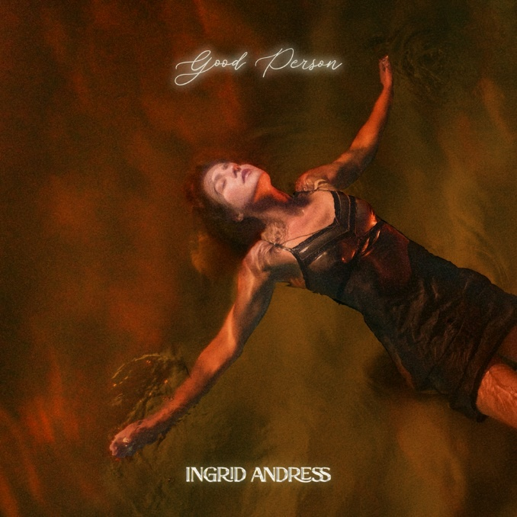

[DOWNLOAD ARTWORK HERE](https://warnermusicgroup.box.com/s/fjirf4tde5foaf2btr0ozjxofdbnmyp7)

4x GRAMMY-nominee **Ingrid Andress** is sharing brand-new music today with the release of **“Treated Me Good”** ([LISTEN HERE](https://ingridandress.lnk.to/treatedmegood)). Co-written and co-produced by Andress alongside frequent collaborators Sam Ellis and Derrick Southerland, it’s the first of three new original songs featured on ***Good Person (Deluxe)***, due next Friday, March 3rd ([PRE-ORDER/SAVE HERE](https://ingridandress.lnk.to/preorder-goodpersondlx)). Andress kicks off her 20+ date trek on ***The Good Person Tour*** tonight with a sold-out performance in Salt Lake City before additional sold-out shows in NYC, Boston, Minneapolis and more before wrapping up in Norway May 24th (see full list of dates below).

In addition, Andress recently earned her second career No. 1 with the GRAMMY-nominated, Platinum-certified hit “Wishful Drinking (with Sam Hunt).” The song is featured on *Good Person* alongside her current single, “**Feel Like This**” ([LISTEN HERE](https://ingridandress.lnk.to/feellikethis)). As seen on [***The Late Show with Stephen Colbert***](https://www.youtube.com/watch?v=8zBYWK7DIjc)and [***Jimmy Kimmel Live!***](https://www.youtube.com/watch?v=7Wx0-FlfmfE)and co-written by Andress, Ellis and Julia Michaels, the track “puts an informed, mature spin on love [with its] adult approach to the mysteries of relationships” (*Billboard*).

Hailed by *The New York Times* as “a Nashville outsider who paved her own way in” ([READ HERE](https://nam04.safelinks.protection.outlook.com/?url=https%3A%2F%2Fwww.nytimes.com%2F2022%2F08%2F25%2Farts%2Fmusic%2Fingrid-andress-good-person.html&data=05%7C01%7CMaryCatherine%40wmg.com%7Cec666e3d235642a50ff308dac0fc16b9%7C8367939002ec4ba1ad3d69da3fdd637e%7C0%7C0%7C638034486207756657%7CUnknown%7CTWFpbGZsb3d8eyJWIjoiMC4wLjAwMDAiLCJQIjoiV2luMzIiLCJBTiI6Ik1haWwiLCJXVCI6Mn0%3D%7C3000%7C%7C%7C&sdata=MUSqLLK%2B6OCddyYRw0Q2GZ7NwjLyHG7Hx0FGTNToU70%3D&reserved=0)), Andress returns to the reflection and confession at the core of her acclaimed debut, *Lady Like*, and plumbs even deeper on *Good Person*. In addition to co-writing every track, Andress found herself in the co-producer’s chair once again alongside Sam Ellis, who played the same role on *Lady Like*. She pushed for bold, experimental sounds that blended banjos with vocoders; swung from sweeping orchestration to spare, acoustic-based arrangements; and showcased previously unexplored parts of her vocal range.

*Good Person* sees Andress entering the next chapter of her career following her record-breaking debut, *Lady Like*, named “one of the year’s strongest albums” by *Associated Press* and one of *Billboard*’s Top 10 Best Country Albums of 2020. The celebrated LP scored Andress three GRAMMY nominations including Best New Artist, Best Country Album and Best Country Song for the multi-platinum No. 1 radio single “More Hearts Than Mine.” She is also a 4x ACM Award, 3x CMA Award and 2x CMT Music Award nominee.

With over one billion global streams and fans spanning the globe, Andress spent last year out on the road with Keith Urban for his North American “The Speed of Now World Tour” and will head out with Walker Hayes in April.

***THE GOOD PERSON TOUR*DATES**

*^ with special guest Madeline Edwards*

• *with special guest Carter Faith*

*+ with special guest Nick Wilson*

*\*  with special guest Blü Eyes*

**FEBRUARY**

24 – Salt Lake City, UT – Commonwealth ^ **SOLD OUT**

25 – Denver, CO – Bluebird ^ **SOLD OUT**

28 – San Francisco, CA – Great American Music Hall ^

**MARCH**

2 – Los Angeles, CA – El Rey ^*

15 – New York City, NY – Gramercy • **SOLD OUT**

16 – Boston, MA – Sinclair • **SOLD OUT**

23 – Grand Rapids, MI – Elevation ^

25 – Minneapolis, MN – Fine Line ^ **SOLD OUT**

**MAY**

4 – Dublin, IRL – Whelans +

5 – Belfast, UK – Limelight 2 +

7 – Glasgow, UK – St. Luke's + **SOLD OUT**

9 – Manchester, UK – Gorilla +

10 – Birmingham, UK – O2 Institute 3 +

11 – London, UK – Scala +

15 – Paris, France – Le Pop Up du Label +

16 – Amsterdam, NL – Melkweg OZ +

17 – Cologne, DE – Blue Shell +

19 – Berlin, DE – Frannz Club +

20 – Hamburg, DE – Nochtwache +

21 – Copenhagen, DK – Lille Vega +

23 – Stockholm, SE – Nalen Club +

24 – Oslo, NO – John Dee +

###

**CONNECT WITH INGRID ANDRESS:**

[FACEBOOK](https://nam04.safelinks.protection.outlook.com/?url=https%3A%2F%2Fwww.facebook.com%2FIngridAndress%2F&data=05%7C01%7COlivia.Lee%40atlanticrecords.com%7C36376b982ed640121af208da821457a2%7C8367939002ec4ba1ad3d69da3fdd637e%7C0%7C0%7C637965321131795674%7CUnknown%7CTWFpbGZsb3d8eyJWIjoiMC4wLjAwMDAiLCJQIjoiV2luMzIiLCJBTiI6Ik1haWwiLCJXVCI6Mn0%3D%7C3000%7C%7C%7C&sdata=WC0si8emyHA%2FgNYzZxbI2E8RLaZ6qb4RaKuHRH9Lk9w%3D&reserved=0) | [TWITTER](https://nam04.safelinks.protection.outlook.com/?url=https%3A%2F%2Ftwitter.com%2Fingridandress&data=05%7C01%7COlivia.Lee%40atlanticrecords.com%7C36376b982ed640121af208da821457a2%7C8367939002ec4ba1ad3d69da3fdd637e%7C0%7C0%7C637965321131795674%7CUnknown%7CTWFpbGZsb3d8eyJWIjoiMC4wLjAwMDAiLCJQIjoiV2luMzIiLCJBTiI6Ik1haWwiLCJXVCI6Mn0%3D%7C3000%7C%7C%7C&sdata=5OdGTnf85%2FJ3U5quWBAy9yGYQi3aiyXHPMtncnY4gSs%3D&reserved=0) | [INSTAGRAM](https://nam04.safelinks.protection.outlook.com/?url=https%3A%2F%2Fwww.instagram.com%2Fingridandress%2F&data=05%7C01%7COlivia.Lee%40atlanticrecords.com%7C36376b982ed640121af208da821457a2%7C8367939002ec4ba1ad3d69da3fdd637e%7C0%7C0%7C637965321131795674%7CUnknown%7CTWFpbGZsb3d8eyJWIjoiMC4wLjAwMDAiLCJQIjoiV2luMzIiLCJBTiI6Ik1haWwiLCJXVCI6Mn0%3D%7C3000%7C%7C%7C&sdata=M5nNDAqrNq9eBRCnQVVltvLK7EdZzMEEc6D%2FQxLnrtQ%3D&reserved=0) | [YOUTUBE](https://nam04.safelinks.protection.outlook.com/?url=https%3A%2F%2Fwww.youtube.com%2Fchannel%2FUCztSwKRcz_jZC4KcGVZH69w&data=05%7C01%7COlivia.Lee%40atlanticrecords.com%7C36376b982ed640121af208da821457a2%7C8367939002ec4ba1ad3d69da3fdd637e%7C0%7C0%7C637965321131951887%7CUnknown%7CTWFpbGZsb3d8eyJWIjoiMC4wLjAwMDAiLCJQIjoiV2luMzIiLCJBTiI6Ik1haWwiLCJXVCI6Mn0%3D%7C3000%7C%7C%7C&sdata=ot%2BoGHBhV20a%2BnU6IapT0BQ7jKl8q2iwmIeJph6dD3M%3D&reserved=0)

**PRESS CONTACTS**

Andrew George | Atlantic Records

[Andrew.George@atlanticrecords.com](mailto:Andrew.George@atlanticrecords.com)

Mary Catherine Rebrovick | Warner Music Nashville

[MaryCatherine@wmg.com](mailto:MaryCatherine@wmg.com)