FOR IMMEDIATE RELEASE
FEBRUARY 9, 2023

JASON DERULO AND DAVID GUETTA
REUNITE FOR NEW FEEL-GOOD RECORD “SATURDAY/SUNDAY”

DERULO TO HEADLINE NFL TIKTOK TAILGATE ON SUNDAY, FEBRUARY 12
LIVE DURING THE FOX SUPER BOWL LVII PREGAME SHOW,
BEGINNING AT 11:00 AM ET ON FOX

LISTEN TO “SATURDAY/SUNDAY” | WATCH OFFICIAL LYRIC VIDEO

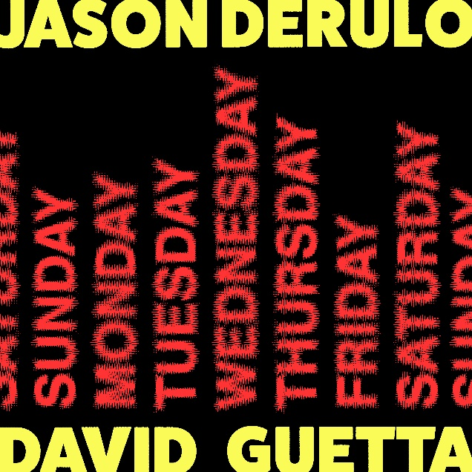
DOWNLOAD HIGH-RES ARTWORK HERE

Multi-Platinum global superstars Jason Derulo and David Guetta have joined forces once again for their feel-good new single, “Saturday/Sunday.” The ultimate showcase for both artists’ signature approach towards club-ready pop anthems, the irresistibly energetic new track is joined by an official lyric video HERE.

Derulo will celebrate “Saturday/Sunday” with a full-length live performance on this weekend’s third annual NFL TikTok Tailgate, the league’s ultimate pregame party before Super Bowl LVII, set for Sunday, February 12. Fans around the world can tune in on @NFL on TikTok at 2:55 PM ET for special programming featuring NFL special guests, TikTok creators, gameday predictions, and much more live from State Farm Stadium in Glendale, AZ. In addition, portions of Derulo’s performance – which will include such hits as the RIAA platinum-certified “Talk Dirty” – will be televised in the FOX Super Bowl LVII Pregame Show, beginning at 11:00 AM ET on FOX (check local listings).

“Great to partner with David Guetta for this new track,” says Jason Derulo. “We worked together a while back on 'Goodbye' with Nicki Minaj so it's great to be on the same team again. This one is summertime ready. Also really looking forward to rocking the Super Bowl with it later this weekend.”

“It’s great to have this collab track out,” says David Guetta. “It’s a record I love so much and I think it is such a banger. I’m really happy to be working with Jason once again, finally!"

“Saturday/Sunday” marks the most recent official collaboration between Derulo x Guetta following their 2018 RIAA Gold-certified “Goodbye (Feat. Nicki Minaj & Willy William),” a worldwide smash that hit the upper reaches of charts around the world including the top 10 on Billboard’s “Hot Dance/Electronic Songs.” In addition, the track’s official music video – co-directed by Derulo – has earned over 150M views via YouTube.

ABOUT JASON DERULO
Forward-thinking, genre-defying, and massively creative, Derulo has staked his claim as one of the most dynamic forces on the global pop landscape. Since breaking through with his 5x RIAA platinum-certified single, “Whatcha Say,” the award-winning singer-songwriter who has a net worth in excess of $100 million, has sold more than 250 million singles worldwide and achieved 15 platinum singles including "Wiggle", "Talk Dirty", "Want to Want Me," "Trumpets," "It Girl", "In My Head," “Ridin' Solo,” “Don’t Wanna Go Home,” “Marry Me,” “ The Other Side,” “Get Ugly,” “Swalla,” “Savage Love” and “Take You Dancing.” Since the start of his solo recording career in 2009, he has earned over 18.2B worldwide streams, and built an unstoppable social media following of over 117M followers across all platforms. Now at work on his highly anticipated fifth album – and full-length debut for Atlantic Records – Derulo has delivered an ongoing series of smash singles that have drawn a stunning 500M+ views, including the irresistibly buoyant “Acapulco,” the RIAA platinum-certified “Take You Dancing,” and Jawsh 685 x Jason Derulo’s 3x platinum-certified chart-topper, “Savage Love (Laxed – Siren Beat).” The latter track – and its official BTS remix – proved an unstoppable international sensation upon its 2020 arrival, peaking at #1 on Billboard’s “Hot 100” as well as atop charts in 16 additional countries around the world. A truly multi-dimensional creator, Derulo has also established himself as an actor and businessman, investing in enterprises like Catch L.A. and Rumble Boxing, becoming part-owner of Bedlam Vodka, launching an innovation-minded podcast, and developing a line of supplements and fitness products with the Najafi Group and BodyBuilding.com. What’s more, Derulo unveiled Jason Derulo’s UZO, an immersive new graphic novel from Z2 Comics based on a TikTok character created by the artist himself. With his TikTok regularly amassing over 10M views per post, Derulo notes that the platform has drastically reshaped his relationship with his fans. Derulo is now amongst TikTok’s biggest superstars, currently the 4th most followed male on the video-sharing platform with the 11th biggest account overall. He continues to see his already astronomical TikTok presence growing daily, now boasting more than 56.9M followers worldwide and over 1.2B likes. Reclaiming his title as the TikTok king, last year he released summer smash single “Slidin’” with a fan-challenged TikTok video to his own rendition of the electric slide. Watch the dance video HERE. His knack for laying undeniably catchy melodies on top of fun, upbeat productions, was the formula for his Summer takeover. To celebrate the single Derulo hosted a wildly extravagant “Slidin’” Weekend in Miami with some of his closest creator friends. The weekend included a private “Slidin’” jet set from LA to Miami; an insanely large “Slidin’” mansion; a sexy “Slidin’” yacht party; hibachi, dinners, clubbing and more! Watch the “Slidin’” recap video HERE.

ABOUT DAVID GUETTA
DJ. Producer. Artist. David Guetta is a musical trailblazer and an international icon. Currently the #4 most streamed artist on Spotify globally and with 2x Grammys awards, 11x Grammy nominations, 7x UK number 1 singles, over 35 billion global streams, 50 million records sold worldwide, and over 72 million monthly Spotify listeners to his name, he has been voted the world’s best DJ in the DJ Mag ‘Top 100’ three times and won the accolade for best electronic artist at the MTV Europe Music Awards. To round off 2022 he won two awards at the LOS40 Music Awards, two awards at MTV EMA’s, the ‘Dance Act of the Year’ award at the iHeartRadio Music Awards and ‘DJ of the Year’ award at the NRJ Music Awards, and was additionally named #1 Producer by 1001Tracklists. Guetta closed out the year in Latin America, performing in Peru for a New Year’s Eve extravaganza before setting out on a huge tour in January.

After a year of huge hits, Guetta enters 2023 at #1 on the Global Spotify Chart with current global smash ‘I’m Good’ with Bebe Rexha. The track has earned Guetta his eleventh Grammy nomination, receiving a nod for ‘Best Dance/Electronic Recording’, and garnered 1 billion global streams and counting!

Throughout 2022 he released a variety of collaborations including commercial hit ‘Don’t You Worry’ with Black Eyed Peas and Shakira and UK Top 5 pop anthem ‘Crazy What Love Can Do’ with Becky Hill and Ella Henderson. A master creative across genres, Guetta has also gone from strength to strength with his underground-focused Future Rave project alongside Morten; the duo released their eagerly awaited Future Rave EP ‘Episode 2’ in November, which featured the powerful lead single ‘You Can’t Change Me’ with Raye. Elsewhere he has provided remixes for some of the world’s biggest stars including pop royalty Coldplay, Dua Lipa and Megan Thee Stallion, Kodak Black... His final release of 2022 was an acid-fuelled remix of Sam Smith & Kim Petras’ ‘Unholy’. He is additionally working on new music for his underground alias Jack Back.

While maintaining an epic level of quality for his live streams during the pandemic and lockdown, he hosted his iconic United At Home series, a number of unforgettable concerts from Paris’ Louvre Museum, the Burj Khalifa in Dubai, the Icon Brickell in Miami, and atop the Rockefeller Center, raising $2 million in donations for numerous charities. Throughout 2022 Guetta appeared at many of the world’s biggest events and festivals, as well as his own residency at Encore Beach Club in Las Vegas and 2 shows a week in Ibiza: Hï Ibiza with Future Rave and Ushuaïa Ibiza with legendary party F*** ME I’M FAMOUS!.

As he continues to dominate the global charts and play some of the most exciting sets of his career, all while expanding his creative vision, exploring new sounds and evolving as an artist, David Guetta demonstrates time and time again why he is the most cherished electronic artist of our generation.

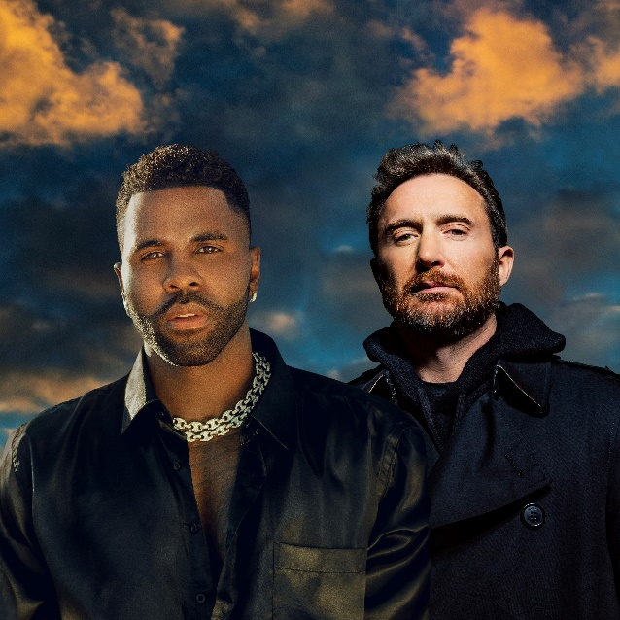
DOWNLOAD HERE

# # #

CONNECT WITH JASON DERULO
OFFICIAL | FACEBOOK | INSTAGRAM | TIKTOK | TWITTER | YOUTUBE

CONNECT WITH DAVID GUETTA
OFFICIAL | FACEBOOK | INSTAGRAM | TIKTOK | TWITTER | YOUTUBE

PRESS CONTACT FOR JASON DERULO
FAIRLEY MCCASKILL | FAIRLEY.MCCASKILL@ATLANTICRECORDS.COM

PRESS CONTACT FOR DAVID GUETTA
PAIGE ROSOFF | PAIGE.ROSOFF@ATLANTICRECORDS.COM

