**JASIAH DROPS “RED EYES BLACK DRAGON” FEATURING 1NONLY**

**SET TO PERFORM AT 2023’S ROLLING LOUD FESTIVAL**

**NEW PROJECT ‘3’ COMING SOON**

[**DOWNLOAD/STREAM "RED EYES BLACK DRAGON”**](https://jasiah.lnk.to/RedEyesBlackDragon)

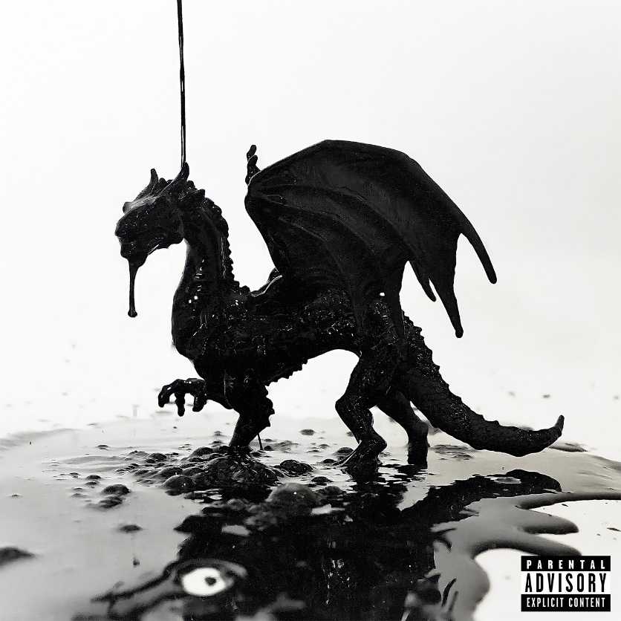

[DOWNLOAD HI-RES ARTWORK](https://warnermusicgroup.app.box.com/s/j3hhq4wx3cuxhag49n2nu2e47hg1bxce)

**Jasiah** releases his latest offering **“RED EYES BLACK DRAGON”** which follows **“KILLERS AND ROBBERS”** featuring **Denzel Curry, midwxst** and **Matt Ox.** Both tracks are a taste of what’s to come on Jasiah’s forthcoming mixtape, ***3***.

[**DOWNLOAD/STREAM KILLERS AND ROBBERS**](https://jasiah.lnk.to/KillersAndRobbers)

Outliers pull the strings of popular culture from the fringes, molding it like clay. Sending shockwaves through the game like a glitch in the matrix, Jasiah unloads a barrage of intense bars, scorching screams, and cathartic melodies. The Ohio-born artist incinerates genre lines only to assert himself as indefinable and indescribable insurgent with an instantly recognizable bark and arresting aesthetic. It’s why he’s quietly emerged as a phenomenon with over half-a-billion streams, consistently sold-out shows, and widespread acclaim from *Brooklyn Vegan*, *Stereogum*, *The Line of Best Fit*, and *UPROXX*, to name a few. However, he bares his mind, body, and soul on his 2023 mixtape, *3*, and much more to come.

**CONNECT WITH JASIAH:**

[WEBSITE](https://nam04.safelinks.protection.outlook.com/?url=https%3A%2F%2Fwww.phreejasiah.com%2F&data=05%7C01%7CTaylor.Apel%40atlanticrecords.com%7Cd1ee598a191e45af45c108db0ad6c3e7%7C8367939002ec4ba1ad3d69da3fdd637e%7C0%7C0%7C638115689750038116%7CUnknown%7CTWFpbGZsb3d8eyJWIjoiMC4wLjAwMDAiLCJQIjoiV2luMzIiLCJBTiI6Ik1haWwiLCJXVCI6Mn0%3D%7C3000%7C%7C%7C&sdata=szg1coS57R1DzsFcHNoa77lZBTRSM8FQ%2BlMv9ugofvk%3D&reserved=0) | [FACEBOOK](https://nam04.safelinks.protection.outlook.com/?url=https%3A%2F%2Fwww.facebook.com%2Fjasiah999%2F&data=05%7C01%7CTaylor.Apel%40atlanticrecords.com%7Cd1ee598a191e45af45c108db0ad6c3e7%7C8367939002ec4ba1ad3d69da3fdd637e%7C0%7C0%7C638115689750038116%7CUnknown%7CTWFpbGZsb3d8eyJWIjoiMC4wLjAwMDAiLCJQIjoiV2luMzIiLCJBTiI6Ik1haWwiLCJXVCI6Mn0%3D%7C3000%7C%7C%7C&sdata=HZ0ErO2giwnmkYWAiS4fnnFB2GSOHrmjesrLH7a%2BVkI%3D&reserved=0) | [TWITTER](https://nam04.safelinks.protection.outlook.com/?url=https%3A%2F%2Ftwitter.com%2Fphreejasiah&data=05%7C01%7CTaylor.Apel%40atlanticrecords.com%7Cd1ee598a191e45af45c108db0ad6c3e7%7C8367939002ec4ba1ad3d69da3fdd637e%7C0%7C0%7C638115689750194345%7CUnknown%7CTWFpbGZsb3d8eyJWIjoiMC4wLjAwMDAiLCJQIjoiV2luMzIiLCJBTiI6Ik1haWwiLCJXVCI6Mn0%3D%7C3000%7C%7C%7C&sdata=eXRFqiNQesd16GoWrkp3JFCge3K1Az6nPZkiBT3d25A%3D&reserved=0) | [INSTAGRAM](https://nam04.safelinks.protection.outlook.com/?url=https%3A%2F%2Fwww.instagram.com%2Fjasiah%2F&data=05%7C01%7CTaylor.Apel%40atlanticrecords.com%7Cd1ee598a191e45af45c108db0ad6c3e7%7C8367939002ec4ba1ad3d69da3fdd637e%7C0%7C0%7C638115689750194345%7CUnknown%7CTWFpbGZsb3d8eyJWIjoiMC4wLjAwMDAiLCJQIjoiV2luMzIiLCJBTiI6Ik1haWwiLCJXVCI6Mn0%3D%7C3000%7C%7C%7C&sdata=9Sv%2B7kagPest6KaypahRgTmX3xKP8xcBdcz%2FthE7jtE%3D&reserved=0) | [YOUTUBE](https://nam04.safelinks.protection.outlook.com/?url=https%3A%2F%2Fwww.youtube.com%2Fchannel%2FUCMLLndGScE19J-WgBOMDOaw&data=05%7C01%7CTaylor.Apel%40atlanticrecords.com%7Cd1ee598a191e45af45c108db0ad6c3e7%7C8367939002ec4ba1ad3d69da3fdd637e%7C0%7C0%7C638115689750194345%7CUnknown%7CTWFpbGZsb3d8eyJWIjoiMC4wLjAwMDAiLCJQIjoiV2luMzIiLCJBTiI6Ik1haWwiLCJXVCI6Mn0%3D%7C3000%7C%7C%7C&sdata=Z5oMtt3uZNLbN3aLPF39gwkXPxQ1ybnYW9CTFrcLq7k%3D&reserved=0)

**CONTACT:**

JASON DAVIS | [JASON.DAVIS@ATLANTICRECORDS.COM](mailto:JASON.DAVIS@ATLANTICRECORDS.COM)