FOR IMMEDIATE RELEASE
FEBRUARY 15, 2023

THE MELODY GAD KRANIUM RETURNS WITH THE RELEASE OF THE LIVE VERSION OF “SPECIAL WOMAN”
COMES ON THE HEELS OF HIS DEBUT PERFORMANCE ON THE KELLY CLARKSON SHOW
FIRST DANCEHALL ARTIST TO GRACE THE STAGE
ICYMI: LISTEN TO THE LATEST EP IN TOO DEEP
DOWNLOAD/STREAM “SPECIAL WOMAN”
WATCH/SHARE LIVE PERFORMANCE
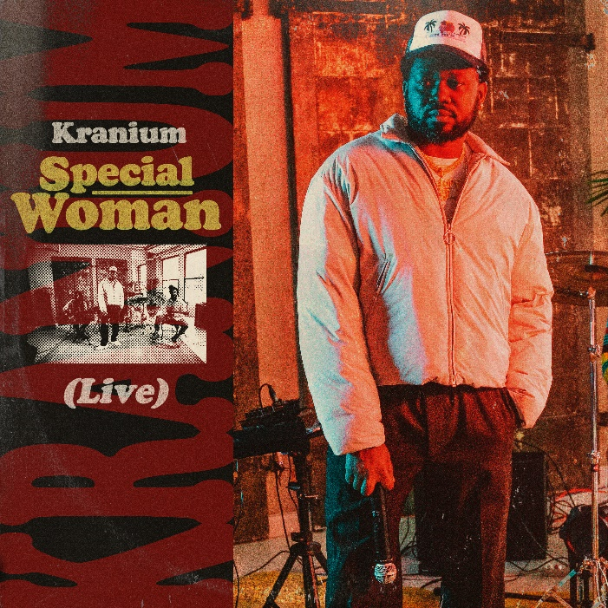
DOWNLOAD HI-RES ARTWORK

If there’s one thing Global Dancehall and Reggae giant, Kranium, is going to do is give you vocals, melodies, and a swag like no other. He’s celebrating his TV performance on The Kelly Clarkson Show with the release of a live version of “Special Woman” produced by renowned producer Unga. This debut performance on The Kelly Clarkson Show marks the first for any Dancehall artist on the show, and is the perfect touch needed. The performance comes on the heels of the release of Kranium’s latest EP In Too Deep, a 7-track experience with hints of Afrobeat, Dancehall, Reggae, and R&B sprinkled throughout.

With multiple Gold, Silver, and Platinum plaque achievements within the U.S., Canada, and U.K. markets, Kranium has proven to be one of R&B/Dancehall’s greatest superstars, driving Dancehall music and culture into the future on his own characteristic terms. The dancehall superstar is now also currently boasting nearly 1 BILLION streams globally. In Too Deep includes production credits from Non Native (Grammy nominated multi-platinum producer; “Calling My Phone” by Lil Tjay & 6lack. He also produced “Wi Deh Yah”), iO, Frankie Music (Grammy award-winning producer; Koffee “Raggamuffin”), and Hardwerk (Grammy-nominated producer; “Bad Kinda Butterflies” Camila Cabello). Preceding the EP is the genre-breaking, “Paranoid (Feat. B-Lovee)” and the R&B heavy “Without You (Feat. Queen Naija).”

ABOUT KRANIUM

Over the span of his career, Kranium has established himself as one of the hottest international dancehall artists in the world. In 2019, Kranium unveiled his debut album, Midnight Sparks to the world. The album saw Kranium continuing to craft a simmering sonic cocktail of reggae, R&B, hip-hop, and soul, including superstar features from the likes of AJ Tracey, Mahalia, Burna Boy, and longtime collaborator Ty Dolla $ign. The album showcased fiery singles as “So Me Move,” “Just The Style (Feat. Alkaline),” “Talkin’ (Feat. PJ),” and “In Charge.” Kranium’s sparkling debut was followed in 2020 with the release of “Gal Policy,” a fan-favorite with a lyric video that accumulated over 14 million views in six months of its release. In addition, Kranium also unveiled “Through The Window,” afterwards closing out the year with a fiery collaboration “Block Traffic (feat. Rytikal).”

In 2021, Kranium released his EP, Toxic, and followed up with the “Wi Deh Yah” single earlier in 2022. A true “set the tone” record that showcases Kranium’s clever lyricism, gift for melodies, and the perfect balance of vocals, “Wi Deh Yah,” displayed the smoothness he’s known for but with a bit of street Dancehall flare. Kranium supported the single with his “Wi Deh Yah” Tour and followed up with an appearance and performance at the 2022 Essence Music Festival. Recently, he released a sexy new single “Without You (Feat. Queen Naija)” and spoke with Billboard about his upcoming EP, In Too Deep. Carl Lamarre of Billboard noted when listening to the In Too Deep: "I've always respected the music and I've always known you were a beast but there is a different kind of machine and mindset you're on. You're going full fledge of R&B [while effortlessly blending it with dancehall]. A lot of people can't make that transition. You are doing it seamlessly and this is going to be something special!”

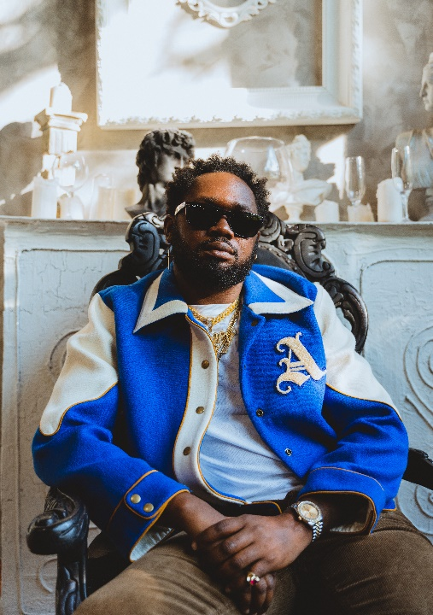

CONNECT WITH KRANIUM
OFFICIAL | TWITTER | INSTAGRAM | FACEBOOK | YOUTUBE

FOR ALL INQUIRIES
SYDNEY MARGETSON
SYDNEY.MARGETSON@ATLANTICRECORDS.COM

