FOR IMMEDIATE RELEASE
FEBRUARY 3, 2023

OHGEESY COMMENCES THE NEW YEAR WITH
NEW SINGLE + VISUAL “GEEKALEEK (FEAT. CASH KIDD)”

BRAND NEW BANGER FEATURES SAMPLE FROM
PETEY PABLO’S HIP-HOP CLASSIC, “FREEK-A-LEEK”

DIRECT SUPPORT ON YG’S THE RED CUP TOUR

TOP-BILLED APPEARANCE AT ROLLING LOUD CALIFORNIA
SET FOR SUNDAY, MARCH 5

EAGERLY AWAITED GEEZYWORLD 2 DUE LATER THIS YEAR

LISTEN HERE | WATCH HERE

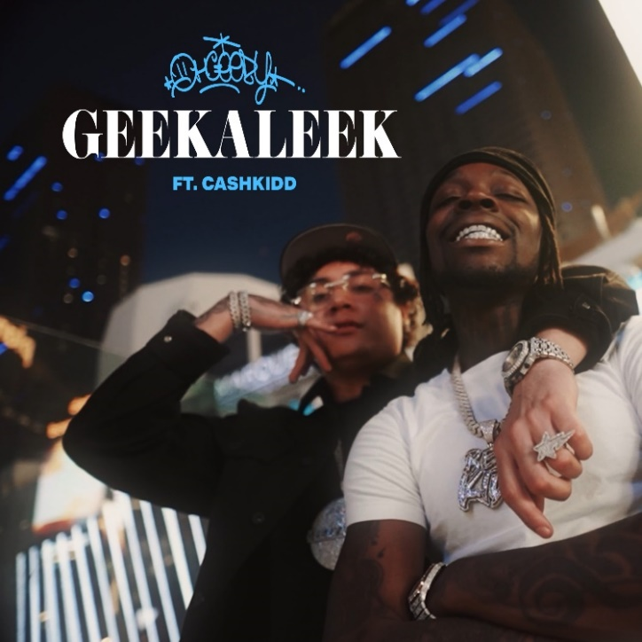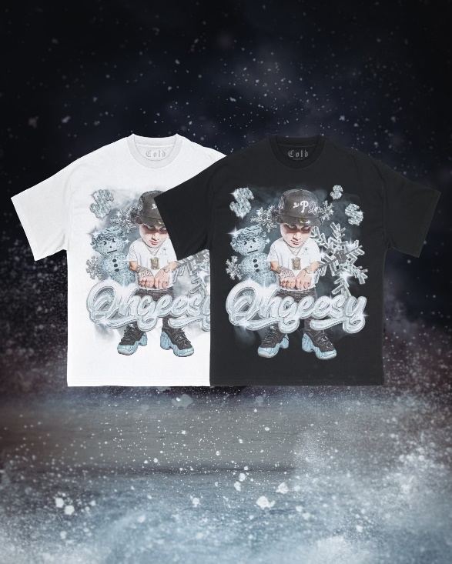
DOWNLOAD HI-RES ARTWORK HERE

Multi-platinum rapper OHGEESY is ramping up anticipation for his eagerly awaited GEEZYWORD 2 mixtape with today’s premiere of, “GEEKALEEK (Feat. Cash Kidd).” Sampled by Petey Pablo’s 2003 smash, “Freek-a-Leek” – the track comes on the heels of the previously released visual, covering the streets of an enticing Las Vegas nightlife. Watch HERE

Due later this year, GEEZYWORLD 2 follows the rapper’s acclaimed 2021 solo debut mixtape, GEEZYWORLD. The forthcoming project includes such powerhouse new tracks as “Gallery,” “Knock Knock,” “Up,” and “1st Day of School,” the anthem produced by longtime Shoreline Mafia collaborator Ron-Ron and notable Detroit producer Stuntman (Megan Thee Stallion, Chief Keef) and joined by a Kuno-directed official video streaming HERE.
Hailed in a recent HYPEBEAST feature interview as “a lone star and certified expert in experimentation, flow and writing killer hooks,” OHGEESY is celebrating his new music and much more on a wide-ranging North American live run supporting GRAMMY® Award-nominated rapper YG’s “The Red Cup Tour,” which began on January 20, 2023 at Denver, CO’s Fillmore Auditorium and is traveling through late February. In addition, OHGEESY will join Future, Lil Uzi Vert, Lil Wayne and a galaxy of hip-hop superstars for a top-billed hometown performance at the upcoming Rolling Loud California on Sunday, March 5 at Inglewood, CA’s Hollywood Park Grounds. For complete details and remaining ticket information, please visit www.ohgeesyofficial.com.

ABOUT OHGEESY:
California never gave rise to a rapper quite like OHGEESY. The Los Angeles-born, Mexican-American, multiplatinum certified artist, entrepreneur, and visionary not only continues the legacy of his hometown, but he also puts a whole culture rarely represented in hip-hop on his back with pride, poise, and power. As such, he emerges as a trailblazer with vicious wordplay, vibrant storytelling, and a vital message. Breathing new life into the culture, OHGEESY co-founded Shoreline Mafia in 2016 and quickly locked down the group’s legacy with 2017’s RIAA gold certified ShorelineDoThatShit, the 2x platinum smash “Bands,” and such platinum certified hits as “Musty” and “Nun Major.”

OHGEESY made his smash solo debut with 2021’s acclaimed GEEZYWORLD, available now in an extended deluxe edition HERE. Hailed by Pitchfork as “a quintessential L.A. rap record,” the album includes such multimillion-streaming hit singles as “Get Fly (Feat. DaBaby),” “Big Bad Wolf (Feat YG),” “Who Else (Feat. BlueBucksClan),” “Secret Service,” “Go Fast (Feat. Eladio Carrion),” “Appetizer (Shoreline Mafia),” and “Make It Happen (Feat. Pressa & Bun Dog),” all accompanied by official visuals streaming now at YouTube.

With hundreds of millions of streams and widespread praise from GQ, Complex, UPROXX, XXL, OkayPlayer, and HotNewHipHop, OHGEESY spent his summer traveling North America on his epic GEEZYWORLD headline tour, presented by Cookies. Special guests included BlueBucksClan, with support from DJ Vision and Hawaii Slim. Further highlights came from show-stopping festival performances at Rolling Loud Miami and Rolling Loud Toronto.

OHGEESY’s still-expanding world, now includes an exclusive Zumiez partnership with his own clothing line "From OTXBOYZ by OhGeesy.'' Sold through his GEEZYWORLD website, the collaboration can be found in select Zumiez storefronts across the US or online HERE. He also co-owns Mexican seafood spot Sunset Mariscos inside of the famed Fred Segal store in West Hollywood. Now, with the imminent arrival of GEEZYWORLD 2 on the horizon, OHGEESY instigates a new era for West Coast rap and beyond.

# # #

OHGEESY
ON TOUR 2023

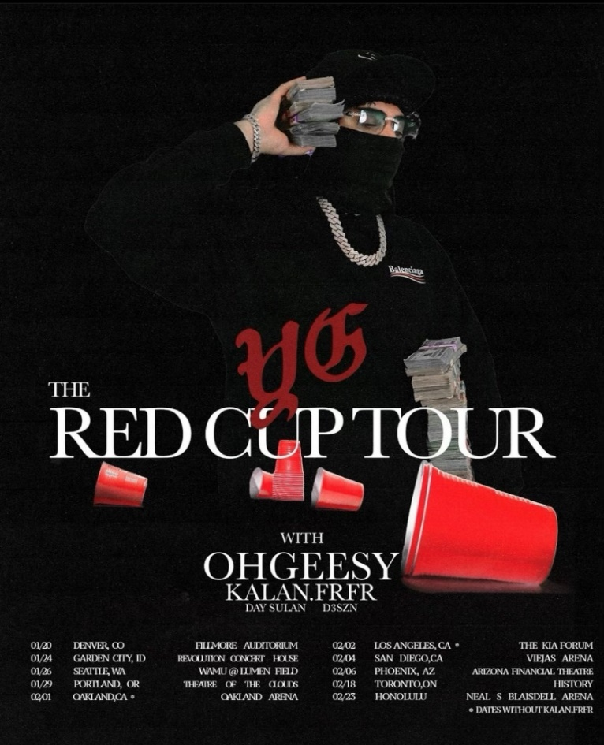

FEBRUARY
1 – Oakland, CA – Oakland Arena *
2 – Los Angeles, CA – Kia Forum *
4 – San Diego, CA – Viejas Arena *
6 – Phoenix, AZ – Arizona Financial Theatre *
18 – Toronto, ON – HISTORY *
23 – Honolulu, HI – Neal S. Blaisdell Center *

MARCH
5 – Inglewood, CA – Rolling Loud California †

* w/ YG’s The Red Cup Tour
† Festival Appearance

# # #
CONNECT WITH OHGEESY
OHGEESYOFFICIAL.COM | FACEBOOK | INSTAGRAM | TWITTER | YOUTUBE

PRESS CONTACT:
Brittany Bell | Brittany.Bell@atlanticrecords.com

