PARAMORE RELEASE NEW TRACK “THE NEWS”
LISTEN HERE

NEW STUDIO ALBUM THIS IS WHY OUT FEBRUARY 10TH ON ATLANTIC RECORDS
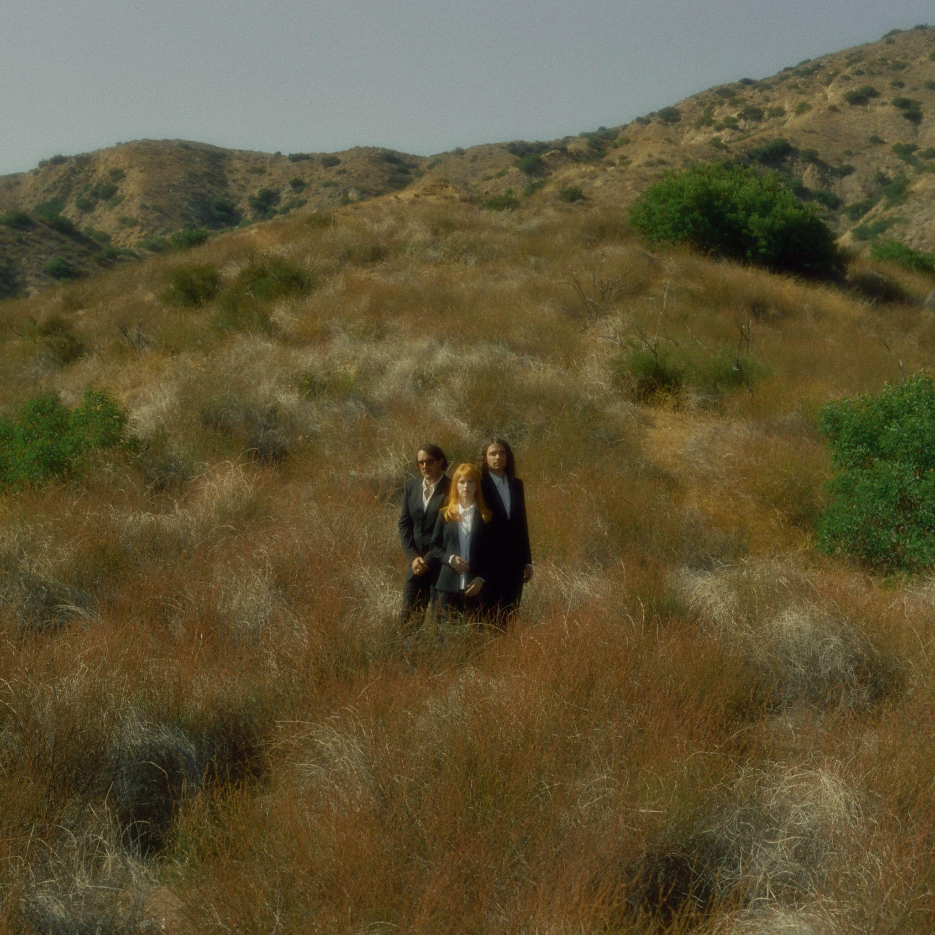
(The News” single art. Photo credit: Zachary Gray. Download High Res HERE)

Shut your eyes but it won’t go away/ Turn on / Turn off/ The news

Following a mischievous roll-out that included mailing portions of the track on CD to Paramore stans and DMing their followers piece-meal lyrics, Paramore’s invigorated return continues with “The News” - the second track to be taken from their highly anticipated sixth studio album This is Why (out February 10, 2023 on Atlantic Records).

The accompanying video, inspired by the band’s favorite horror movies and thrillers, was filmed in their hometown of Nashville, TN and directed by Mike Kluge and Matthew DeLisi. One of Paramore’s most striking, agile and frenetic songs, “The News” puts drummer Zac Farro and guitarist Taylor York’s dynamic chemistry at the forefront while Hayley Williams’ lyrics unleash the feelings of helplessness and anxiety that come with a desire to stay informed and engaged with current events, coupled with the emotional toll of being overwhelmed by the 24 hour news cycle.

Says Hayley, “The News is one of those songs that came together pretty quickly and felt exciting from the start. It feels like a happy medium between classic Paramore angst and bringing in some influences we’ve always had but never exploited. Watching Zac track drums for this one was one of my favorite memories from the studio. Lyrically, it probably explains itself. The 24-hr news cycle is just impossible to comprehend. And I feel a pang of guilt when I unplug to protect my headspace. The common reaction, or non-reaction, seems to be dissociation. Not one of us is innocent of that and who could blame us?”

STREAM “THE NEWS” HERE
WATCH THE VIDEO FOR “THE NEWS” HERE

The Grammy-winning trio revealed their new album plans in September with the release of the album’s title track. “This Is Why,” currently climbing streaming and alternative radio charts around the globe - saw the beloved band make their Tonight Show Starring Jimmy Fallon debut in between a run of intimate theater dates and festival headlines. Excitement for Paramore’s live shows has never fiercer; they were recently announced to headline the kick-off of the Bud Light Super Bowl Music Fest in Glendale, AZ on Feb 9th and will join Taylor Swift on the opening night of her Eras Tour there on March 17th. Prior to their tour kickoff, the band will be doing a special, intimate album release show for fans on February 6 at The Grand Ole Opry House in Nashville.

Spring 2023 sees Paramore embark on their own global tour in support of This is Why, kicking off in South America in March, followed by a UK run in April, and a North American run starting in May. Support comes from Bloc Party, Foals, The Linda Lindas and Genesis Owusu. For the band’s largest headline arena shows in more than a decade they’ll make stops at some of North America’s most iconic venues including New York’s Madison Square Garden, Toronto’s Scotiabank Arena, Austin’s Moody Center, Los Angeles’ Kia Forum, Seattle’s Climate Pledge Arena and more before wrapping up in St. Paul, MN at Xcel Energy Center on August 2nd. The band are donating a portion of their ticket sales to organizations working in areas of essential community support, including Support & Feed.

When Paramore revealed they were recording together in January 2022 the response from music fans around the world was immediate and celebratory. In the time since the Grammy-winning, RIAA-certified multi-Platinum band released their last album, After Laughter - and Hayley Williams unveiled two lauded solo albums - Paramore have become more popular than ever. Over the last few years Paramore’s influence and popularity has snowballed, as the age of streaming organically propelled them into a position as one of the world’s biggest, most culturally compelling rock bands. For the band, who formed as teenagers in Tennessee, their 20 year trajectory has seen them grow from youthful outsiders to bone-fide pop culture icons, permeating the musical landscape by inspiring a new generation of musical talent.

PRE-ORDER THIS IS WHY HERE

UPCOMING PARAMORE TOUR DATES:
Mon Feb 6 - Nashville, TN - Grand Ole Opry House
Thu Feb 9 - Phoenix, AZ - Bud Light Super Bowl Music Fest 2023+
Thu March 2 - Santiago De Surco, Peru - Arena Perú
Sun March 5 - Santiago, Chile - Movistar Arena
Tue March 7 - Comuna 14, Argentina - Argentinian Racetrack of Palermo
Thu March 9 - Rio De Janeiro, Brazil - Qualistage
Sat March 11 - São Paulo, Brazil - Centro Esportivo Tiete
Sun March 12 - São Paulo, Brazil - Centro Esportivo Tiete
Tue March 14 - Bogotá, Colombia - Movistar Arena
Fri March 17 - Glendale, AZ - State Farm Stadium=
Sat March 18 - Glendale, AZ - State Farm Stadium=
Thu April 13 - Dublin, Ireland - 3Arena
Sat April 15 - Cardiff, United Kingdom - International Arena
Mon April 17 - Glasgow, United Kingdom - OVO Hydro
Tue April 18 - Manchester, United Kingdom - AO Arena
Thu April 20 - London, United Kingdom - O2 Arena
Sat April 22 - Birmingham, United Kingdom - Utilita Arena
Sun April 23 - London, United Kingdom - O2 Arena
Tue May 23 – Charlotte, NC – Spectrum Center*~
Thu May 25 – Atlanta, GA – State Farm Arena*~
Sat May 27 – Atlantic City, NJ – Adjacent Festival+
Tue May 30 – New York, NY – Madison Square Garden*~
Wed May 31 – New York, NY – Madison Square Garden*~
Fri June 02 – Washington, DC – Capital One Arena*~
Sun Jun 04 – Cleveland, OH – Rocket Mortgage Fieldhouse*~
Mon Jun 05 – Indianapolis, IN – Gainbridge Fieldhouse*~
Wed Jun 07 – Detroit, MI – Little Caesars Arena*~
Thu Jun 08 – Toronto, ON – Scotiabank Arena*~
Sat Jun 10 – Columbus, OH – Schottenstein Center*~
Sun Jun 11 – Pittsburgh, PA – PPG Paint Arena*~
Tue Jun 13 – Orlando, FL – Amway Center*~
Wed Jun 14 – Hollywood, FL – Hard Rock Live*~
Thu Jul 06 – New Orleans, LA – Smoothie King Center^!
Sat Jul 08 – Fort Worth, TX – Dickies Arena^!
Sun Jul 09 – Austin, TX – Moody Center^!
Tue Jul 11 – Houston, TX – Toyota Center^!
Thu Jul 13 – Denver, CO – Ball Arena^!
Sun Jul 16 – San Diego, CA – Viejas Arena^
Wed Jul 19 – Los Angeles, CA – Kia Forum^
Wed Jul 20 – Los Angeles, CA – Kia Forum^
Sat Jul 22 – San Francisco, CA – Chase Center^
Mon Jul 24 – Seattle, WA – Climate Pledge Arena^!
Tue Jul 25 – Portland, OR – Veterans Memorial Coliseum^!
Thu Jul 27 – Salt Lake City, UT – Vivint Arena^!
Sat Jul 29 – Tulsa, OK – BOK Center^!
Sun Jul 30 – St Louis, MO – Enterprise Center^!
Wed Aug 02 – St. Paul, MN – Xcel Energy Center^!

*With Support Bloc Party
^With Support from Foals
!With Support from The Linda Lindas
~With Support from Genesis Owusu
+Festival Performance
=Supporting Taylor Swift

Praise for Paramore:

“another bold yet sonically grounded triumph: while the production recalls the art-rock idiosyncrasies of After Laughter, Hayley Williams sneers, spins and strikes with the tenacity of her Riot! Work.” - Billboard

“Williams sings, with biting mock-sweetness, over a backbeat and a hopping bass line. Choppy, clenched guitar chords goad her as she sneers an irritated response to a sourly divided national mood” - New York Times

“...it's working as a power trio here: a singer, drummer and guitarist barreling ahead at the most thrilling heights of their musicianship” - NPR

“Fan interaction was an integral part of the concert, and perhaps what makes Paramore shows so special — besides Williams’ never-faltering powerhouse vocals and the band’s tight musicality.” - Variety

“With a packed setlist that spanned 20 years of hit-making, the band celebrated everything they've achieved - and proved that the best is yet to come." - Rolling Stone
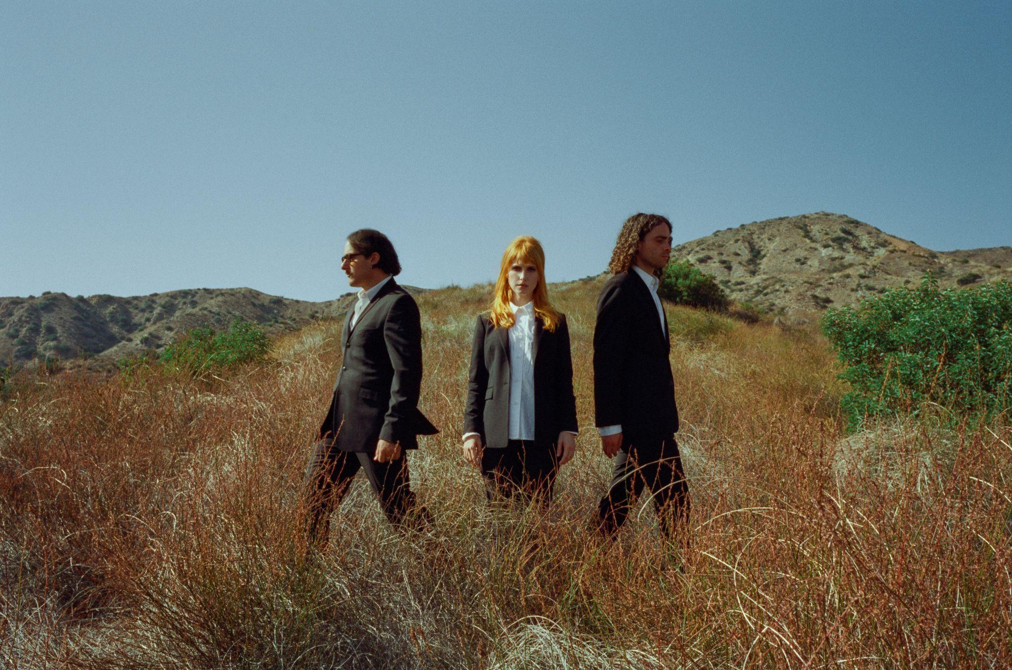
(Photo credit: Zachary Gray. Download High Res HERE)

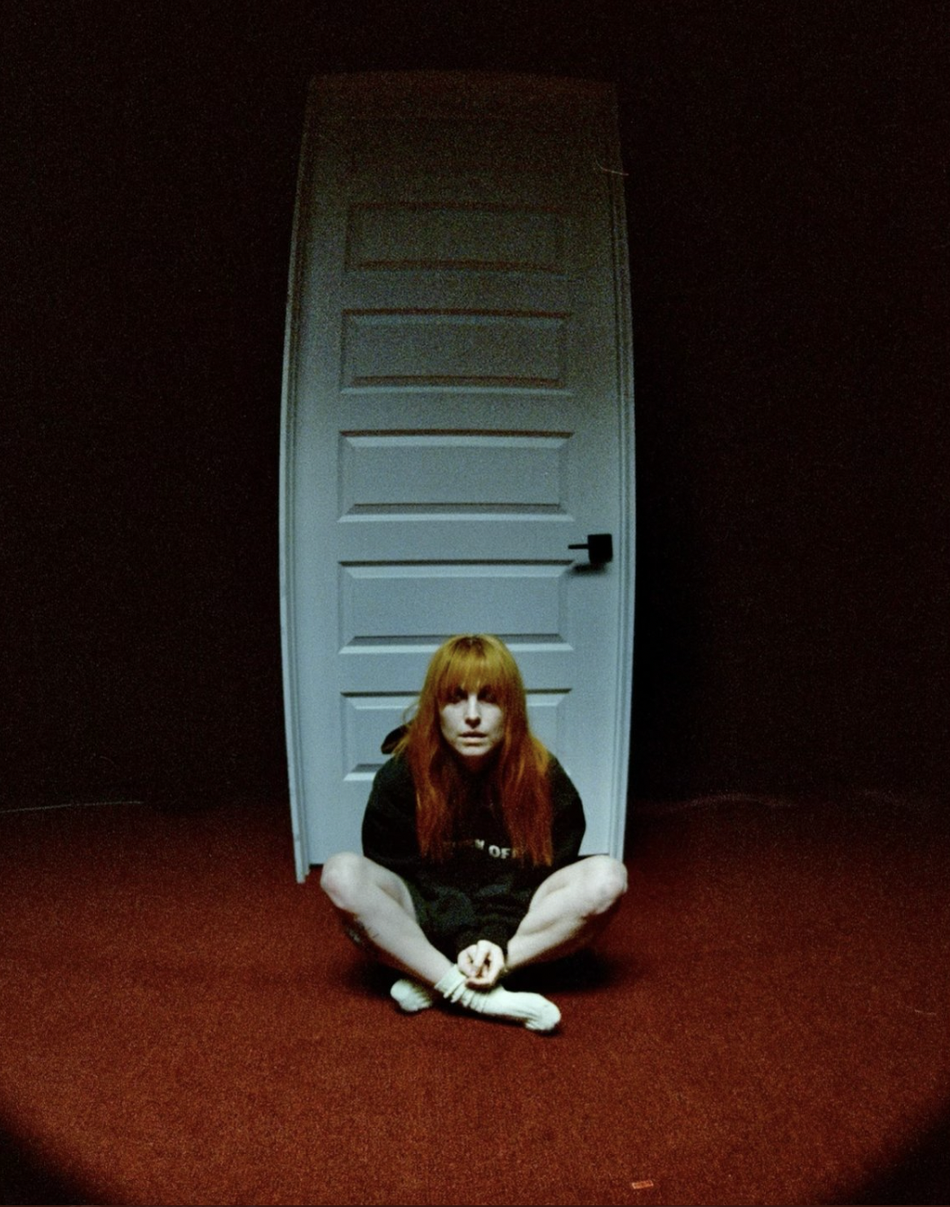
(“The News” video still)

KEEP UP WITH PARAMORE:
Web/ Instagram /TikTok/ Twitter /Facebook

For more information on Paramore:

Chloë Walsh @ The Oriel Co / Anna Ross @ The Oriel Co

chloe@theoriel.co
anna@theoriel.co

Christina Kotsamanidis @ Atlantic Records
Christina.Kotsamanidis@atlanticrecords.com

Tour requests:
Alex Courides @ The Oriel Co:
alex@theoriel.co

