FOR IMMEDIATE RELEASE
FEBRUARY 22, 2023

MELANIE MARTINEZ IS REBORN WITH ENIGMATIC TRAILER
HERALDING LONG-AWAITED NEW ALBUM, PORTALS

MULTI-PLATINUM ALT-POP PHENOMENON SHARES MYSTERIOUS SHORT VIDEO
WATCH HERE

PORTALS ARRIVES VIA ATLANTIC RECORDS ON MARCH 31st

PRE-ORDERS AVAILABLE NOW HERE

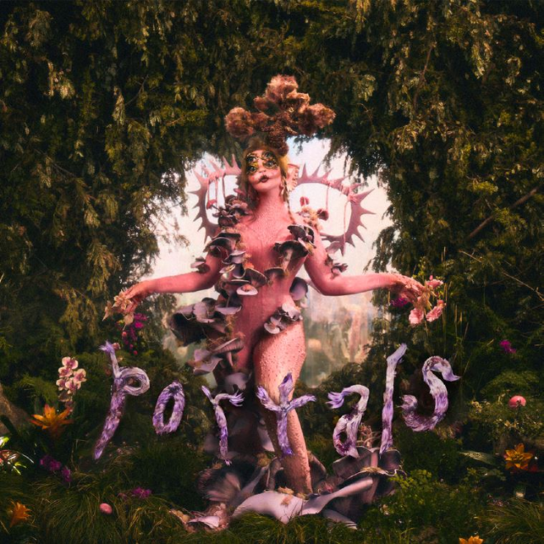
DOWNLOAD PHOTOS HERE

With over 12 billion global streams, 4 billion official YouTube views, more than 37 million followers across social media platforms, and 27 million videos posted on socials using her music, Melanie Martinez reemerges with a spellbinding new trailer heralding the arrival of her hugely anticipated new album, PORTALS, arriving via Atlantic Records on Friday, March 31st. Pre-orders are available now HERE.

Martinez lifted the curtain on PORTALS earlier this week with an instantly viral TikTok video confirming the death of her notorious alter-ego “Cry Baby,” last seen considering whether to walk into the light at the beguiling conclusion of 2019’s internationally acclaimed full-length film, K-12. Today’s exclusive trailer – directed by Martinez and streaming now HERE – now sees the appearance of a mysterious egg from which an enigmatic figure emerges.

“Portals screams death is life is death is life is death is life. A continuous loop. A circle.” – MELANIE MARTINEZ

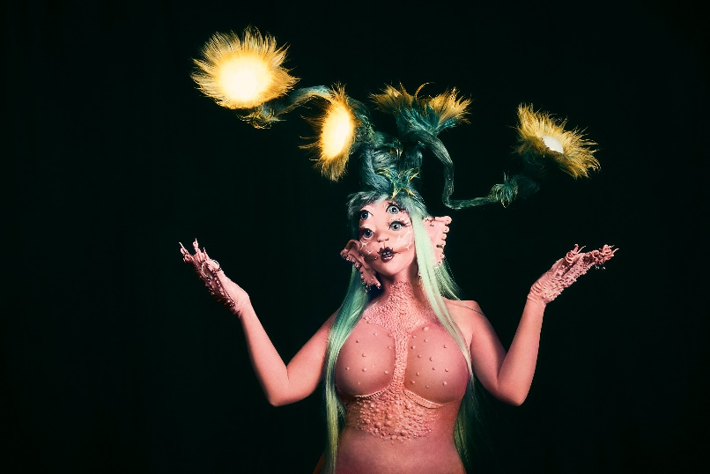

PORTALS marks the 27-year-old NYC-born singer-songwriter-filmmaker’s first full-length release in nearly four years following her 2 billion-streaming, RIAA Gold-certified second album, K-12, which proved a sensation upon its September 2019 release, entering the Billboard 200 at #3 – Martinez’s highest chart placement thus far – with further debuts at #1 on the Alternative album chart, and #1 on the Soundtrack album chart.

Hailed by Forbes as “a perfect conceptual album in the streaming age,” K-12 also serves as a soundtrack companion to an eerily enchanting musical film. written, directed, and starring Martinez, now with over 104M views to date via YouTube alone HERE. Praised by Billboard as “a visual dream world of the 24-year-old’s own making… a whimsical, highly dramatized version of school life, filled with pastels, magic, oversized hair bows and baby doll dresses,” K-12 was the 6th highest grossing film in the US on the day of its September 3, 2019 theatrical release, with one-night-only screenings in over 425 cinemas in 32 countries.

Named to Forbes’ “30 Under 30 2021,” Martinez has brought her idiosyncratic vision to an array of diverse enterprises, including last year’s instantly sold-out collaboration with footwear brand Koi. In addition to her myriad musical and visual efforts, Martinez has also shown herself to be an unforgettable live performer via sold-out headline shows and festival performances around the planet. A number of hugely anticipated festival appearances are currently set though the next month, including Lollapalooza Argentina (March 18), Lollapalooza Chile (March 19), Bogota, Columbia’s Estéreo Picnic (March 23), and Lollapalooza Brazil (March 25). A wide-ranging international live schedule will be announced soon.

Martinez truly set forth on what has proven a remarkable creative journey with her 2015 debut album, CRY BABY. An unforgettable collection of provocative alt-pop framed as a modern fairy tale, complete with storybook illustrations and a dramatic structure that takes listeners through the life of its title character, the album instantly affirmed the multi-talented Martinez as an irrefutable artistic icon, thanks in part to a phenomenally popular series of hit singles and imaginative self-directed visuals that have amassed 6 billion total streams and 1.5 billion video views.

Named by SPIN as one of 2015’s top albums, CRY BABY made its Billboard 200 debut at #6 upon its initial release while also entering the “Top Alternative Albums” chart at #1. In addition to its own 2x RIAA Platinum certification, all of the album’s 13 original tracks – as well as three further songs featured on the CRY BABY (DELUXE EDITION) – have now been certified Gold or Platinum by the RIAA.

CRY BABY took on a stunning second life in 2020 when the longtime fan-favorite “Play Date“ – featured on the album’s Deluxe Edition – exploded into a true alt-pop sensation with millions of user-generated videos across TikTok. Now boasting over 1B worldwide streams along with 2x RIAA Platinum certification, “Play Date” propelled CRY BABY back onto the upper half of the Billboard 200 more than five years after its initial release. Billboard honored Martinez’s historic achievement, hailing her “committed aesthetic” while noting, “Instead of relying on hooks designed for Top 40, Martinez has found an audience by combining dark alt-pop, vulnerable storytelling and a penchant for striking audio-visual ideas...The fact that (CRY BABY) has persisted on the albums chart following its August 2015 release is a testament to the connection Martinez has developed with her listeners.”

# # #

CONNECT WITH MELANIE MARTINEZ
OFFICIAL | FACEBOOK | INSTAGRAM |TIKTOK | TWITTER | YOUTUBE

PRESS CONTACT:
Christina Kotsamanidis
Christina.Kotsamanidis@atlanticrecords.com

