SKRILLEX RELEASES ALBUM ‘QUEST FOR FIRE’

FEATURING FRED AGAIN.., FOUR TET, MISSY ELLIOT, JAMIE XX, DYLAN BRADY, BIBI BOURELLY, STARRAH & MORE OUT NOW

LISTEN TO THE NEW ALBUM HERE.

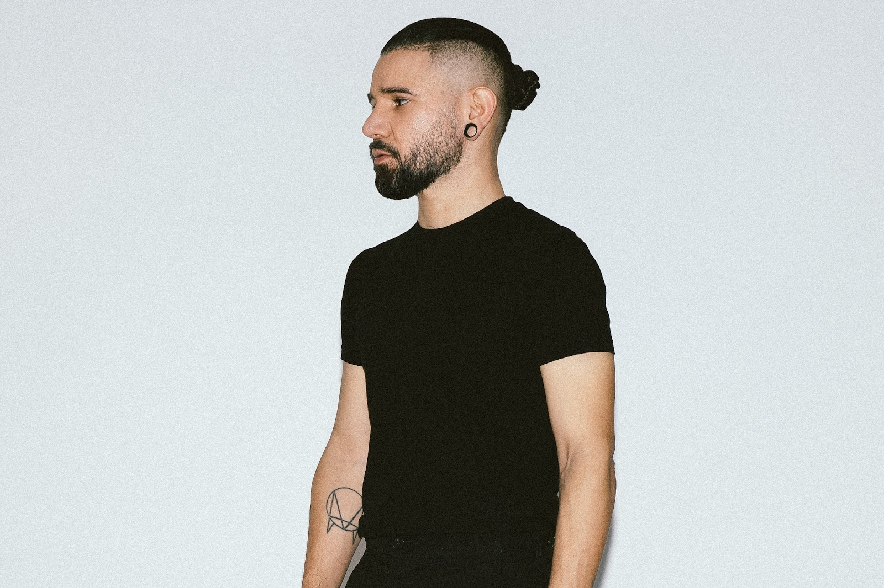
Photo Credit: Marilyn Hue

Skrillex releases his highly anticipated album Quest For Fire (OWSLA / ATLANTIC RECORDS) after having a monumental run of performances and releases this year including sold out pop-ups in NYC this week at Good Room and Le Poisson Rouge along with a Madison Square Garden show this Saturday February 18th. The Grammy award winning musician enlists help from fellow pioneering artists such as Fred again.., Four Tet, Jamie XX, Dylan Brady, & more, further etching his name as one of dance music’s greats. With his first release of the year “Rumble” featuring Fred again.., & Flowdan having garnered major accolades the other songs on this album follow its lead and remain nothing less than extraordinary. Appearances from some of Skrillex’s most forward-thinking friends are seen throughout the project on tracks such as “Ratata” featuring pop-culture icon Missy Elliot and “A Street I Know” featuring the eclectic Eli Keszler. Other collaborators include Sleepnet, Noisia, Josh Pan, Porter Robinson, Bibi Bourelly, Joker, Starrah, and Nai Barghouti resulting in one of Skrillex’s most club oriented and masterful bodies of work to date.

Listen to Skrillex’s new album Quest for Fire here.
Quest For Fire
1.) Skrillex & Bobby Raps, “Leave Me like This”
2.) Skrillex, Mr. Oizo, & Missy Elliott, “RATATA”
3.) Skrillex, Joker, & Sleepnet, “Tears”
4.) Skrillex, Fred Again.., & Flowdan, “Rumble”
5.) Skrillex, Starrah, & Four Tet, “Butterflies”
6.) Skrillex, Aluna, & Kito “Inhale Exhale”
7.) Skrillex & Eli Keszler, “A Street I Know”
8.) Skrillex & Nai Barghouti, “Xena”
9.) Skrillex, Swae Lee, Siiickbrain, & Posij “TOO BIZARRE (juked)”
10.) Skrillex, Flowdan, BEAM, & PEEKABOO, “Hydrate”
11.) Skrillex, “Warped Tour ‘05 with pete WENTZ”
12.) Skrillex, & Starrah, “Good Space”
13.) Skrillex, Noisia, Josh Pan & Dylan Brady, “Supersonic (My Existence)”
14.) Skrillex “Hazel Theme”
15.) Skrillex, Porter Robinson & Bibi Bourelly, “Still Here (with the ones that I came with)”

