SKRILLEX ANNOUNCES HIGHLY ANTICIPATED ALBUM QUEST FOR FIRE SET TO DROP NEXT FRIDAY FEBRUARY 17 ALONGSIDE ACCOMPANYING BASEMENT DJ SET VIDEO

WATCH THE ELECTRIFYING MUSICIAN PREVIEW ALBUM TRACKS
https://www.youtube.com/watch?v=hb0XLX0b4Y4

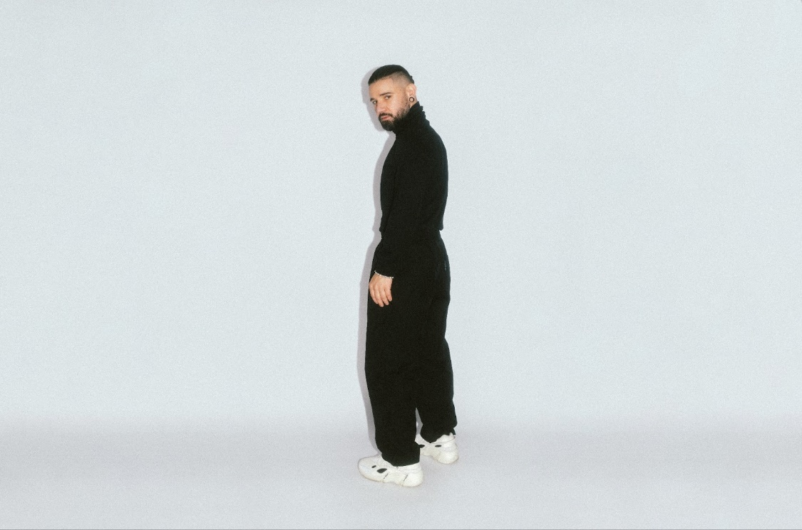
Photo Credit: Marilyn Hue

Grammy award winning DJ and producer Skrillex officially announces a release date for his highly anticipated album Quest For Fire on Instagram today with videos and a link to his preview of tracks. This new album is set to drop on Friday, February 17th on OWSLA / Atlantic Records. The highly acclaimed musician recently recorded a DJ set live from his basement giving fans a sneak peak of the entire album.

Skrillex started this year on a hot streak after releasing multiple collaborative singles such as “Way Back” featuring PinkPantheress & Trippie Redd, “Leave Me Like This” featuring Bobby Raps, “Xena” featuring Nai Barghouti, and “Real Spring” featuring Bladee which was accompanied by his first music video of the year. The globetrotting musician also took his talent to dance floors across the world by way of multiple pop-up performances across the UK, often joined by fellow friends and collaborators Fred again.. and Four Tet all while sharing his travels with fans through social media.

Skrillex’s new album Quest For Fire set to drop Friday, February 17.
Pre-order:
https://skrillex.lnk.to/QuestForFire?fbclid=PAAaZ_RFtqpEWbiVvp8UEJ3-yf6DV0EPVQ1RYJCWHtuYRjPfMwpH8AZ8DN0i8

