SKRILLEX RELEASES NEW MUSIC VIDEO FOR “CEREMONY” FEATURING YUNG LEAN & BLADEE

WATCH THE VIDEO HERE

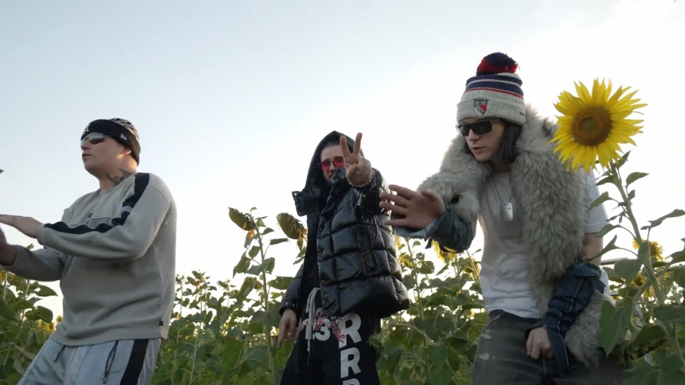

Following a historical week in New York full of surprise pop-up performances, two new albums, and a monumental sold out five hour rave at Madison Square Garden alongside Fred again.., and Four Tet, Skrillex releases a new music video for his single “Ceremony” featuring Yung Lean & Bladee. This song comes from his second album Don’t Get Too Close which he surprise dropped mid-performance on Saturday during his set at MSG. Filmed during his musical travels around the world, particularly during his time spent in Bangkok with Yung Lean and Bladee, the video comes as a celebration of life as Skrillex and his collaborators are seen partying around town, rendezvousing through a flower field, and sharing drinks with friends in between clips of a nightclub performance.

Watch the new music video for Skrillex’s single “Ceremony” featuring Yung Lean & Bladee here.

