SKRILLEX, FRED AGAIN, & FOUR TET ANNOUNCE SURPRISE SHOW AT MADISON SQUARE GARDEN THIS SATURDAY FEBRUARY 18

ANNOUNCES FEATURED GUESTS VIA BILLBOARDS IN JAPAN

TICKETS WILL BE GOING ON SALE TODAY AT 1PM EST HERE

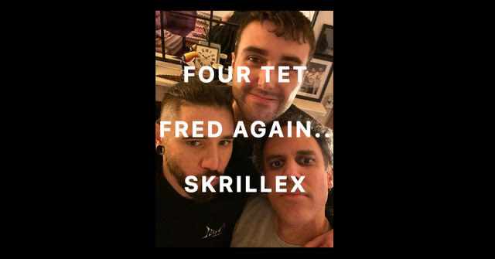

Skrillex, Fred again.., & Four Tet announce that they will be performing live from New York’s Madison Square Garden on Saturday 2/18. While already having played three last minute shows together at some of London’s most iconic venues such as Troxy and Electric Ballroom, this will be the first time they bring the party to a massive venue in the States. The three friends have been living together in New York while working on new music this week and sold out an electrifying Valentine’s Day pop up at Good Room last night. Having released his single “Don’t Get Too Close” on OWSLA / ATLANTIC RECORDS featuring Bibi Bourelly & vocals done by Sonny Moore himself on Monday along with his newest album Quest For Fire being set to drop this Friday February 17, this week is expected to be monumental for everyone involved in the project and fans who have been keeping up with recent events alike.

