FOR IMMEDIATE RELEASE
FEBRUARY 23, 2023

SIR CHLOE CONFIRMS DEBUT ALBUM I AM THE DOG
DUE OUT MAY 19 VIA ATLANTIC RECORDS

UNVEILS NEW SONG “HOOVES”

LISTEN HERE | WATCH HERE

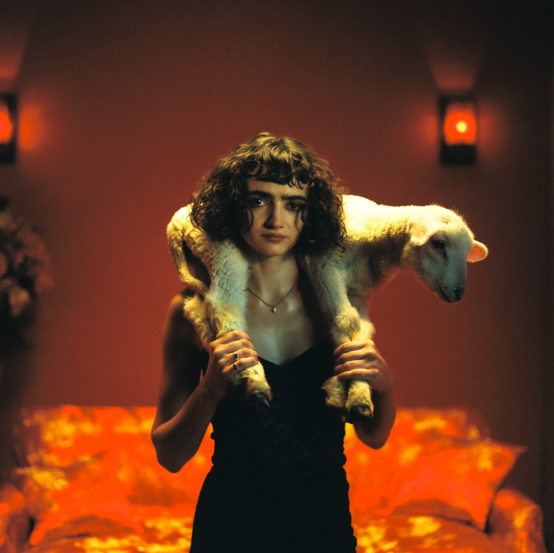
DOWNLOAD PRESS PHOTO HERE // CREDIT: GRANT SPANIER

I Am The Dog, the debut album from Sir Chloe — the project of vocalist, songwriter and guitarist Dana Foote — is slated for release May 19 via Atlantic Records — Pre-Order/Pre-Save HERE. Today, they share a new song, the album’s lead single, “Hooves,” alongside a video — Listen HERE + Watch HERE.
Additionally, Sir Chloe confirms support for a coheadline tour with Phoenix and Beck, alongside Japanese Breakfast, Weyes Blood and Jenny Lewis — See full routing below.
Made with Grammy-winning producer John Congleton (Lana Del Rey, St. Vincent, Angel Olsen) with songwriting contributions from Teddy Geiger (Caroline Polachek, Sylvan Esso, Lizzo) and Sarah Tudzin (Weyes Blood, Amen Dunes, Slowdive), I Am The Dog encapsulates the thrilling paradoxical nature of Sir Chloe. Thematically, the album grapples with finding control in the innate chaos of life, highlighting and interrogating this tension, only to destabilize it and opt for chaos once again. Anchored by Foote’s emotional and dynamic voice, the album toes the line between expression and concealment, making a fetish of the unsaid with lyrics that are simultaneously frank and ambiguous. With this constant push and pull propelling the album forward, Foote’s aim isn’t to be at rest but rather to ask why she cannot be.
Foote put Sir Chloe together in college to serve as her senior thesis, going on to write the band’s first major hits “Michelle” — which has accumulated more than 180 million streams on Spotify — and “Animal” on the floor of her dorm room. The rest of the songs on Sir Chloe’s 2020 EP Party Favors were recorded in a warehouse that the band transformed into a recording space with just $100 and sheer will. Following the success of the EP and two additional singles in 2022, the band — which consists of Foote, Emma Welch, Teddy O'Mara, Palmer Foote, and Austin Holmes — toured arenas with Portugal. The Man and alt-J, opened for the Pixies and headlined two tours of their own in the United States and Europe, with sold out stops in New York, Los Angeles, London, Paris, Amsterdam and more.

SIR CHLOE – I AM THE DOG
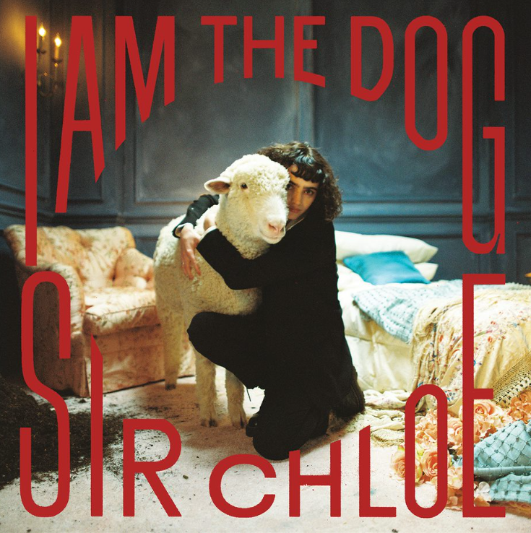
DOWNLOAD ARTWORK HERE // CREDIT: GRANT SPANIER

1. Should I
2. Salivate
3. Center
4. Know Better
5. Leash
6. Hooves
7. Obsession
8. Daddy’s Car
9. Cake
10. I Am The Dog
11. Feel Again

SIR CHLOE LIVE

AUGUST
3—Bend, OR—Hayden Homes Amphitheater*
5—Concord, CA—Concord Pavilion*
7 —Los Angeles, CA—Kia Forum*
8—San Diego, CA—Viejas*
11—Phoenix, AZ—Footprint Center*
12—Las Vegas, NV—Michelob Ultra Arena*
15—Morrison, CO—Red Rocks*
18—Rogers, AR—Walmart Amp*
20—Houston, TX—Cynthia Woods Pavilion*
21—Dallas, TX—Dos Equis Pavilion*
22—Austin, TX—Moody Center*
31—Chicago, IL—Huntington Bank Pavilion*

SEPTEMBER
2—Detroit, MI—Pine Knob Music Theater*
3—Toronto, ON—Budweiser Stage*
5—Boston, MA—MGM Music Hall*
6—Boston, MA—MGM Music Hall*
8—Philadelphia, PA—Mann Music Center*
10—Columbia, MD—Merriweather Post Pavilion*

* with Phoenix & Beck

###

CONNECT WITH SIR CHLOE
OFFICIAL | FACEBOOK | INSTAGRAM | TWITTER | SPOTIFY | YOUTUBE

For press inquiries, please contact:
Jessica Nall / Jessica.Nall@atlanticrecords.com
Libby Kober / Libby.Kober@atlanticrecords.com

