FOR IMMEDIATE RELEASE
FEBRUARY 24, 2023

SUECO SHARES NEW SINGLE “POS”

SELF-DEPRECATING ANTHEM PRODUCED BY MIKE SHINODA OF LINKIN PARK
AND FREQUENT COLLABORATOR COLIN BRITTAIN
LISTEN HERE

WASTED SPACE WORLD TOUR
GETS UNDERWAY MAY 3 IN NEW HAVEN, CT
WITH SUPPORT FROM TEENAGE DISASTER FOR US DATES
TICKETS ON SALE NOW HERE

HIGHLIGHTS INCLUDE TOP-BILLED FESTIVAL PERFORMANCES
AT ATLANTIC CITY, NJ’S BAMBOOZLE
AND DAYTONA BEACH, FL’S WELCOME TO ROCKVILLE

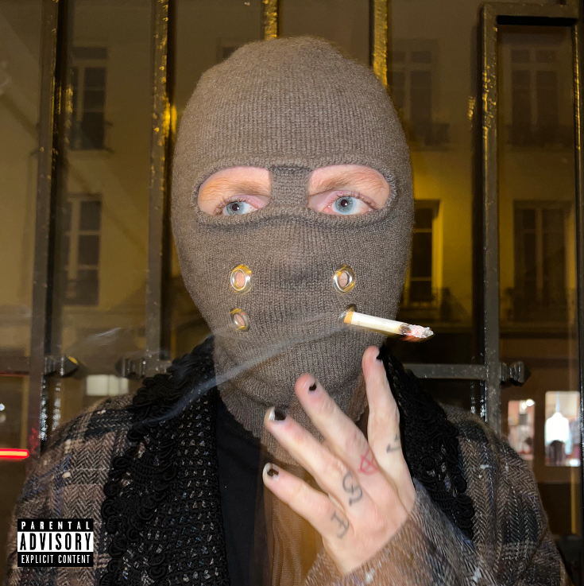
DOWNLOAD HI-RES ARTWORK HERE

RIAA Platinum certified singer, producer, and multi-instrumentalist Sueco has shared a brand new single, “POS,” produced by Mike Shinoda of Linkin Park and frequent collaborator Colin Brittain (5 Seconds of Summer, All Time Low, Papa Roach, Sum 41) - Listen HERE.

“I wrote POS about the negative voice that’s in your head and trying to silence or run away from it,” Sueco shared. “The high pitched chorus is supposed to represent the voice itself and the shift to a unaltered tone at the end yelling ‘STFU’ represents the trying to silence it, while the verses are all storytelling based. It’s something I’ve struggled with my whole life, overcoming the dark thoughts, and I think it’s an issue we all deal with to one extent or the other. it can be the hardest thing to shine light on the darkest places within ourselves but it’s only then that we can air them out and change for the better.”

Sueco will mark his new music and much more with the Wasted Space World Tour. With support from Teenage Disaster for US dates, the tour gets underway May 3 with a headline show at New Haven, CT’s Toad’s Place and then continues through a top-billed festival performance at Daytona Beach, FL’s Welcome To Rockville on Sunday, May 21. From there, the Los Angeles, CA-based artist will cross the Atlantic for headline shows and festival sets in the UK, France, Belgium, Germany, Austria, Poland, and the Czech Republic. Tickets for all newly announced US headline dates are on sale now. For full details and ticket information, please see www.sueco.com.

SUECO
WASTED SPACE WORLD TOUR 2023

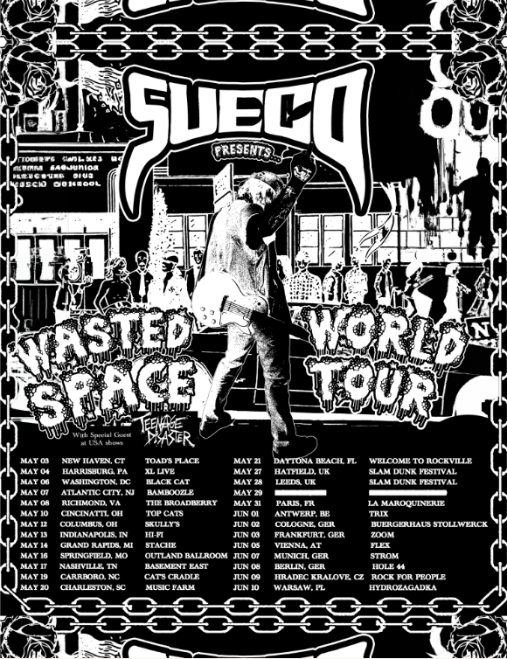

MAY
3 – New Haven, CT – Toad's Place
4 – Harrisonburg, PA – XL Live
6 – Washington, DC – Black Cat
7 – Atlantic City, NJ – Bamboozle Festival*
8 – Richmond, VA – The Broadberry
10 – Cincinnati, OH – Top Cat’s
12 – Columbus, OH – Skully’s
13 – Indianapolis, IN – HI-FI
14 – Grand Rapids, MI – The Stache at The Intersection
16 – Springfield, MO – Outland Ballroom
17 – Nashville, TN – Basement East
19 – Carrboro, NC – Cat’s Cradle
20 – Charleston, SC – Music Farm
21 – Daytona Beach, FL – Welcome to Rockville *
27 – Hatfield, UK – Slam Dunk Festival (South) *
28 – Leeds, UK – Slam Dunk Festival (North) *
31 – Paris, France – La Maroquinerie

JUNE
1 – Antwerp, Belgium – Trix Club
2 – Cologne, Germany – Buergerhaus Stollwerck
3 – Frankfurt, Germany – Zoom
5 – Vienna, Austria – Flex
7 – Munich, Germany – Strom
8 – Berlin, Germany – Hole 44
9 – Hradec Kralove, Czech Republic – Rock For People *
10 – Warsaw, Poland - Hydrozagadka

* FESTIVAL APPEARANCE

# # #

“POS” follows last year’s It Was Fun While It Lasted (Deluxe), an expanded new edition of Sueco’s acclaimed debut LP available now via Atlantic Records HERE. The deluxe release includes 21 tracks in total, among them such breakthrough singles as “Loser,” “SOS (Feat. Travis Barker),” “Sober/Hungover (Feat. Arizona Zervas),” “Drunk Dial,” and the chart-topping RIAA Gold certified breakthrough, “Paralyzed,” the latter of which reached #1 on both Spotify’s “Viral 50 US” and Billboard’s “Rock Digital Song Sales” while also proving Sueco’s first-ever Billboard “Hot 100” and Rolling Stone “Top 100” hit. Additional highlights include fan favorites like the RIAA Platinum certified smash, “Fast,” as well as such standout singles as “Next Ex,” “Salt,” “Last Thing I Do,” and the irresistible punk pop anthem, “Funeral.” Official music videos, lyric videos, and much more are streaming now at the official Sueco YouTube channel HERE.

Hailed by Ones To Watch as an artist “whose humor and meteoric success is unexpected, unpredictable, and nothing short of enthralling,” Sueco spent much of last year traveling the world on his biggest headline tour thus far, with virtually every show in the US, the UK, and Europe completely sold out. What’s more, Sueco recently joined chart-topping labelmate Oliver Tree as special guest on his blockbuster “Cowboy Tears Tour” while also lighting up such festivals as Gulf Shores, AL’s Hangout Music Festival, the UK’s Reading and Leeds, Atlanta, GA’s Music Midtown, and Dover, DE’s Firefly Music Festival, to name only a few.

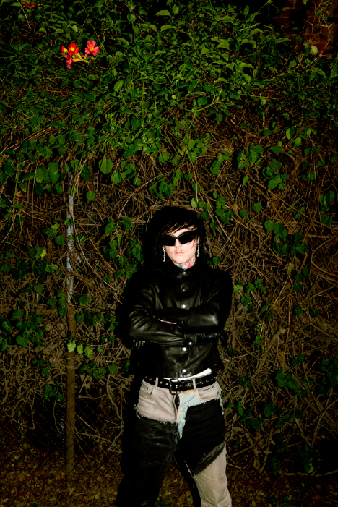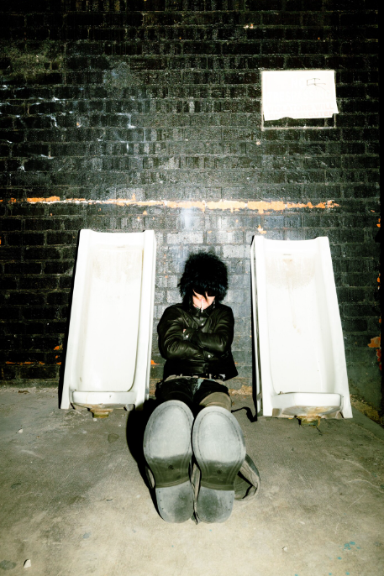
DOWNLOAD PRESS PHOTOS HERE
CREDIT: JAIME GARCIA

# # #

CONNECT WITH SUECO
WEBSITE | FACEBOOK | INSTAGRAM l SOUNDCLOUD l TIKTOK | TWITTER l YOUTUBE

For press inquiries, please contact:
Jessica Nall // Jessica.Nall@atlanticrecords.com

