TIËSTO DROPS OFFICIAL REMIX OF HBO®’S THE WHITE LOTUS TITLE THEME “RENAISSANCE” WITH CRISTOBAL TAPIA DE VEER

LISTEN HERE | WATCH OFFICIAL VISUALIZER HERE

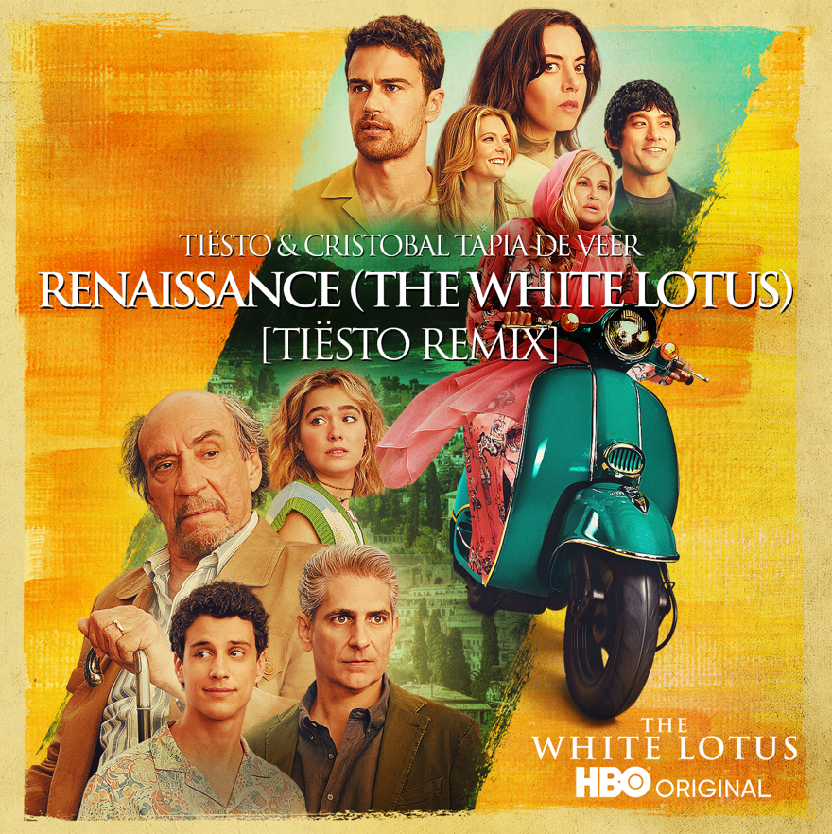
DOWNLOAD HI-RES ARTWORK

GRAMMY® Award-winning, RIAA platinum-certified international icon Tiësto has shared his own one-of-a-kind spin on “Renaissance” the title theme from Season 2 of HBO’s Emmy®-winning series, The White Lotus, available now at all DSPs and streaming services HERE. Written by Chilean-Canadian composer Cristobal Tapia de Veer, “Renaissance” is the first official remix of the viral hit, with Tiësto’s version already taking over dance floors worldwide. The official remix is joined by an official visualizer premiering today at YouTube HERE.

“As a huge fan of The White Lotus I couldn’t be more excited to be releasing the official remix” said Tiësto. “I was instantly hooked on the theme song so I had to put my spin on it for my live sets… every time I play it, the crowd goes crazy! I’m thrilled HBO wanted to partner and make it official.”

"Renaissance” (The White Lotus) [Tiësto Remix] follows Tiësto’s latest global release, “10:35,” the worldwide hit single co-created by Tiësto and multi-platinum singer/songwriter Tate McRae in partnership with Dubai’s new ultra-luxury resort Atlantis The Royal, available for streaming and download HERE. The track will be featured on Tiësto’s upcoming album Drive.

ABOUT TIËSTO:
Tiësto is a pillar electronic music and an artist that transcends beyond that -- Tiësto is an experience. When you hear the name and hear his signature sound on the dance floor, you know you’re about to have the best night of your life. Throughout his unparalleled career, the Grammy® Award-winning, platinum-certified, international icon has brought electronic music to the masses, first rising out of the underground scene to become one of the biggest and most influential DJ/producers of all time. He’s played the mainstage of every major international dance music festival and created the template for Las Vegas DJ residencies. Meanwhile, he’s sold more than 36 million albums, clocked six Billboard Hot 100 hits and aggregated an incredible 11+ billion worldwide streams. But the truth is, Tiësto is just now getting started. A leading figure of the global Dance Music movement, he helped forge the bridge between electronic and pop, evolving the sound of mainstream music itself in the process. The artist born Tijs Verwest has found a particular sweet spot in this crossover realm, gaining critical acclaim and millions of new fans with a litany of hits including “The Business” and 2021’s “The Motto.” Together, these tracks have been streamed more than 2.6 billion times. His new LP, Drive, finds the artist at the height of his powers. Functioning as the crowning achievement of the last several years of his career, the album showcases the sleek and sexy sound that’s become Tiësto’s signature. Named for the perpetual momentum of his career and the physical movement his work continues to inspire, Drive makes the thrill of the dancefloor available whenever, and wherever, listeners turn it on.
DL PHOTO HERE

ABOUT THE WHITE LOTUS
From Mike White, THE WHITE LOUTS is a social satire set at an exclusive resort and follows the exploits of various guests and employees over the span of a week. The first installment of the series was set in Hawaii and the second installment was set in Sicily. Created, written and directed by Mike White, season two was executive produced by White, David Bernad and Mark Kamine. The White Lotus is available to stream on HBO Max.

ABOUT HBO MAX
HBO Max™ is a streaming platform that offers best in class quality entertainment, delivering the greatest array of series, movies, and specials from the iconic brands of HBO, Warner Bros., and DC, as well as Max Originals and blockbuster films. The platform launched in the United States in May 2020 and introduced a lower priced, advertising-supported tier in June 2021. Currently available in 61 countries, HBO Max began its global rollout launching in markets across Latin America and the Caribbean in 2021, followed by European launches in the Nordics, Iberia, the Netherlands and Central and Eastern Europe.

# # #

CONNECT WITH TIËSTO:
OFFICIAL | FACEBOOK | INSTAGRAM | SPOTIFY | TIKTOK | TWITTER | YOUTUBE

FOR MORE INFORMATION ON TIËSTO:
Paige Rosoff – Atlantic Records
Paige.Rosoff@atlanticrecords.com

FOR MORE INFORMATION ON HBO MAX
Mellony Torres – HBO Max
Mellony.Torres@warnermedia.com

