FOR IMMEDIATE RELEASE
FEBRUARY 17, 2023

MULTI-PLATINUM SINGER-SONGWRITER VANCE JOY
ANNOUNCES FINAL SHOWS ON THE
IN OUR OWN SWEET TIME TOUR

NEWLY ANNOUNCED DATES BEGIN AUGUST 25 –
INCLUDING STOPS AT CO’S ICONIC RED ROCK AMPHITHEATRE
AND NY’S SUMMERSTAGE IN CENTRAL PARK

TICKETS AVAILABLE NOW HERE

16-TRACK LIVE ALBUM LIVE AT SYDNEY OPERA HOUSE DUE OUT APRIL 14
ALBUM PRE-SAVE AND VINYL PRE-ORDERS AVAILABLE HERE

ALBUM INCLUDES LIVE RENDITIONS OF “MISSING PIECE” AND “CLARITY”
WHICH PEAKED AT #2 AND #3 ON ALT RADIO RESPECTIVELY

“SATURDAY SUN (LIVE AT SYDNEY OPERA HOUSE)” RELEASED TODAY
LISTEN HERE

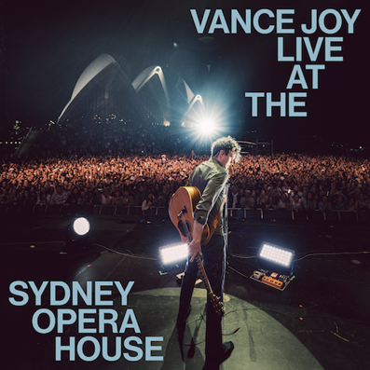
DOWNLOAD HI-RES IMAGE

Multi-platinum global superstar Vance Joy has announced a series of summer headline dates getting underway August 25 at Vancouver, BC’s Deer Lake Park and then making stops at such historic venues as Morrison, CO’s Red Rocks Amphitheatre (August 27), New York City’s SummerStage in Central Park (August 30), and Nashville, TN’s Ryman Auditorium (September 1-2). General on-sales begin Friday, February 17 at 10:00 am (local). For complete details, please see www.vancejoy.com.

The newly announced dates mark the end of the North American leg on Joy’s epic In Our Own Sweet Time Tour. Support on the newly announced shows comes from Canada’s very own Dan Mangan and Ruby Waters, and fellow Australian Singer Songwriter Dan Sultan.

Today also sees the premiere of “Saturday Sun (Live At Sydney Opera House),” a stellar concert version of Joy’s RIAA gold-certified 2018 fan favorite. “Saturday Sun (Live At Sydney Opera House)” heralds the upcoming release of Vance Joy Live At The Sydney Opera House, a 16-track new album recorded last year during two very special headline performances at the world-famous Sydney Opera House Forecourt in Sydney, Australia. Vance Joy Live At The Sydney Opera House arrives on April 14; pre-saves and vinyl pre-orders are available now HERE.

Recorded November 18 and 19, 2022 during the Australia leg of Joy’s sold out In Our Own Sweet Time World Tour, Vance Joy Live At The Sydney Opera House includes electrifying new renditions of such RIAA platinum certified hits as “Georgia,” “Mess Is Mine,” and of course, the 6x platinum certified classic, “Riptide.” Highlights include live versions of “Clarity” and “Catalonia,” both available now at all DSPs and streaming services HERE, with the latter track joined by an official live performance video streaming now at YouTube HERE.

The original studio versions of “Clarity” and “Catalonia” are among the many highlights of Joy’s acclaimed new album, In Our Own Sweet Time, available everywhere now via Atlantic Records HERE. The Australian singer-songwriter’s most personal full-length thus far, In Our Own Sweet Time includes such emotionally charged tracks as “Looking At Me Like That,” “Don’t Fade,” and the RIAA gold certified smash, “Missing Piece,” all joined by official music videos streaming now at YouTube. Currently boasting over 43.5M global streams, “Clarity” has fast proven a popular favorite around the world, ascending to the top 5 at Alternative radio outlets across America while also earning prestigious “Song of the Year” and “Best Pop Release” nominations from Australia’s 2022 ARIA Music Awards. In addition, the official music video for the album’s “Every Side of You” recently took home the ARIA for “Best Video” – Joy’s fourth ARIA Award to date.

Hailed by Rolling Stone as “a refreshing twist on the singer’s signature sound,” In Our Own Sweet Time has also been met by worldwide critical applause from such top media outlets as Billboard, V, UPROXX, NME, Guitar World, and American Songwriter, to name only a few.

VANCE JOY
IN OUR OWN SWEET TIME TOUR
NORTH AMERICA 2023

FEBRUARY
15 – Hamilton, ON – FirstOntario Centre (SOLD OUT) *
17 – Columbus, OH – KEMBA Live! (SOLD OUT) *
18 – Chicago, IL – The Chicago Theatre (SOLD OUT) *
19 – Minneapolis, MN – State Theatre (SOLD OUT) *
21 – Winnipeg, MB – Centennial Concert Hall (SOLD OUT) *
22 – Saskatoon, SK – TCU Place *
23 – Calgary, AB – Jack Singer Concert Hall (SOLD OUT) *
24 – Calgary, AB – Jack Singer Concert Hall (SOLD OUT) *
27 – Edmonton, AB – Winspear Centre (SOLD OUT) *
28 – Edmonton, AB – Winspear Centre (SOLD OUT) *

MARCH
3 – Seattle, WA – Paramount Theatre (SOLD OUT) *
4 – Seattle, WA – Paramount Theatre (SOLD OUT) *
6 – Portland, OR – Keller Auditorium *
9 – Oakland, CA – Fox Theater (SOLD OUT) *
10 – Oakland, CA – Fox Theater *
11 – Inglewood, CA – YouTube Theater *
16 – San Diego, CA – Soma *
18 – Phoenix, AZ – Arizona Federal Theatre *
20 – Austin, TX – ACL Live at the Moody Theater *
21 – Austin, TX – ACL Live at the Moody Theater (SOLD OUT) *
23 – Atlanta, GA – Coca–Cola Roxy *
24 – Charlotte, NC – The Fillmore (SOLD OUT) *
25 – Washington, DC – The Anthem (SOLD OUT) *

AUGUST
25 – Vancouver, BC – Deer Lake Park #
27 – Morrison, CO’s Red Rocks Amphitheatre +
30 – New York, NY – SummerStage in Central Park +

SEPTEMBER
1 – Nashville, TN – Ryman Auditorium +
2 – Nashville, TN – Ryman Auditorium+

* w/ Special Guest Jack Botts
# w/ Special Guest Dan Mangan & Ruby Waters
+ w/ Special Guest Dan Sultan

# # #

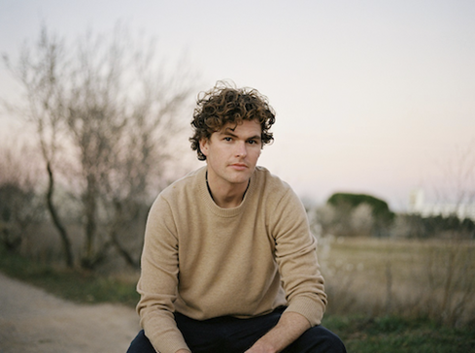
DOWNLOAD HI-RES IMAGE
PHOTO CREDIT: CELINA MARTINS

CONNECT WITH VANCE JOY:
WEBSITE | FACEBOOK | TWITTER | INSTAGRAM | YOUTUBE

For press inquiries, please contact:
Kelly McWilliam // Kelly.McWilliam@atlanticrecords.com
Libby Kober // Libby.Kober@atlanticrecords.com

