FOR IMMEDIATE RELEASE
MARCH 17, 2023

ABSOFACTO CONTINUES THE MYSTERY OF NITESHIFT
WITH “UNQUIT YOU”

EXQUISITELY NOSTALGIC NEW TRACK MARKS LATEST CHAPTER
IN RIAA PLATINUM-CERTIFIED PRODUCER/ARTIST’S
VISIONARY NITESHIFT PROJECT

LISTEN TO “UNQUIT YOU” HERE | WATCH OFFICIAL MUSIC VIDEO HERE

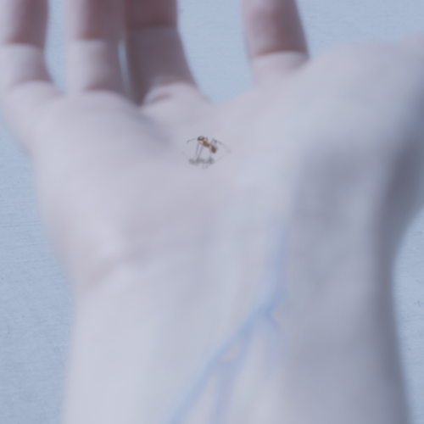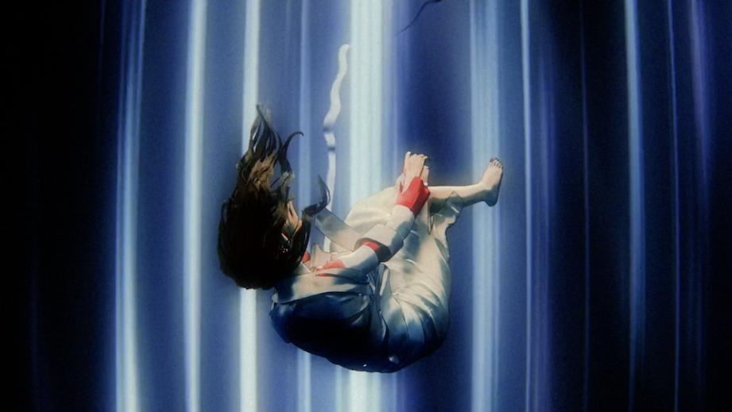
DOWNLOAD ARTWORK + THUMBNAIL HERE

RIAA Platinum-certified artist, producer and creator Absofacto has shared his latest track, “Unquit You.” Pairing the powerful visual language of classic 70’s horror with one of Absofacto’s most exquisitely nostalgic songs to date, the track marks the latest release from the mysterious world of NITESHIFT – a multi-dimensional, ongoing creative experience comprising singles, visuals, films, interactive elements, and much more. “Unquit You” is joined by an equally potent visual – Watch HERE.

Absofacto – a.k.a Los Angeles, CA-based musician/artist Jonathan Visger – first opened the door on NITESHIFT with “VIBE TIL I DIE,” featuring love-sadKID and LIMBO. Featured on Sirius XM Alt Nation’s “Advanced Placement” upon its debut late last year, “VIBE TIL I DIE” arrived alongside a cinematic companion video – created by director Jacqueline Kulla and Absofacto – Watch HERE.

“NITESHIFT is for people who want to feel challenged and discover something truly new for themselves,” Absofacto says. “Yes, it’s a literal place…but it’s also a puzzle, a mystery, a community, and a tool for expanding your horizons in every way. Stories on stories. Discoveries on discoveries. It’s about immersing yourself in the infinite depth of being alive. The scope of it will become apparent over time, and it can actually transform your perspective on the world around you. As human beings on Earth, we all have the same confusing experience of being born into a structure we didn’t design and having to make sense of the world around us. We wonder, ‘What direction are we supposed to go in? What are we supposed to value? Why are we even here?’ Within NITESHIFT, you get to embrace that mystery and search for answers for yourself.”

Absofacto initially achieved global impact with the RIAA Platinum-certified viral hit “Dissolve,” tallying more than 500M streams and more than 3M TikTok creates. Named SiriusXM Alt Nation’s #1 song of 2019, “Dissolve” paved the way for future fan favorite singles such as “Someone Else’s Dream.” Even as his profile rose, he had the unshakable feeling that there was a much deeper pursuit to go on, especially in the final hours of the day before sleep when a deluge of visions flooded his mind. From here, the door to NITESHIFT came into focus.

With NITESHIFT, Absofacto set out to develop a truly one-of-kind project that was deep, resonant and designed to be continuously discovered for years to come. The result is a mysterious audio/visual/narrative world that he will present over the course of 2023, by way of a visually stunning series of music videos, near daily shortform content and much more.

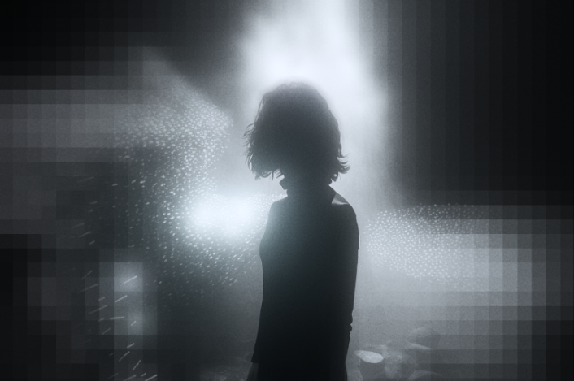
DOWNLOAD ABSOFACTO / NITESHIFT PHOTO HERE

CONNECT WITH ABSOFACTO
OFFICIAL | FACEBOOK | TWITTER | INSTAGRAM | YOUTUBE

CONTACT
Jessica Nall // Jessica.Nall@atlanticrecords.com

