FOR IMMEDIATE RELEASE
MARCH 16, 2023

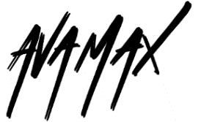

AVA MAX REVEALS OFFICIAL VISUALIZER FOR “GHOST”

RIAA MULTI-PLATINUM CERTIFIED POP STAR LIFTS CURTAIN ON LATEST SINGLE
FROM CRITICALLY ACCLAIMED NEW ALBUM, DIAMONDS & DANCEFLOORS

WATCH “GHOST” VISUALIZER

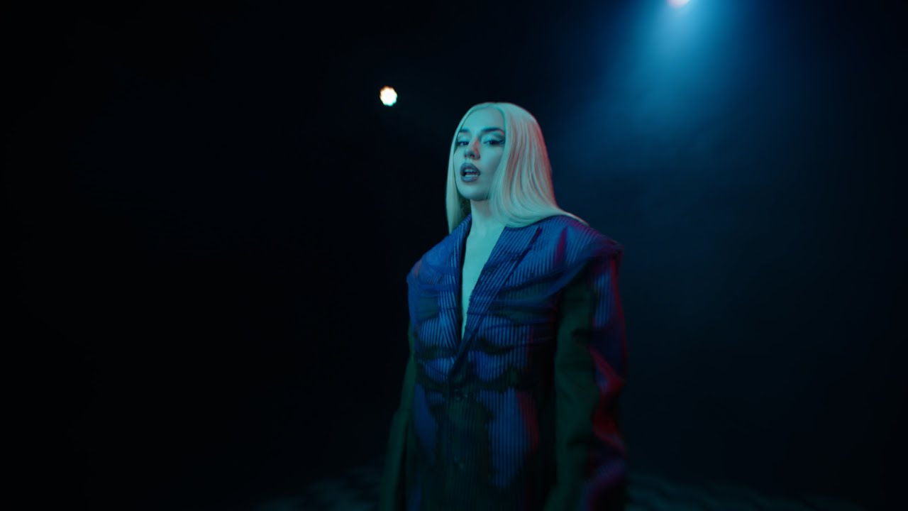
DOWNLOAD THUMBNAIL HERE

"She wanted to pair her soul-crushing lyrics with upbeat, dance-ready melodies... What came out was some of Max’s best work yet” – ROLLING STONE

“...Diamonds & Dancefloors is shaping up to be a more introspective record as Max ruminates on the times she’s been hurt. But rather than wallow in self-pity, she picks herself up and heads straight to the dancefloor” – FORBES

RIAA multi-platinum certified global pop sensation Ava Max has shared the official visualizer for “Ghost,” the latest single from her acclaimed sophomore album, Diamonds & Dancefloors - Watch HERE.

The eagerly awaited follow-up to Ava’s RIAA Platinum-certified 2020 debut album, Heaven & Hell, the disco-powered Diamonds & Dancefloors includes such passionately self-assured singles as “One of Us,” “Cold As Ice,” “Dancing’s Done,” “Weapons,” “Maybe You’re The Problem,” and “Million Dollar Baby,” the latter of which now boasts over 140M global streams after garnering 10M streams and 8M music video views in just two weeks after its release. Hailed by PAPER as “a euphoric euro dance number,” “Million Dollar Baby” is joined by an official music video, directed by Andrew Donoho (Khalid, Janelle Monae, Paul McCartney), currently boasting over 30M views HERE.

Hailed by Rolling Stone as “Max’s best work yet,” Diamonds & Dancefloors was written by Ava Max alongside an elite cast of GRAMMY® Award-winning writers and producers, including Henry Walter (Miley Cyrus, Maroon 5), Mathew James Burns (Lady Gaga, Ariana Grande), Peter Rycroft (Little Mix, Becky Hill), Sean Douglas (Lizzo), Pablo Bowman (Jonas Brothers, Anne-Marie), Madison Love (Madison Beer, Camila Cabello), Michel “Lindgren” Schulz (John Legend, Dua Lipa), Melanie Fontana (BTS, John Legend) and Ryan Tedder (Beyonce, Leona Lewis, Adele).

Ava – who recently celebrated the release of Diamonds & Dancefloors with a sold-out headline event at Los Angeles, CA’s famed Hollywood Forever Cemetery – is currently set to embark on her biggest world tour to date, including stops in the UK, Belgium, France, the Netherlands, Norway, Switzerland, Italy, Portugal, Germany, Spain, and Finland. North American dates include a top-billed performance at Pittsburgh, PA’s Pride on the Shore (June 3) as well as a headline concert at Milwaukee, WI’s BMO Pavilion (July 1). Additional dates will be announced. For complete details and ticket availability, please see www.avamax.com/tour.

Ava further marked Diamonds & Dancefloors with a stellar performance on CNN’s New Year’s Eve Live, followed by an appearance on The Kelly Clarkson Show as well as an exclusive Rolling Stone feature interview, which raved, “Max wanted to pair her soul-crushing lyrics with upbeat, dance-ready melodies…Her vocals shine on ‘Ghost’ as she sings about ‘feeling haunted’ by her ex over sparkling synth lines. On the disco-drenched ‘Hold Up, Wait a Minute,’ Max questions her partner’s connection with a past love. And her most emotional song on the project, ‘One of Us,’ started as a ballad but transformed into an empowering anthem about coming to terms with the end of a relationship.”

WHAT CRITICS ARE SAYING ABOUT DIAMONDS & DANCEFLOORS

“Ava Max is partying like it’s 2000 and 2004 on the thumping ‘Million Dollar Baby,’ a sleek, calisthenic pop song.” – THE NEW YORK TIMES

“With touches of Eighties synths and retro-futurism, the Albanian American pop star delivers electro-pop bangers that will make you dance and cry at the same time” – ROLLING STONE

“‘Weapons’ is Ava Max doing what she does best – conjuring empowering, technicolor Europop that’s camp and impeccably constructed” – PAPER MAGAZINE

“Maybe you’re the problem, and maybe this is the most upbeat breakup song ever….this song was made for blasting at full volume and dancing with your girlfriends.” – V MAGAZINE
# # #

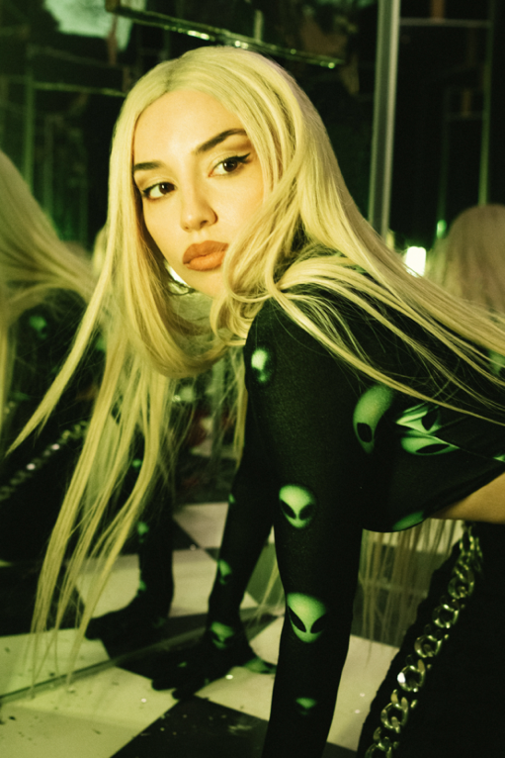
DOWNLOAD HI-RES PRESS PHOTO
PHOTO CREDIT: MARILYN HUE

# # #
CONNECT WITH AVA MAX:
OFFICIAL | FACEBOOK | INSTAGRAM I TIKTOK | TWITTER | YOUTUBE

Press Contacts:
Kelly McWilliam / Kelly.McWilliam@atlanticrecords.com
Ashley Kalmanowitz / Ashley.Kalmanowitz@atlanticrecords.com

