FOR IMMEDIATE RELEASE
MARCH 10, 2023

BANKROL HAYDEN DROPS 29
EAGERLY-AWAITED, STAR-STUDDED NEW MIXTAPE AVAILABLE NOW

FIRST-EVER NORTH AMERICAN HEADLINE TOUR
KICKS OFF APRIL 15 IN SAN DIEGO, CA

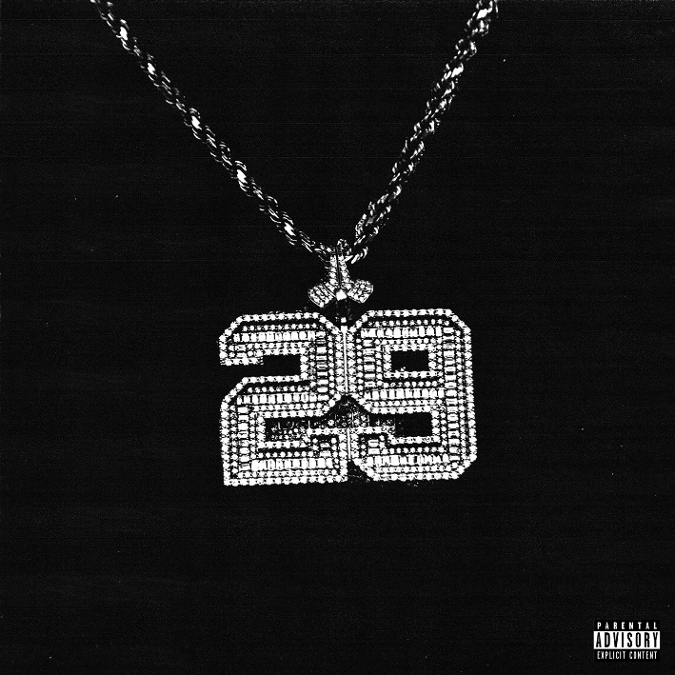
DOWNLOAD HI-RES ARTWORK

“Bankrol Hayden has continuously released memorable music since debuting in 2018. His quick, melodic flow is unique, and his hooks stay with you.” – POPDUST

Rising hip-hop star Bankrol Hayden has unveiled his eagerly-awaited new mixtape 29, available now on DSPs and streaming services via Atlantic Records HERE. Star-studded with features such as Blueface, OHGEESY, and Maxo Kream on his latest single “Bop Slide,” the 19-track mixtape sees Bankrol Hayden doubling down on his signature quotable lyrics, hard-hitting bars, and melodic hooks.

“29 is my divine number, it’s a number that brings the worst and best memories. And a number that follows me, guides me. I had the opportunity to work with some of my close friends on my second mixtape and I’m proud of the different layers fans will get to experience of me. It represents the peaks and pits of my life the last three years and I was fortunate to work with producers, writers who helped me display my duality on this project.” – BANKROL HAYDEN

29 offers an honest look into the few years since the 1-billion streaming rapper’s powerful debut mixtape, Pain Is Temporary. The brand-new project was unveiled earlier this year with the melodic “Can’t Change For You (Feat. charlieonnafriday & Arden Jones),” joined by an official music video directed by JakeTheShooter (Nessa Barrett, Sueco, Akon). Watch HERE.

Bankrol Hayden wrapped up 2022 with Christmas basketball anthem, “Courtside.” Produced by longtime collaborator Einer Bankz (Travis Scott, 21 Savage), the bespoke track was created specifically for EPSN and ABC’s “NBA on Christmas Day” campaign and was featured extensively over the holiday season throughout all NBA on ESPN coverage, spanning promos, in-game placement, social media, and more. Named as the featured artist for all “NBA on Christmas Day” coverage, Bankrol Hayden – accompanied by producer Einer Bankz – celebrated the premiere of “Courtside” with a special appearance and live performance on ESPN’s NBA Today. Watch HERE.

Bankrol Hayden will celebrate his recent successes and much more with a long-awaited North American tour – his first headline run to date. With support from openers Karri, Killbunk and YHIM, “The 29 Tour” begins April 15 at San Diego, CA’s Voodoo Room and then continues through a May 18 finale at Los Angeles, CA’s The Echo. For more information and ticket availability, please visit www.bankrol.co.

TRACKLIST:

BANKROL HAYDEN
29
(Atlantic Records)

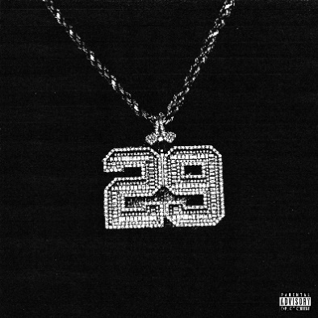

- 2001
- Cabo
- Deep End (feat. Lil Skies)
- Banana
- Bop Slide (feat. Blueface, OHGEESY & Maxo Kream)
- Come Through (feat. Lil Tecca)
- No Drama
- Way Back
- Cincinnati
- Bussdown Baby
- Can’t Change For You (feat. Arden Jones & charlieonnafriday)
- Fuck Love
- Karri’s Interlude
- Should I Stay
- Let Go
- Loyalty Over Love
- Van Hayden
- Penthouse (feat. Zzz.)
- Life Is Too Short

# # #

THE 29 TOUR

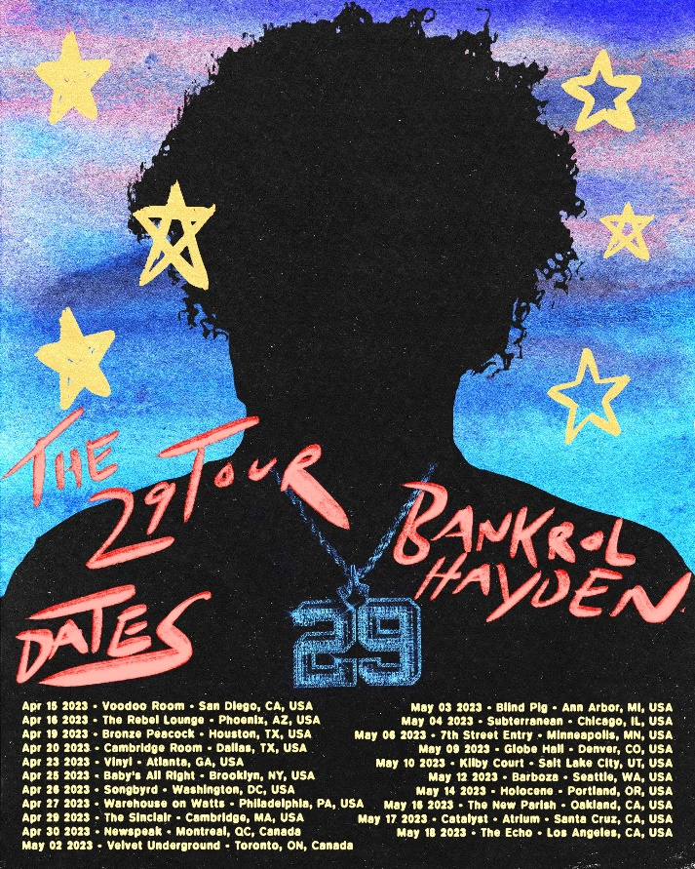

APRIL
15 – San Diego, CA – Voodoo Room
16 – Phoenix, AZ – The Rebel Lounge
19 – Houston, TX – Bronze Peacock
20 – Dallas, TX – Cambridge Room
23 – Atlanta, GA – Vinyl
25 – Brooklyn, NY – Baby’s All Right
26 – Washington, DC – Songbyrd
27 – Philadelphia, PA – Warehouse on Watts
29 – Cambridge, MA – The Sinclair
30 – Montreal, QC – Newspeak

MAY
2 – Toronto, ON – Velvet Underground
3 – Ann Arbor, MI – Blind Pig
4 – Chicago, IL – Subterranean
6 – Minneapolis, MN – 7th Street Entry
9 – Denver, CO – Globe Hall
10 – Salt Lake City, UT – Kilby Court
12 – Seattle, WA – Barboza
14 – Portland, OR – Holocene
16 – Oakland, CA – The New Parish
17 – Santa Cruz, CA – Catalyst (Atrium)
18 – Los Angeles, CA – The Echo

# # #

ABOUT BANKROL HAYDEN:
With over 1B streams to date to date, Bankrol Hayden is a true phenomenon, continuously earning fans around the globe with his positive brand of soulful, pop-forward hip-hop. The talented young artist first broke out in 2017 with a series of popular YouTube videos and SoundCloud favorites. Viral smashes as “B.A.N.K.R.O.L.,” “29,” and the RIAA gold certified “Brothers (Feat. Luh Kel)“ followed, the latter of which scored 30M Spotify streams and 6.5M YouTube plays in under six months. Bankrol Hayden made his Atlantic Records debut in 2020 with the hugely popular “Costa Rica,” quickly earning RIAA gold certification before following up with his powerful debut mixtape, Pain Is Temporary, highlighted by such emotionally charged tracks as “Whatchu On Today (Ft. Polo G),” “Drop A Tear (Ft. Lil Baby),” and “Rich Bitch,” all joined by official music videos streaming now at YouTube.

“Can’t Change For You” continues a run of radiant new music from Bankrol Hayden, including “Deep End (Feat. Lil Skies),” “Van Hayden,” “F*ck Love” the RIAA gold-certified “Costa Rica,” “Cabo,” “No Drama,” and 2021’s smash hit, “Come Through (Ft. Lil Tecca),” the latter of which boasted over 100M worldwide streams after making top playlists such as Spotify’s “Rap Caviar” and “Most Necessary,” Apple Music’s “#OnRepeat” and “The Plug,” Amazon’s “Fresh Hip-Hop,” and more.

Featured among YouTube’s “Artist on the Rise: Trending” series, Bankrol Hayden has also proven to be an electrifying live performer. Highlights include Chicago’s Juice WRLD Day Festival and a series of summer festival sets, with his first headline tour kicking off this Spring.

CONNECT WITH BANKROL HAYDEN
OFFICIAL | FACEBOOK | INSTAGRAM | TIKTOK | TWITTER | YOUTUBE

PRESS CONTACT
FAIRLEY MCCASKILL | FAIRLEY.MCCASKILL@ATLANTICRECORDS.COM

TOUR PRESS CONTACT
TIANA TIMMERBERG | TIANA.TIMMERBERG@ATLANTICRECORDS.COM

# # #

