RELEASES NEW SINGLE
“RAINCATCHERS”

TAKEN FROM HER FORTHCOMING ALBUM
PORTRAITS
OUT JULY 14, 2023

BUY/STREAM “RAINCATCHERS” HERE
WATCH THE OFFICIAL MUSIC VIDEO HERE
PRE-ORDER PORTRAITS HERE

photo credit: Thibault Theodore | download hi-res here

Birdy is back! Today – March 3, 2023 – Birdy releases her bold and striking new single, “Raincatchers,” out via Warner Music (buy/stream here). If you think you know Birdy, think again. The track – undoubtedly her most exciting and unforgettable to date – is the first release taken from her forthcoming album, Portraits, due out July 14, 2023 (pre-order here).

“Raincatchers” is accompanied by a stunning new music video, directed by Max McLachlan and co-written by Birdy (watch here).

On “Raincatchers,” Birdy shifts from her customary stripped-back motifs and moves to an 80s-influenced aesthetic, laden with polished and gleaming alt-pop overtones.

In her most confident album yet, Portraits sees Birdy take a liberated leap into the unknown – her timeless songwriting style now infused with a fresh, exuberant rush of energy and inventive, off-kilter production flourishes. It’s the sound of a creative stepping into a new world and, thrillingly, finding her true voice.

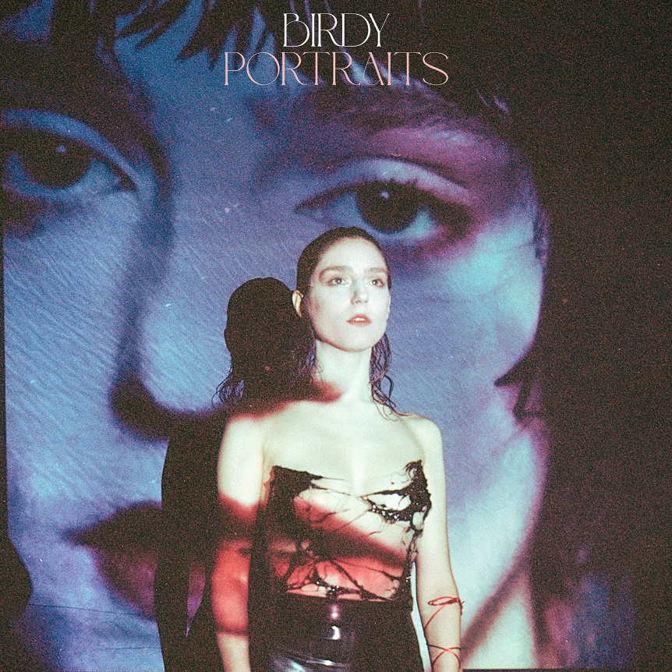
download hi-res artwork here

At the end of March, Birdy will embark on a European tour, which includes a sure-to-be standout date at London’s Eventim Apollo on April 23.

Birdy will also be performing at Annabel’s in London next Wednesday, March 8, as a part of International Women’s Day. Please find ticketing information here [full tour routing is enclosed below].

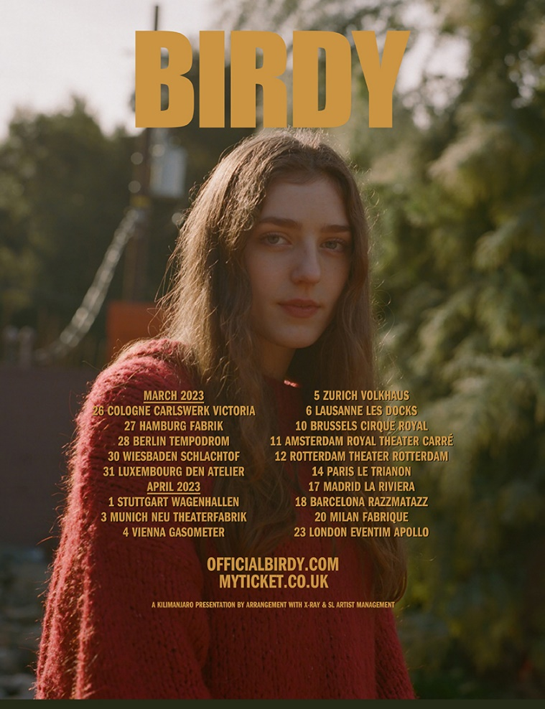
download hi-res admat here

In 2023, Birdy is back with her forthcoming fifth studio album, Portraits, ushering in a new chapter and marking a confident change in direction for an artist who has achieved an unbelievable amount since releasing her debut album, Birdy.

At just 26 years old, Birdy has solidified herself as one of the UK’s leading homegrown talents; her incredible achievements to date include 3 top 5 albums and countless Platinum and Gold certifications, exceeding sales of 8 million records globally. Whether featuring on blockbuster soundtracks for the likes of Pixar, Netflix, and Amazon, collaborating with leading artists across genres, or motivating a generation with a viral TikTok sound, Birdy is forever finding new ways to engage new audiences. On DSPs, Birdy’s committed fanbase has helped her to surpass an incredible 5 billion streams and counting; she counts 18 million followers across all streaming services.

Birdy continues to be an unmissable draw in the live arena, too. Her rich, multi-layered stage productions have seen her sell out three consecutive nights at The Sydney Opera House, play to over 10,000 people across two nights at London’s Eventim Apollo, and reach many more milestones on global world tours. She has also headlined festivals across Europe and Asia, performed at the UK’s famed Glastonbury Festival, and has earned both BRIT and GRAMMY® Award nominations.
BIRDY | SPRING 2023 UK/EU TOUR DATES

MARCH
8 – Annabel’s – London
26 – Carlswerk Victoria – Cologne
27 – Fabrik – Hamburg
28 – TEMPODROM – Berlin
30 – Schlachthof Wiesbaden – Wiesbaden
31 – Den Atelier – Luxembourg

APRIL
1 – Wagenhallen – Stuttgart
3 – Theaterfabrik – Munich
4 – Planet.tt Bank Austria Halle Gasometer – Vienna
5 – Volkshaus – Zürich
6 – Les Docks – Lausanne
10 – Royal Circus – Brussels
11 – Royal Theater Carré – Amsterdam
12 – Theater Rotterdam Schouwburg – Rotterdam
14 – Le Trianon – Paris
17 – La Riviera – Madrid
18 – Sala Razzmatazz – Barcelona
20 – Fabrique – Milan
23 – Eventim Apollo – London
25 – 3Olympia Theatre – Dublin

CONNECT WITH BIRDY:
WEBSITE | INSTAGRAM | TWITTER | FACEBOOK | TIKTOK

For more information on Birdy, please contact:
Libby Kober | Libby.Kober@atlanticrecords.com

