DAISY JONES & THE SIX RELEASE DOUBLE SINGLE “SPECIAL GIFT FOR OUR FANS”

“IT WAS ALWAYS YOU” & “AURORA (LIVE FROM SNL)” OUT TODAY FOLLOWING OVERWHELMING FAN DEMAND – LISTEN HERE

CO-WRITTEN & PRODUCED BY GRAMMY® AWARD WINNER BLAKE MILLS

DAISY JONES & THE SIX DEBUTED AT #1 ON BILLBOARD EMERGING ARTISTS CHART

AURORA DEBUTED AT #1 ON BILLBOARD SOUNDTRACKS CHART; #4 VINYL ALBUMS & AMERICANA/FOLK ALBUMS; #9 CURRENT ALBUM SALES; #10 TOP ALBUM SALES

BUY/STREAM AURORA HERE | PURCHASE ON VINYL HERE

LIMITED SERIES ADAPTATION OF NEW YORK TIMES BESTSELLING LITERARY PHENOMENON OUT NOW ON PRIME VIDEO – PRODUCED BY AMAZON STUDIOS AND HELLO SUNSHINE

“Stillwater walked so Daisy Jones & The Six could stage-dive… the harmonies on ‘Look At Us Now (Honeycomb)’ are infectious… you can imagine that The Six really were the biggest band in the world for a minute.” – ROLLING STONE

“Aurora is an unprecedented project for a book-to-screen adaptation and musical storytelling on television…” – ENTERTAINMENT WEEKLY

“Notably, Daisy Jones & The Six mark the first act to hit No. 1 on Emerging Artists whose formation stems from a scripted series.” – BILLBOARD

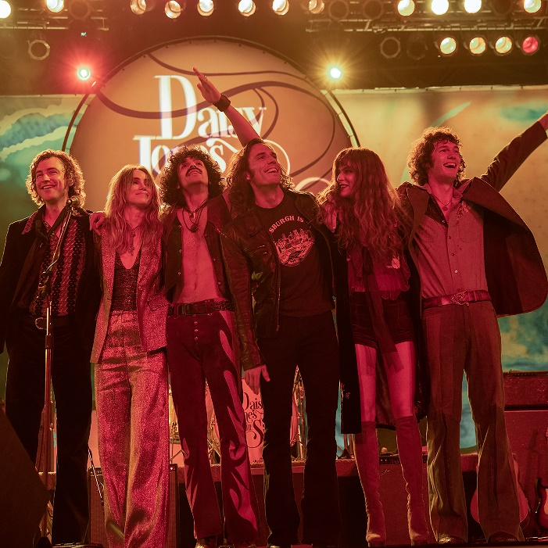
download hi-res artwork here

Atlantic Records is proud to release Daisy Jones & The Six’s “Special Gift For Our Fans,” a double single comprised of previously-unreleased tracks “It Was Always You” and “Aurora (Live from SNL)” – listen here. Both songs are lifted from the penultimate episode of the Prime Video limited series ‘Daisy Jones & The Six,’ which concluded its ten-episode rollout on the streaming platform last week.

Today’s release arrives in response to massive fan demand following the airing of the hit series’ final episodes.

Kevin Weaver (President, Atlantic Records, West Coast) shares: It’s been clear to all of us from the start, how passionate the fanbase is for Daisy Jones & The Six. Never was that more obvious than when the fans took to social media last week loudly campaigning for the releases of these 2 new songs that appeared in the series’ final episodes. In response to this overwhelming demand – and as a special gift to the band’s diehard fans – Atlantic Records couldn’t be more excited for this week’s release of “It Was Always You” and “Aurora (Live from SNL).”

Co-written and produced by GRAMMY®-winning songwriter, producer, and multi-instrumentalist Blake Mills (Bob Dylan, Fiona Apple, Alabama Shakes, John Legend, Perfume Genius), “It Was Always You” and “Aurora (Live From SNL)” are the latest additions to Daisy Jones & The Six’s growing catalog, which has been streamed over 50 million times thus far.

The band’s full-length album Aurora was produced in its entirety by Mills, with additional production from renowned producer Tony Berg (Phoebe Bridgers, Andrew Bird). Taken from page to screen to recording studio, it marks the storied debut LP from the titular band of Taylor Jenkins Reid’s beloved, New York Times bestselling novel Daisy Jones & The Six.

Aurora released to tremendous acclaim from critics and fans alike, debuting at #1 on Billboard’s Soundtracks chart, #4 on the Billboard Vinyl Albums & Americana/Folk Albums charts, #9 on Top Current Albums, #10 on Top Albums, and more. Daisy Jones & The Six themselves debuted at #1 on Billboard’s Emerging Artists chart – becoming the first act from a scripted series or film to do so. (They also became the first such act to hit #1 on the iTunes Top Albums chart.)

In addition to Aurora, today’s release follows the stunning Amazon Original version of “Look At Us Now (Honeycomb),” performed by Marcus Mumford & Maren Morris and out exclusively via Amazon Music (buy/listen here).

The original duet of “Look At Us Now (Honeycomb)” – featuring lead vocals from limited series co-stars Riley Keough and Sam Claflin – currently sits at the top of viral charts around the globe.

‘Daisy Jones & The Six’ debuted as the #1 Prime Video series earlier this month, and boasted a massive 1.5 billion social impressions within the first 3 days of the show’s rollout (watch all ten episodes of the limited series here). The highly-anticipated series arrived via Amazon Studios and Reese Witherspoon’s media company Hello Sunshine, who optioned Reid’s work in 2018 – before Daisy Jones & The Six ever even hit bookshelves. Upon the novel’s release in early 2019, it received coveted recognition as a ‘Reese’s Book Club Pick.’

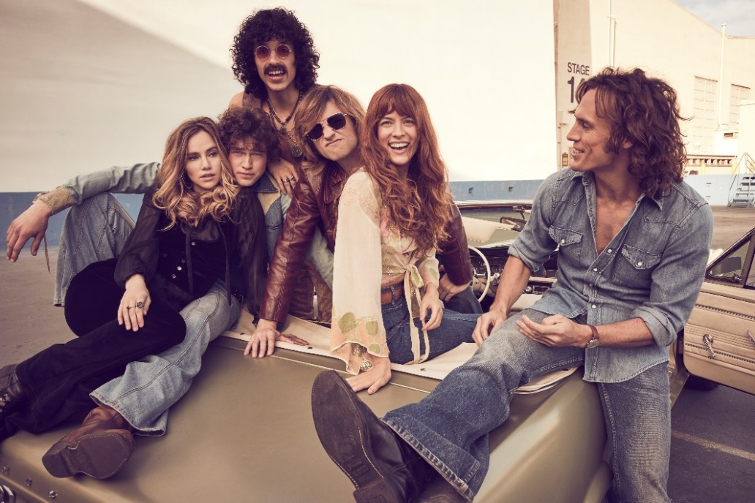
download hi-res photo here

With over 25 original songs, co-written by GRAMMY®-winning songwriter, producer, and multi-instrumentalist Blake Mills, Aurora and other music from throughout Daisy Jones & The Six boasts co-writing credits from several of the biggest names in music, including Marcus Mumford and Jackson Browne, with additional production from renowned record producer Tony Berg, and alongside instrumentalists from The Who, Nine Inch Nails, Pearl Jam, David Bowie, Elton John, Jeff Beck, The Wallflowers, and more. Other co-writers on Aurora include Chris Weisman, Ethan Gruska, and Z Berg, among others.

Mills – who also executive produced the music from the series – recorded the entirety of Aurora with Keough and Claflin at Sound City Studios. The iconic Van Nuys, CA space – now jointly run by Mills and Berg – also serves as the backdrop in both the book and limited series for the creation of the album.

***

DAISY JONES & THE SIX – AURORA TRACKLIST:
- Aurora
- Let Me Down Easy
- Kill You To Try
- Two Against Three
- Look At Us Now (Honeycomb)
- Regret Me
- You Were Gone
- More Fun To Miss
- Please
- The River
- No Words

ABOUT DAISY JONES & THE SIX – THE LIMITED SERIES:
Based on the best-selling novel by Taylor Jenkins Reid, Daisy Jones & The Six is a limited musical-drama series detailing the rise and precipitous fall of a renowned rock band. In 1977, Daisy Jones & The Six were on top of the world. Fronted by two charismatic lead singers—Daisy Jones (Riley Keough) and Billy Dunne (Sam Claflin)—the band had risen from obscurity to fame. And then, after a sold-out show at Chicago's Soldier Field, they called it quits. Now, decades later, the band members finally agree to reveal the truth. This is the story of how an iconic band imploded at the height of its powers.

The series stars Riley Keough as Daisy Jones, Sam Claflin as Billy Dunne, Camila Morrone as Camila Dunne, Will Harrison as Graham Dunne, Suki Waterhouse as Karen Sirko, Josh Whitehouse as Eddie Roundtree, Sebastian Chacon as Warren Rhodes, Nabiyah Be as Simone Jackson, and Tom Wright as Teddy Price, with a special guest appearance by Timothy Olyphant as Rod Reyes.

From Amazon Studios and Hello Sunshine, Daisy Jones & The Six is executive produced by Reese Witherspoon and Lauren Neustadter for Hello Sunshine and Brad Mendelsohn for Circle of Confusion. Scott Neustadter and Michael H. Weber created the series based on the novel by Taylor Jenkins Reid, who also produces. Scott Neustadter is executive producing and co-showrunning with Will Graham, who also serves as an executive producer. James Ponsoldt directed the first five episodes and serves as an executive producer, Nzingha Stewart directed four of the remaining episodes, and Graham directed one.

Daisy Jones & The Six premieres March 3, with new episodes released every Friday through March 24, exclusively on Prime Video in more than 240 countries and territories worldwide. For more information, visit the Amazon Studios Press Site.

***

CONNECT WITH DAISY JONES & THE SIX
WEBSITE | FACEBOOK | TWITTER | INSTAGRAM | YOUTUBE | TIKTOK

***

Atlantic Records Press Contact:
Libby Kober | Libby.Kober@atlanticrecords.com

Prime Video Press Contacts:
Melissa Armstrong | Melissa.Armstrong@amazonstudios.com
Kevin McAlpine | Kevin.McAlpine@amazonstudios.com
Reegan Smyth | Reegan.Smyth@amazonstudios.com

