DEATH CAB FOR CUTIE RELEASES ASPHALT MEADOWS (ACOUSTIC) – LISTEN HERE

CURRENT SINGLE “PEPPER” HITS #1 AT TRIPLE A + HEADED TO TOP 10 AT ALTERNATIVE – AFTER DEBUTING AS #1 MOST ADDED AT BOTH FORMATS

BAND NOW HAS 5TH MOST #1s IN TRIPLE A CHART HISTORY

UK/EU ASPHALT MEADOWS TOUR UNDERWAY; NORTH AMERICAN RUN SET FOR MAY + JUNE

20TH ANNIVERSARY CO-HEADLINE TOUR WITH THE POSTAL SERVICE KICKS OFF SEPT. 5 – HIGHLY-ANTICIPATED RUN ALMOST ENTIRELY SOLD-OUT

BUY/STREAM ASPHALT MEADOWS (ACOUSTIC) HERE
PRE-ORDER ASPHALT MEADOWS (ACOUSTIC) ON VINYL HERE
BUY/STREAM ASPHALT MEADOWS HERE

“Twenty-five years into its career, the band brings its incisive, anguished writing to a particularly 2022 brand of existential angst on its 10th album, ‘Asphalt Meadows’… an expansive album…” – THE NEW YORK TIMES

“If you haven’t heard yet, Death Cab for Cutie is back back… [their] best album in over a decade...” – VULTURE

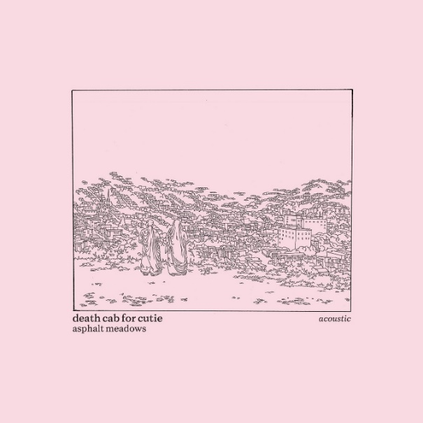
download hi-res acoustic album artwork here

8x GRAMMY® Award-nominated rock band Death Cab for Cutie has released Asphalt Meadows (Acoustic) (buy/stream here), a stripped-down take on their critically acclaimed 10th studio album Asphalt Meadows, released this past September via Atlantic Records.

The new LP was previewed by advance tracks “Foxglove Through The Clearcut (Acoustic),” “Pepper (Acoustic),” and a moving cover of “The Plan” – released in tribute to the late Mimi Parker, their close friend and drummer for the iconic band Low.

Co-produced by Andy Park (Pedro the Lion, Joseph, Noah Gunderson) and Death Cab for Cutie, Asphalt Meadows (Acoustic) is available to pre-order on vinyl here.

Of the new version of the record, the band shares: We recorded Asphalt Meadows (Acoustic) over 4 days in December 2022 with our friend Andy Park. Our goal was to reinterpret our latest album with the most minimal arrangements possible and present the songs in their rawest, most intimate forms. Some songs were able to take shapes similar to those on the proper album. Others required full re-engineering to snap into focus.

This week, the band is also celebrating their 8th #1 at Triple A radio with current single “Pepper” (the original studio version) moving into the top spot. As Billboard first reported, this slots the band into a tie for the fifth-most #1’s in the Adult Alternative Airplay chart’s 27-year history, alongside John Mayer.

Additionally, “Pepper” sits at #12 at Alternative radio, where it has been quickly ascending. Upon debuting at radio in mid-January, the track became the most added song at both the Alternative and Triple A formats.

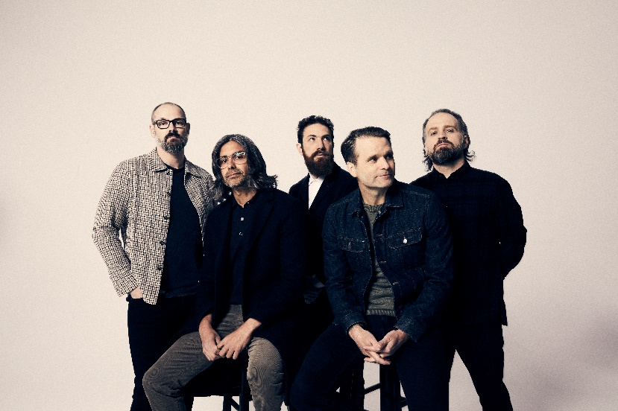
download hi-res press photo here; credit: Jimmy Fontaine

Death Cab for Cutie is currently in the midst of their UK/EU Asphalt Meadows tour, which includes stops in Berlin, Amsterdam, Dublin, and many other cities, before culminating with two nights in London [March 28th at Roundhouse + March 29th at Royal Albert Hall]. The third North American leg of the Asphalt Meadows tour will commence May 31st in Indianapolis.

This fall, Death Cab for Cutie and The Postal Service will embark on their highly-anticipated co-headline tour, celebrating the 20th anniversaries of each band’s seminal 2003 record, Transatlanticism and Give Up, respectively. Last month, the iconic bands – both fronted by lead vocalist and guitarist Ben Gibbard – added a third night in Denver, CO at Mission Ballroom, as well as brand new dates in Austin, TX and Grand Prairie, TX.

Also last month, Warpaint and The Beths were added as support on select dates, while Built to Spill is set to support the second LA show at the Hollywood Bowl [October 15th] and Iron & Wine – known for their beloved rendition of The Postal Service’s “Such Great Heights” – will kick off the third and final Hollywood Bowl date [October 17th], which will also mark the culmination of the historic tour.

Having been named one of GQ’s “12 Pop Culture Releases We’re Most Looking Forward to in 2023” and of the “23 concerts and albums” the Los Angeles Times is “most excited for in 2023,” the full co-headline tour is almost entirely sold-out.

All upcoming ticketing information can be accessed here.

***

ASPHALT MEADOWS (ACOUSTIC) – TRACKLIST:
- I Don’t Know How I Survive (Acoustic)
- Roman Candles (Acoustic)
- Asphalt Meadows (Acoustic)
- Rand McNally (Acoustic)
- Here to Forever (Acoustic)
- Foxglove Through The Clearcut (Acoustic)
- Pepper (Acoustic)
- I Miss Strangers (Acoustic)
- Wheat Like Waves (Acoustic)
- Fragments From the Decade (Acoustic)
- I’ll Never Give Up On You (Acoustic)
- The Plan

***

DEATH CAB FOR CUTIE | 2023 ASPHALT MEADOWS HEADLINE TOUR DATES

MARCH
10 – Tilburg, Netherlands – 013 *
11 – Amsterdam, Netherlands – Paradiso * – SOLD OUT
12 – Cologne, Germany – E-Werk * – LOW TICKETS
14 – Antwerp, Belgium – De Roma * – SOLD OUT
15 – Luxembourg, Luxembourg – Den Atelier *
16 – Paris, France – Salle Pleyel *
18 – Nottingham, United Kingdom – Rock City * – LOW TICKETS
19 – Dublin, Ireland – Bord Gáis Energy Theatre * – SOLD OUT
21 – Birmingham, United Kingdom – O2 Institute *
22 – Edinburgh, United Kingdom – Usher Hall *
23 – Glasgow, United Kingdom – Barrowland * – LOW TICKETS
25 – Manchester, United Kingdom – O2 Apollo * – LOW TICKETS
27 – Brighton, United Kingdom – Dome * – LOW TICKETS
28 – London, UK – Roundhouse * – LOW TICKETS
29 – London, United Kingdom – Royal Albert Hall * – SOLD OUT

MAY
31 – Indianapolis, IN – TCU Amphitheater at White River State Park ^

JUNE
2 – Toronto, ON – Massey Hall ^ – LOW TICKETS
3 – Toronto, ON – Massey Hall ^ – LOW TICKETS
4 – Cleveland, OH – Agora Theatre ^ – SOLD OUT
6 – Milwaukee, WI – Riverside Theater ^ – LOW TICKETS
7 – Omaha, NE – The Admiral ^ – SOLD OUT
9 – Salt Lake City, UT – Venue TBA ^
10 – Missoula, MT – KettleHouse Amphitheater ^
12 – Calgary, AB – Grey Eagle Resort and Casino – Grey Eagle Event Centre ^ – SOLD OUT
14 – Vancouver, BC – Commodore Ballroom – SOLD OUT
15 – Vancouver, BC – Commodore Ballroom – SOLD OUT
16 – Troutdale, OR – McMenamins Edgefield Amphitheatre ^ – SOLD OUT
17 – Bend, OR – Hayden Homes Amphitheater ^

DEATH CAB FOR CUTIE x THE POSTAL SERVICE | 2023 CO-HEADLINE TOUR DATES

SEPTEMBER
5 – Washington, DC – The Anthem – SOLD OUT
6 – Washington, DC – The Anthem – SOLD OUT
8 – Portland, ME – Cross Insurance Arena – SOLD OUT
9 – Kingston, RI – Ryan Center – SOLD OUT
10 – New Haven, CT – Westville Music Bowl – LOW TICKETS
12 – Boston, MA – MGM Music Hall at Fenway – SOLD OUT
13 – Boston, MA – MGM Music Hall at Fenway – SOLD OUT
14 – Washington, DC – Merriweather Post Pavilion – SOLD OUT
17 – Detroit, MI – Meadow Brook Amphitheater # – SOLD OUT
19 – New York, NY – Madison Square Garden # – SOLD OUT
20 – New York, NY – Madison Square Garden # – SOLD OUT
21 – Philadelphia, PA – Mann Center for the Performing Arts # – SOLD OUT
24 – Minneapolis, MN – The Armory # – SOLD OUT
26 – Denver, CO – Mission Ballroom # – SOLD OUT
27 – Denver, CO – Mission Ballroom # – SOLD OUT
28 – Denver, CO – Mission Ballroom # – SOLD OUT
30 – Austin, TX – Germania Insurance Amphitheater & – SOLD OUT

OCTOBER
1 – Grand Prairie, TX – Texas Trust CU Theatre & – LOW TICKETS
3 – Phoenix, AZ – Arizona Financial Theatre & – SOLD OUT
4 – Las Vegas, NV – The Theater at Virgin Hotels & – SOLD OUT
6 – Seattle, WA – Climate Pledge Arena & – SOLD OUT
7 – Seattle, WA – Climate Pledge Arena & – SOLD OUT
9 – Berkeley, CA – Greek Theatre – UC Berkeley & – SOLD OUT
10 – Berkeley, CA – Greek Theatre – UC Berkeley & – SOLD OUT
11 – Berkeley, CA – Greek Theatre – UC Berkeley & – SOLD OUT
13 – Los Angeles, CA – Hollywood Bowl & – SOLD OUT
15 – Los Angeles, CA – Hollywood Bowl % – SOLD OUT
17 – Los Angeles, CA – Hollywood Bowl @

* w/ Special Guest Slow Pulp
^ w/ Special Guest Lomelda
# w/ Special Guest Warpaint
& w/ Special Guest The Beths
% w/ Special Guest Built to Spill
@ w/ Special Guest Iron & Wine

***

CONNECT WITH DEATH CAB FOR CUTIE
DEATHCABFORCUTIE.COM | FACEBOOK | TWITTER | INSTAGRAM | YOUTUBE | TIKTOK

