FOR IMMEDIATE RELEASE
MARCH 3, 2023

FINESSE2TYMES RETURNS 90 DAYS LATER WITH DELUXE EDITION OF
DEBUT MIXTAPE

ACCOMPANIED BY AN OFFICIAL VISUAL FOR “HOW TO ACT”

INCLUDES 6 NEW TRACKS WITH FEATURES FROM KEVIN GATES, 2 CHAINZ, AND NARDO WICK

HIT RECORD “BACK END” HAS AMASSED OVER 60M AUDIO STREAMS AND 50M VIEWS WHILE SPENDING 5TH CONSECUTIVE WEEK ON BILLBOARD’S HOT 100

SET TO PERFORM AT BEALE STREET MUSIC FESTIVAL ON SATURDAY, MAY 6TH &
BROCCOLI CITY FEST ON SATURDAY, JULY 15TH

DOWNLOAD/STREAM 90 DAYS LATER
WATCH/SHARE “HOW TO ACT”

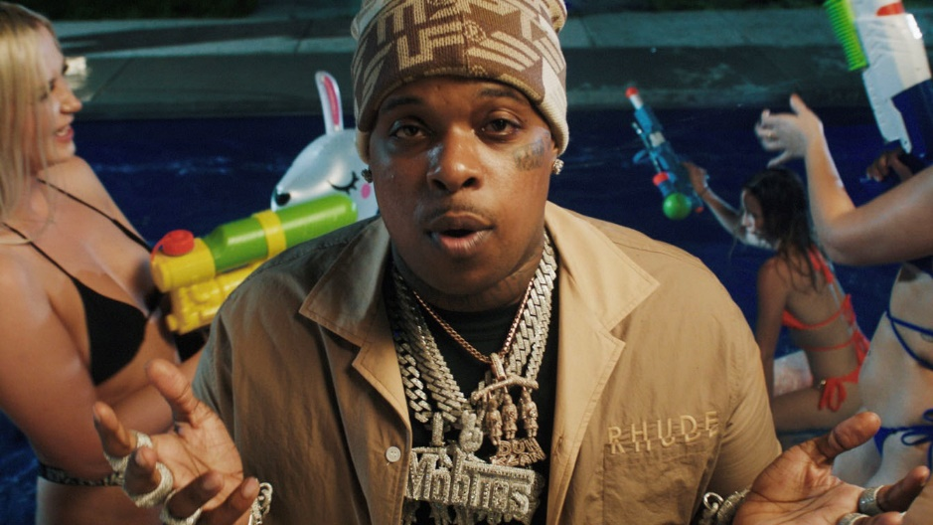

“Packed with an authenticity that can’t be bought and the hunger of a new rapper, Finesse2tymes came out swinging.”
- XXL

“…the hunger is undeniable.”
- PITCHFORK

Today, Memphis rising star Finesse2tymes, has officially released the deluxe version of his debut mixtape, 90 DAYS LATER, 90 days after the original’s release. The deluxe arrives with 6 new tracks and includes features from Kevin Gates, 2 Chainz and Nardo Wick (full tracklisting below) and is accompanied by an official visual for “How To Act” and the recently released “Out of State.” Finesse will also be seen at Beale Street Music Festival on Saturday, May 6th in Memphis, TN and Broccoli City Festival on Saturday, July 15th in Washington, D.C. Tickets for both are available for purchase now.

DOWNLOAD/STREAM 90 DAYS LATER
WATCH/SHARE “HOW TO ACT”

The original 90 DAYS mixtape has amassed over 200M audio streams while the visuals have collected over 180M views thus far. The project was met with praise as Pitchfork highlighted standout record “Finesse Duh P” (3M+ views) as their “must-hear rap song of the day” and XXL stamped him as “a Memphis rapper whose pointed and intricate rap flows made him a standout artist in a packed scene.” His viral earworm “Back End” now has over 60M audio streams, over 50M views, peaked at #8 on YouTube’s Top Music Videos and currently in the top 5 at Urban Radio. The record earned him his first career entry on Billboard’s Hot 100 and has now spent its 5th consecutive week on the chart. Finesse has also released two special editions of 90 DAYS, ChopNotSlop and Sped-Up, both available for streaming now.

Finesse was named as Apple Music’s Hip-Hop Artist To Watch for 2023, Amazon Music’s 2023 Breakthrough Artist To Watch, and Spotify’s Most Necessary Artist Of 2023. He also recently debuted his Uproxx Sessions performance of his hit single “Back End” and his VEVO CTRL performance of “Overdose” and “Back End.” Audiomack stamped Finesse as one of “10 Rappers You Should Know Right Now.”
His highly anticipated debut mixtape was representative of the fundamental 90 days since his release from prison in July of 2022. From dropping several singles that instantly skyrocketed to finalizing his deal with Mob Ties/Bread Gang/Atlantic Records around his 90th day of release. 90 DAYS LATER continues to be a representation of his relentless pursuit of success in the rap game and beyond. He has now accumulated over 190M+ audio streams and 220M+ collective YouTube views thus far.
# # #

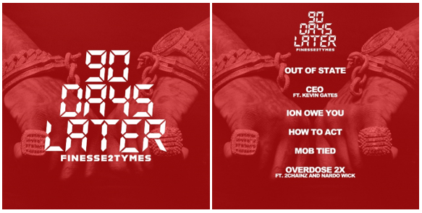
DOWNLOAD HI-RES ARTWORK

90 DAYS LATER
- Out of State
- CEO ft. Kevin Gates
- Ion Owe You
- How to Act
- Mob Tied
- Overdose 2X ft. 2 Chainz & Nardo Wick
- Goin’ Straight In 2 (Intro)
- Outside
- Get Even
- Finesse Duh P
- Rules To The Streets
- Still Wit It (Feat. Tay Keith)
- Back End
- Nobody (Feat. Gucci Mane)
- Lil Baby
- Overdose
- Black Visa (Feat. Moneybagg Yo)
- Humble
- If You Still Wit Me (Feat. Lil Baby)
- Summo
- Go
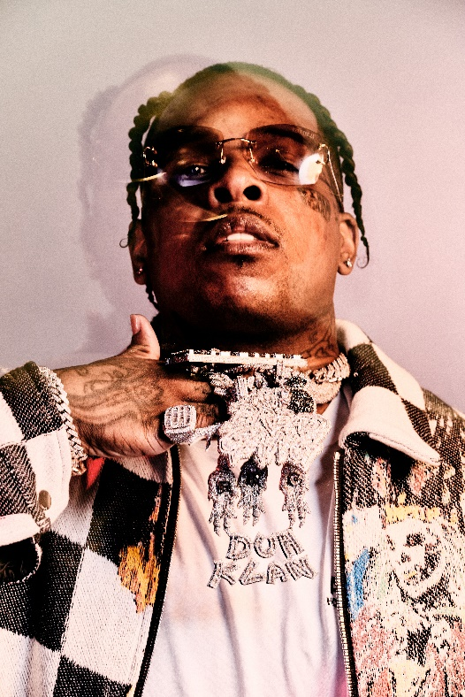
DOWNLOAD HI-RES PRESS PHOTOS

FINESSE2TYMES
It took rapper Finesse2tymes just 90 days to remix his life, following five years in prison. The Memphis, Tennessee native not only repaired broken relationships, but he inked a deal with Mob Ties/Atlantic Records and recorded arguably some of the best music in his career. The culmination of that time is his upcoming project 90 Days. Finesse has weathered the storm, changed his stars, and is now geared for his place in the sun.

Born and raised on the East Side of Memphis, most of Finesse’s young adulthood was surrounded by the walls of a prison cell. His first prison stint happened at 14 and he was in and out of prison until his most recent release. At 21, he started formally making music, forming a collective called Memphis Greatest Underrated with several local artists including Blac Youngsta and Moneybagg Yo. The crew released a self-titled EP in 2019 while Finesse was serving his final stint in prison as the group disbanded. While away, Finesse perfected his craft, writing rhymes and plotting his next moves to ensure this prison sentence will be his last. He found a way to keep track of the major players in the industry who followed his music. Among them was Mob Ties Founder and CEO J Prince Jr., son of legendary Rap-A-Lot kingpin J. Prince, who later signed him. At the top of July 2022, Finesse left prison and boarded a private jet bound for Houston. The start of his new life had finally begun.

He dropped the menacing “Get Even” within the first week of his release, cracking the 30 million mark in views on YouTube alone. He chased it with “Back End,” showcasing a more sophisticated style that still harbored his gruff delivery. He even mended fences with Moneybagg Yo, surprising fans everywhere with their collaborative “Black Visa” track and informally inaugurating his signing with Bagg’s Bread Gang. Few can comprehend Finesse’s hustle, yet it’s a combination of age, experience, understanding, and healing. Finesse2Tymes has long plotted on the release of 90 Days, an autobiographical work that will run the gamut of his life and career. The work will undoubtedly secure Finesse’s place in rap stardom, though for him, his goal is even bigger than music; it’s to change lives.

CONNECT WITH FINESSE2TYMES
TWITTER | INSTAGRAM| TIKTOK| FACEBOOK| YOUTUBE

PRESS CONTACT
SELAM BELAY SELAM.BELAY@ATLANTICRECORDS.COM

