FOR IMMEDIATE RELEASE
MARCH 22, 2023

JAYSON CASH LIGHTS UP APPLE MUSIC WITH
INCENDIARY “FIRE IN THE BOOTH” FREESTYLE

CARSON, CA RAPPER SHOWS OFF EXPLOSIVE LYRICAL SKILLS ON
APPLE MUSIC’S WORLD FAMOUS CHARLIE SLOTH RAP SHOW

WATCH “FIRE IN THE BOOTH” FREESTYLE NOW AT APPLE MUSIC HERE

YOUTUBE PREMIERE SET FOR THURSDAY, MARCH 23 AT 2:00 PM (ET)

APPLE MUSIC’S CHARLIE SLOTH RAP SHOW AIRS SATURDAY, MARCH 25 AT 3:00 PM (ET)

BRAND NEW 3-PACK PROJECT, SOME MORE OF IT, AVAILABLE NOW VIA ATLANTIC RECORDS

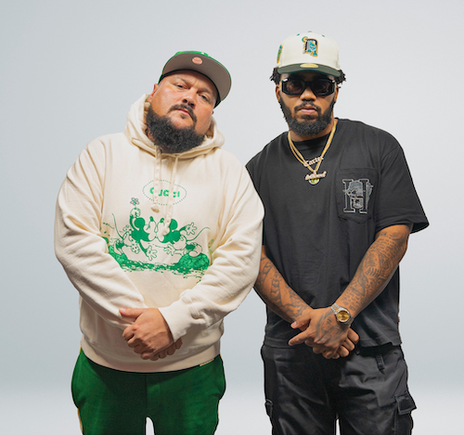
DOWNLOAD HI-RES IMAGES HERE

“One of the hottest new artists in West Coast hip hop.” – THE SOURCE

“One of the most exciting artists in the industry right now.” – LYRICAL LEMONADE

Carson, CA-based rapper Jayson Cash is displaying his critically acclaimed skills with an explosive new “Fire In The Booth” freestyle, streaming now on Apple Music HERE. The dynamic improvisation will have its official YouTube premiere on Thursday, March 23 at 2:00 pm (ET)/11:00 am (PT), followed with its debut on Apple Music’s world-famous Charlie Sloth Rap Show, airing Saturday, March 25 at 3:00 pm (ET)/12 noon (PT).

Cash – who is currently starring on the cover of Apple’s hugely influential “Charlie Sloth Fire In The Booth” playlist – recently shared his first release of 2023, Some More Of It, available now via Atlantic Records at all DSPs and streaming services HERE. Highlights of the 3-pack project include the dynamic title track, “Some More Of It,” joined by an official music video – directed by award-winning filmmaker Devone X. King and featuring a cameo by the legendary Bishop Don Magic Juan – streaming now at YouTube HERE.

Some More Of It marks the follow-up to last winter’s harmonious hit single, “Okay Okay,” produced by long-time collaborators Tha Eastie Boyz (Blxst, Schoolboy Q, Ty Dolla $ign) and accompanied by an official visual directed by Favor Films now boasting close to 6M views HERE.

Last year saw the acclaimed arrival of Cash’s Atlantic Records debut mixtape, Read The Room, showcasing such smash singles as the Mustard-produced “Top Down,” “Him (Feat. Dom Kennedy),” “Priority (Feat. Blxst),” and “Selfish (Feat. Major Myjah),” the latter joined by an official music video, inspired by classic scenes from director John Singleton’s 2001 film, Baby Boy, streaming via YouTube HERE.

Cash – whose label signing was announced with an exclusive feature in Billboard – took to his socials shortly after the release of Read The Room to kick off his own version of Freestyle Fridays, dropping 14 freestyles on Instagram backed by a wide range of classic beats – spanning Kendrick Lamar, Mobb Deep, and The Notorious B.I.G. to YG, EST GEE, and The Game – all streaming now on YouTube HERE.

Hailed by FLOOD as a “standout lyricist,” Cash lit up last fall’s BET Hip Hop Awards in Atlanta, GA with a show-stealing freestyle during the award ceremonies’ annual cypher. Highlights from the cypher – featuring Reuben Vincent, Sa-Roc, Guapdad 4000, Big Boss Vette and fellow Carson, CA native, DJ HED spinning for all the cypher moments throughout the show – can be viewed HERE.

Other 2022 highlights include an appearance on Sway’s Universe Cypher (streaming HERE), as well as electrifying freestyles across platforms such as A Trip To The Corner Store (watch HERE), Real 92.3 LA’s Bootleg Kev & DJ Hed (watch HERE), and Power 106 Los Angeles’ LA Leakers (watch HERE), the latter of which has earned more than 32K views via YouTube and sees Cash rapping over Jermaine Dupri’s “Money Ain’t A Thang” and Snoop Dogg’s “Still A G Thang.” In addition, he’s dropped freestyles direct from his car including verses over Jack Harlow’s “First Class” (watch HERE), Buddy’s “Wait Too Long (Feat. Blxst)” (watch HERE), and Suga Free’s “I’d Rather Give You My Bitch” (watch HERE). What’s more, after local LA magazine, A Day In LA, dropped their “LA Rap Report Card” and gave Jayson a “D+,” instead of being salty about the grade, he jumped in the booth (watch HERE) forcing the Editor-In-Chief of the magazine to respond in fun. Mustard soon stepped up to stan the freestyle as a new fan and “Top Down” was created. Cash later sat down with the EIC for A Day In LA podcast to discuss the grade (watch HERE).

# # #

CONNECT WITH JAYSON CASH
INSTAGRAM | TWITTER | FACEBOOK | SNAPCHAT | YOUTUBE

PRESS CONTACT
BRITTANY.BELL@ATLANTICRECORDS.COM

# # #

