For Immediate Release
MARCH 3, 2023

Jax returns with “Cinderella snapped”

Hotly anticipated follow-up to global smash single “Victoria’s Secret” available now via Atlantic Records

Summer tour with Big Time Rush kicks off June 22 in Fort Worth, TX

Nominated for ‘Best New Pop Artist’ at 2023 iHeartRadio Music Awards

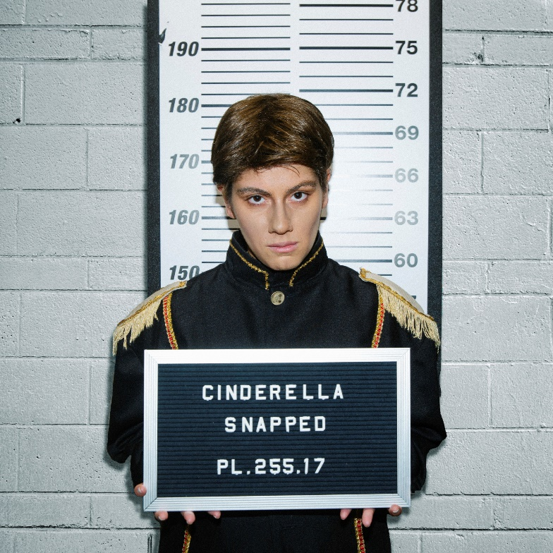
DOWNLOAD HIGH-RES ART/IMAGES

STREAM “Cinderella Snapped”: LINK

Multi-talented singer-songwriter Jax makes her explosive return with new single “Cinderella Snapped” – available now via Atlantic Records. Far from a fairytale, the track serves as a resilient anthem (akin to her global smash hit “Victoria’s Secret”) against the societal norms forced upon us.

“I wanted to write a song from Cinderella’s perspective, if she and all the princesses rewrote their stories and burned the fairytale system down. My intention was to throw a little dose of equality into the stories I grew up with. I always wondered how it would have shaped who I was if all the princesses I looked up to had more purpose than being saved by a prince.” – JAX

Jax had nothing short of an incredible 2022, highlighted by the meteoric rise of her RIAA-certified Gold single “Victoria’s Secret.” The explosive song proved an incredible viral sensation, garnering over 267 million global streams since release, her debut entry on the Billboard Hot 100, and peaks of #9 on Top 40 and #2 on Hot AC radio. Originally shared on TikTok as part of her viral “The Kid I Babysit” series, Jax wrote “Victoria’s Secret” as an ode to body positivity and anti-bullying. Her personal take and blunt honesty quickly resonated with her followers and beyond, sparking a movement that ultimately garnered a response from the company itself. She’s since performed the song live on The TODAY Show, The Drew Barrymore Show, Dick Clark’s Rockin’ New Year’s Eve and at the 2022 iHeartRadio Music Festival in Las Vegas, in addition to joining the line-up for iHeartRadio’s 2022 Jingle Ball tour (including stops at Madison Square Garden in New York City and The Kia Forum in Los Angeles). 2022 also saw Jax take home the iHeartRadio Music Award for TikTok Songwriter of the Year, in addition to a nomination for Best New Pop Artist at the upcoming 2023 iHeartRadio Music Awards.

This summer, Jax will hit the road in support of Big Time Rush’s North American Can’t Get Enough Tour – kicking off June 22nd in Fort Worth, TX and running through mid-August. For full routing, visit jaxwritessongs.com.

“Cinderella Snapped” and “Victoria’s Secret” mark the latest in a catalog of fan-favorite singles from Jax – including her heartwarming ballad “Like My Father” which has amassed over 230 million streams and was crowned amongst “the best father-daughter dance songs of all time” by The Knot. Meanwhile, her nostalgia-fueled anthem “90s Kids” received over 1 million weekly streams for 21 consecutive weeks, swooning single “To All The Boys I’ve Loved Before” was deemed “a viral hit” by Billboard, and label-debut single “Ring Pop” yielded high-profile appearances on The Ellen DeGeneres Show, Access Hollywood & more.

Raised in New Jersey by way of New York, Jax got her start by performing a wide variety of genres and in bands growing up. At the age of 18, she developed cancer above her vocal cords, which returned following a couple months of remission right as she relocated to Los Angeles in pursuit of her music. Left unable to sing herself, Jax turned to songwriting for others and found industry success behind-the-scenes.

As her ability to perform returned, Jax needed to pivot yet again when the COVID-19 pandemic struck. This time she turned to TikTok, posting a hilarious response to the pop gem “Stacy’s Mom” from “Stacy’s Mom’s Perspective” which exploded with nearly 9 million views in just a few months and follow-ups including “Update from Avril Lavigne & Sk8er Boi 18 years later.” She continued to go viral a dozen or more times over, having now amassed over 13.4 million followers on the platform and over 228 million “likes” to date. With a massive online audience under her belt, Jax began sharing her own original music in late 2020 to an overwhelmingly positive response and now over 747 million global career streams.

DOWNLOAD HIGH-RES ART/IMAGES

CONNECT WITH JAX:
TikTok | YouTube | Instagram | Twitter | Facebook | Press Assets

CONTACT:
Ted Sullivan | ted.sullivan@atlanticrecords.com

