FOR IMMEDIATE RELEASE
MARCH 17, 2023

ATLANTA’S RISING STAR RETURNS WITH HER FIRST 2023 RELEASE
“AREA CODES”
FOLLOW-UP TO THE PREVIOUSLY RELEASED SINGLE “BOUT U”
KALI IS NOW BOASTING OVER 140M STREAMS TO DATE AND OVER 60M VIEWS
STREAM HERE
Rising Atlanta, GA rap star Kali is back with her first single of the year, “Area Codes” with production from YG! Beats and Tate Kobang. In "Area Codes" Kali gives fans a glimpse into her roster of guys in different area codes. Originally teased at the end of January, the TikTok sound currently has over 10K+ creates and the original Twitter teaser has over 1.5M+ views. This song is something fun for the girls and the perfect anthem for the summer. This single serves as the official follow up to her last single of 2022, “Bout U.”
# # #

KALI
Kali’s had a landmark year with 2022. After the release of her highly acclaimed EP Toxic Chocolate, Kali was admitted into the XXL 2022 Freshman Class. This momentous, career-defining feat was supported by her thrilling freestyle and cypher performances streaming now. She continued her run with the release of the singles “FNF (Freestyle)” and “Wet” with each visual at over a combined 1M views via YouTube. Toxic Chocolate – available now at all DSPs and streaming services – arrived earlier in 2022 amidst both popular and critical acclaim, with Hot New Hip Hop simply declaring her “Rap's Next ‘It’ Girl.” The EP is highlighted by the incendiary singles, “UonU (Feat. Yung Bleu)“ and “Standards,” the latter of which had its exclusive premiere – alongside Kali’s debut interview – on Apple Music’s New Music Daily Radio with Zane Lowe. Kali then increased the power of Toxic Chocolate with the surprise addition of the fan favorite “Chainzzz (Feat. Muni Long)” as well as a revised sequence.

The arrival of Toxic Chocolate was further joined by an electrifying performance of the EP standout, “New Day,” filmed exclusively for UPROXX Sessions and streaming now HERE. UPROXX further praised Kali for “her gift for wordplay and her spicy relationship sensibilities,” adding, “(Kali) turns the tables on the f*ckboys of hip-hop, using their manipulative tactics to even the odds and give them a taste of their own medicine.” After raking in over 100 million streams and receiving praise from Nylon, HIGHSNOBIETY, XXL, Essence, Complex, Brooklyn Vegan, Kali is ready to take her career to new heights with a new love, new music, and a new focus.
# # #
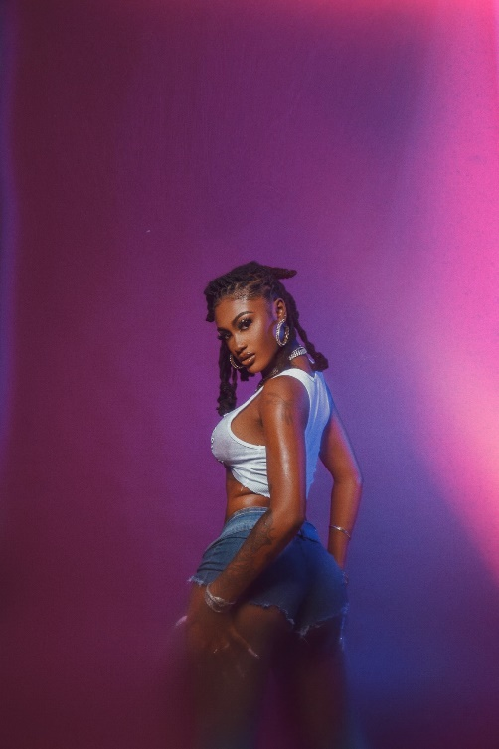

CONNECT WITH KALI
TIKTOK | TWITTER | INSTAGRAM | FACEBOOK | YOUTUBE

PRESS CONTACT
Ariana White | Ariana.White@AtlanticRecords.com

