FOR IMMEDIATE RELEASE
FEBRUARY 10, 2023

KEVIN GATES IS READY TO SERVE “BREAKFAST” ON HIS NEW SINGLE
ACCOMPANIED BY COMPANION VISUAL STREAMING NOW
STEAMY VISUAL FEATURES LONG-TIME PARTNER DREKA AS THE LEADING LADY
COMES ON THE HEELS OF THE RE-RELEASE OF THE LUCA BRASI STORY (A DECADE OF BRASI) IN CELEBRATION OF THE PROJECT’S 10th ANNIVERSARY
THE OFFICIAL KEVIN GATES DISCORD SERVER IS NOW LIVE
DOWNLOAD/STREAM “BREAKFAST”
WATCH/SHARE “BREAKFAST”
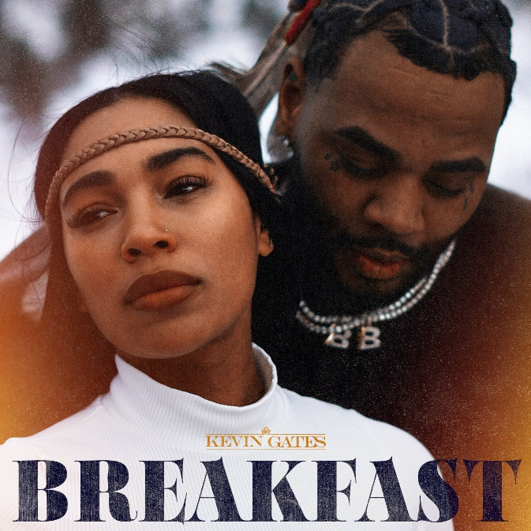
DOWNLOAD HI-RES ARTWORK

RIAA multi-platinum certified rap superstar, Kevin Gates, is back to celebrate his birthday with the release of his first single for 2023, “Breakfast” via Bread Winner Alumni/Atlantic Records. The single features production from DJ Chose, Charley Cooks, & WZRD BLVD with visual direction by Gerard Victor of Shot Selection. The track is a seductive, energy packed record right on time for Valentine’s Day and the accompanying visual features Kevin’s partner, Dreka, as the leading lady for the sultry track. The release of “Breakfast” comes just on the heels of last week’s re-release of The Luca Brasi Story (A Decade of Brasi) in celebration of the 10-year anniversary of the debut project. Last week also saw the launch of official Kevin Gates Discord server.
ABOUT KEVIN GATES

Kevin Gates transformed into one of the most impactful and inimitable rappers in the game by simply being Kevin Gates. Nearly 15 years into an unbelievable career, he doesn’t chase trends. He doesn’t censor himself. He doesn’t hold back. Instead, he speaks his mind and fulfills every promise. It’s why the Baton Rouge, LA native has racked up over 6 billion streams, 6 billion views, and dozens of multiplatinum, platinum, and gold certifications. It’s why his 2013 song “Thinking With My Dick” reached Billboard’s Hot 100 for the first time in 2022 and became #1 overall sound on TikTok. It’s why he’s logged four Top 5 entries on the Billboard Top 200 in addition to seven Top 5 entries on both the Top Rap Albums Chart and the Top R&B/Hip-Hop Albums Charts. It’s why he’s sold out successive headline tours, delivered show-stopping sets at Rolling Loud and JMBLYA, and ignited arenas with Cardi B. It’s why he’s received various high-profile award nominations. It’s why he’s reached rarified air, emerging as second best-selling hip-hop artist of 2016 only behind Drake. It’s why he’s also spawned countless think pieces. Among those, Pitchfork described 2019’s gold-certified I’m Him as “another showcase for the Baton Rouge rapper’s fully formed and gloriously weird personality” and praised, “The hooks are magnificent, his most boisterous and fine-tuned since Islah.” As always, he doesn’t compromise on 2021’s Only The GeneralsPart II [Bread Winner Alumni/Atlantic Records] and more music on the horizon. He’s only gotten better at being Kevin Gates. Kevin continues his reign with the release of his third full length LP, KHAZA. Since the album’s release Kevin has released several singles to keep the momentum building including: “Big Lyfe,” “Bad For Me,” “Intro,” “Metro,” “Major League,” and his explosive “Super General (Freestyle).” The album was supported by his KHAZA national tour with several sold out dates across the country, first kicking off in Dallas, TX.

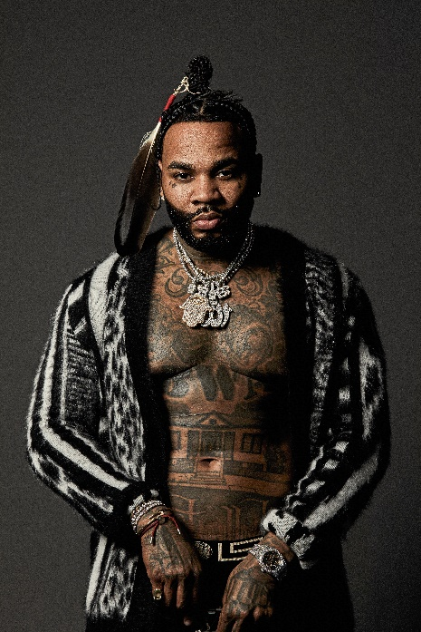

CONNECT WITH KEVIN GATES
WEBSITE | TWITTER | TIKTOK | INSTAGRAM | FACEBOOK | SOUNDCLOUD | YOUTUBE

FOR KEVIN GATES INQUIRIES, CONTACT
SYDNEY.MARGETSON@ATLANTICRECORDS.COM

