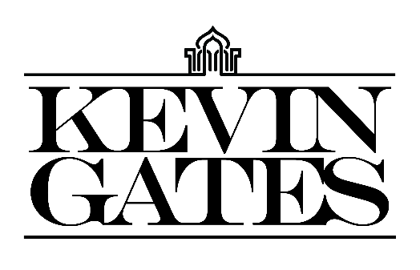

BOILER:
Kevin Gates transformed into one of the most impactful and inimitable rappers in the game by simply being Kevin Gates. Nearly 15 years into an unbelievable career, he doesn’t chase trends. He doesn’t censor himself. He doesn’t hold back. Instead, he speaks his mind and fulfills every promise. It’s why the Baton Rouge, LA native has racked up over 6 billion streams, 6 billion views, and dozens of multiplatinum, platinum, and gold certifications. It’s why his 2013 song “Thinking With My Dick” reached Billboard’s Hot 100 for the first time in 2022 and became #1 overall sound on TikTok. It’s why he’s logged four Top 5 entries on the Billboard Top 200 in addition to seven Top 5 entries on both the Top Rap Albums Chart and the Top R&B/Hip-Hop Albums Charts. It’s why he’s sold out successive headline tours, delivered show-stopping sets at Rolling Loud and JMBLYA, and ignited arenas with Cardi B. It’s why he’s received various high-profile award nominations. It’s why he’s reached rarified air, emerging as second best-selling hip-hop artist of 2016 only behind Drake. It’s why he’s also spawned countless think pieces. Among those, Pitchfork described 2019’s gold-certified I’m Him as “another showcase for the Baton Rouge rapper’s fully formed and gloriously weird personality” and praised, “The hooks are magnificent, his most boisterous and fine-tuned since Islah.” As always, he doesn’t compromise on 2021’s Only The GeneralsPart II [Breadwinners Association/Atlantic Records] and more music on the horizon. He’s only gotten better at being Kevin Gates. Kevin continues his reign with the release of his third full length LP, KHAZA. Since the album’s release Kevin has released several singles to keep the momentum building including: “Big Lyfe,” “Bad For Me,” “Intro,” “Metro,” “Major League,” and his explosive “Super General (Freestyle).” The album was supported by his KHAZA national tour with several sold-out dates across the country, first kicking off in Dallas, TX. Kevin kicked off 2023 with the official DSPs release of his debut mixtape, The Luca Brais Story (A Decade of Brasi). He immediately followed up with the stand-alone release of his “Breakfast” single with the visual featuring his longtime partner, Dreka, as the leading lady.

