FOR IMMEDIATE RELEASE
FEBRUARY 06, 2023

GLOBAL SUPERSTAR LIL UZI VERT’S SMASH HIT “JUST WANNA ROCK” REACHES PLATINUM STATUS
THE COMPANION VISUAL IS NOW AT OVER 50M VIEWS
THE SINGLE HAS NOW AMASSED OVER 158M AUDIO STREAMS
LAST NIGHT THE RAP PHENOM CLOSED OUT THE 50TH YEAR CELEBRATION OF HIP HOP AT THE 65TH GRAMMY AWARDS
“JUST WANNA ROCK” IS NOW THE UNOFFICIAL ANTHEM FOR THE PHILADELPHIA EAGLES
PREVIOUSLY RELEASED SINGLE “XO TOUR LLIF3” WAS ALSO CERTIFIED DIAMOND BY THE RIAA LAST DECEMBER
WATCH LIL UZI VERT WALK OUT WITH THE TEAM DURING THEIR LAST GAME
WATCH DJ DRAMA COSIGN THE SINGLE AS THE TEAM’S UNOFFICIAL ANTHEM
WATCH/SHARE “JUST WANNA ROCK”
DOWNLOAD/STREAM “JUST WANNA ROCK”
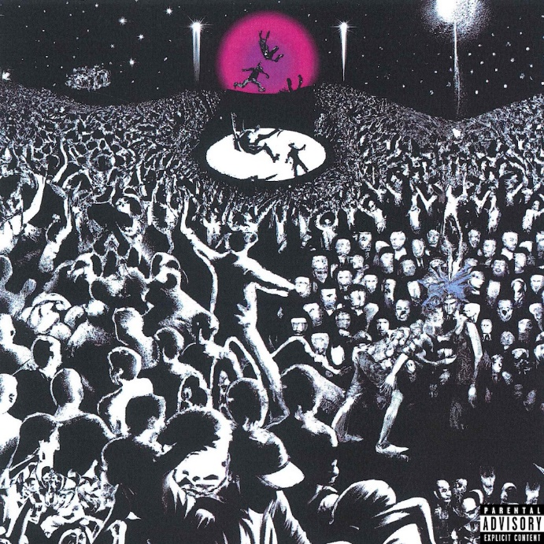
DOWNLOAD HI-RES ARTWORK

Today, Grammy nominated artist Lil Uzi Vert’s smash hit “Just Wanna Rock” was certified platinum by the RIAA. The platinum selling single has seen huge success since its release late last year with support via the viral dance across social media and the accompanying visual (50M+ views). “Just Wanna Rock” is also having a massive cultural moment as the unofficial anthem for the Philadelphia Eagles. Uzi can be seen here walking out with the team during their last game to the song and hip-hop legend DJ Drama can be heard here confirming the sentiment. Last night, the rap phenom closed out the 50th year of hip hop celebration at the 65th Grammy Awards along some of hip-hop’s greats including LL Cool J and The Roots. This past December, their previously released single “XO Tour Llif3” was certified diamond by the RIAA. Uzi is expected to continue performing the massive hit at their upcoming festival performances and headlining tour.

ABOUT LIL UZI VERT

In addition to Lil Uzi Vert’s 2018 Grammy nomination as “Best New Artist”, the artist also received the “Breakout Artist of the Year Award” and the “Breakthrough Artist” award during Billboard’s 2017 Touring Awards. The rap superstar has also been featured on several record-breaking tracks including Travis Scotts’ RIAA 3X platinum certified “Wasted” featuring Kanye West, the RIAA gold certified single with Future “Drankin and Smokin” and Lil Baby’s RIAA platinum certified “Commercial” single to name a few. In 2020, Uzi dropped the deluxe edition of the long-awaited release, Eternal Atake, which includes part two of the album, titled LUV vs. The World 2, reaching #1 on the Billboard 200. Eternal Atake would go on to gain RIAA Platinum certification and was nominated for favorite rap/hip hop album at the 2020 American Music Awards. Immediately following these projects, Uzi and Future released both Pluto x Baby Pluto and the deluxe version in the same year. The Eternal Atake would go on to peak at #2 on Billboard 200 and features the notable singles “Patek” and “Over Your Head.” Uzi made his 2022 return a strong one with a flood of national festival performances and the release of the EP Red & White. He followed up the EP release with his latest single “Just Wanna Rock.”

# # #

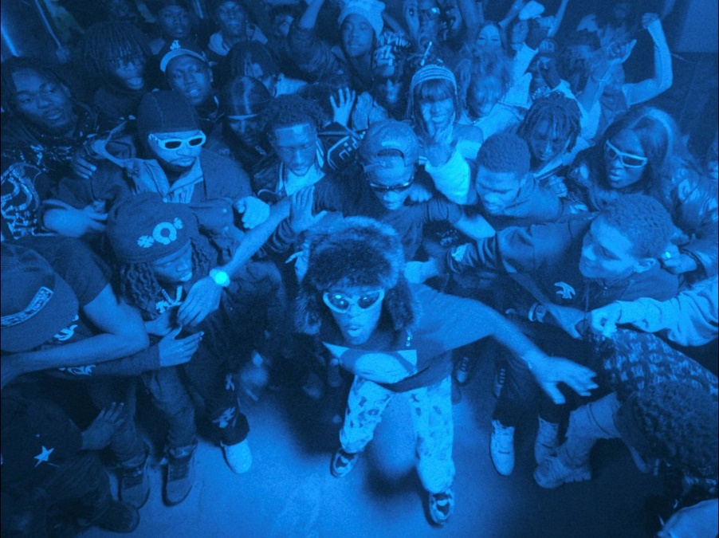

CONNECT WITH LIL UZI VERT
INSTAGRAM | FACEBOOK | TWITTER | SOUNDCLOUD | OFFICIAL

FOR ALL INQUIRIES, PLEASE CONTACT
SYDNEY.MARGETSON@ATLANTICRECORDS.COM
JANA FLEISHMAN
JANAF@ROCNATION.COM

