2x GRAMMY® AWARD-WINNING MULTI-PLATINUM
SINGER & SONGWRITER
LAUREN DAIGLE
ANNOUNCES FALL 2023 US DATES FOR
THE KALEIDOSCOPE TOUR

TICKETS ON SALE FRIDAY, MARCH 31 AT 10AM LOCAL

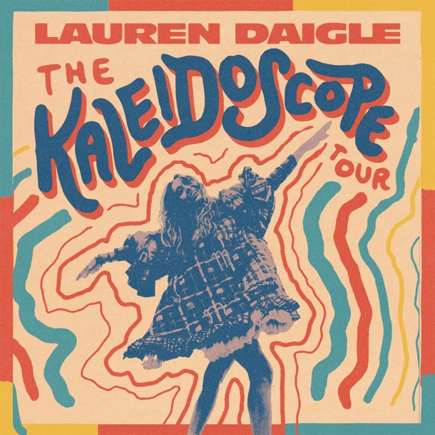

NEW SINGLE “THANK GOD I DO”
TO BE PERFORMED LIVE ON THE TODAY SHOW
THURSDAY, MARCH 30

SELF-TITLED ALBUM
SET FOR MAY 12 RELEASE
VIA ATLANTIC RECORDS/CENTRICITY MUSIC

PRE-SAVE LAUREN DAIGLE ALBUM HERE
LISTEN TO CURRENT SINGLE “THANK GOD I DO” HERE

Today, two-time GRAMMY® Award-winning singer-songwriter Lauren Daigle announces her much-anticipated US arena tour, set for fall 2023. The Kaleidescope Tour kicks off on September 6 in Memphis, TN with entirely new and innovative stage production. The 30-city run will take Daigle across the country – from New Jersey’s Prudential Center (October 20) to LA’s Crypto.com Arena (November 10), with stops in Boston, Atlanta, and Seattle as well as cities in which Daigle hasn’t performed in nearly four years, including Baton Rouge, Baltimore and Tulsa.

The Kaleidoscope Tour will feature many of Daigle’s #1s, including her groundbreaking smash “You Say,” “Rescue,” “Look Up Child,” her new single “Thank God I Do,” as well as music from her forthcoming self-titled album which will include 20 songs released in two parts this spring and later this year.

Register now at www.laurendaigle.com to access the Lauren Daigle pre-sale beginning Tuesday, March 28 at 12pm local time. Citi cardmembers will have access to presale tickets beginning Wednesday, March 29 at 12pm local time until Thursday, March 30 at 10pm local time through the Citi Entertainment program. For complete presale details visit www.citientertainment.com. General on-sale is Friday, March 31 at 10am local time. Full routing below.

In addition, Daigle is also set to perform “Thank God I Do” on the Today Show next Thursday, March 30th – marking the song’s network television premiere. (Check local listings).

“Thank God I Do” is Lauren’s biggest first week streaming song across all DSPs, has been added to a record breaking 120+ radio stations across multi-formats in just its first week, and is her strongest single launch at radio to date. The song also received major acclaim with Billboard writing, “the piano ballad features the signature soar that fans have been waiting to return, but her voice has deepened with time, matching the epic sweep of the strings on the track and readying the masses for a prolonged showcase.”

“Thank God I Do” marks the launch of a new creative chapter for the multi-platinum selling, Louisiana-born artist, who just last month announced signing to Atlantic Records in partnership with longtime label home Centricity Music. With a creative team led by Grammy®-winning producer Mike Elizondo (Twenty One Pilots, Mary J. Blige, Fiona Apple, Carrie Underwood), and featuring co-writers Natalie Hemby, Shane McAnally, Amy Wadge, Lori McKenna, Jason Ingram and Jon Greene, to name a few, Lauren Daigle comprises twenty soulful and uplifting songs to be released in two parts. The first ten arrives May 12, and the other ten release later this year.

Listen to “Thank God I Do” HERE – Daigle’s first release via Atlantic Records/Centricity Music – and pre-save Lauren Daigle album HERE. Download hi-res press photo HERE.

With over a billion streams and years of sold-out US and international tours to her name, Lauren Daigle continues to cement her status as a modern vocal powerhouse with a global, ever-growing fanbase. Daigle is a two-time Grammy®, seven-time Billboard Music Award, four-time American Music Award, and ten-time GMA Dove Music Award winner.

Since the release of her GRAMMY® Award-winning, platinum-certified 2018 album Look Up Child – which includes the breakthrough hit single “You Say” – Daigle has been a mainstay on the Billboard charts. When Look Up Child debuted at No. 3 on the Top 200 Albums chart, Daigle became the first female artist in history to simultaneously hit the Top 10 on both Billboard’s Pop and Christian Album charts. She went on to break another record when the LP reached 100 weeks at No. 1 on the Top Christian Albums chart, which is the greatest number of weeks that any artist has spent at the top of any individual album chart. Similarly, the 5x platinum-certified “You Say” is the longest-running No. 1 to appear on any weekly Billboard chart.

Off stage, Daigle remains committed to investing her time to promote music education, work with at-risk youth, and provide care for children, the elderly, and those in need through The Price Fund, an organization she founded in 2018. To date, she has distributed over $2.4 million to 40 nonprofits around the world.

DATE | MARKET | VENUE
Thu Jul 13, 2023 | Philadelphia, PA | TD Pavilion at the Mann*
Fri Jul 14, 2023 | Lewiston, NY | Artpark Amphitheater*
Wed Sep 6, 2023 | Memphis, TN | FedExForum
Thu Sep 7, 2023 | Bossier City, LA | Brookshire Grocery Arena
Fri Sep 8, 2023 | Baton Rouge, LA | Raising Cane's River Center
Thu Sep 14, 2023 | Grand Rapids, MI | Van Andel Arena
Fri Sep 15, 2023 | Indianapolis, IN | Gainbridge Fieldhouse
Sat Sep 16, 2023 | Hoffman Estates, IL | NOW Arena
Thu Sep 28, 2023 | Wichita, KS | INTRUST Bank Arena
Fri Sep 29, 2023 | Des Moines, IA | Wells Fargo Arena
Sat Sep 30, 2023 | Minneapolis, MN | Target Center
Wed Oct 4, 2023 | Charleston, WV | Charleston Coliseum
Thu Oct 5, 2023 | Louisville, KY | KFC Yum! Center
Fri Oct 6, 2023 | Atlanta, GA | State Farm Arena
Thu Oct 19, 2023 | Boston, MA | Agganis Arena
Fri Oct 20, 2023 | Newark, NJ | Prudential Center
Sat Oct 21, 2023 | Baltimore, MD | CFG Bank Arena
Thu Oct 26, 2023 | Kansas City, MO | T-Mobile Center
Fri Oct 27, 2023 | St. Louis, MO | Enterprise Center
Sat Oct 28, 2023 | Columbus, OH | Schottenstein Center
Fri Nov 10, 2023 | Los Angeles, CA | Crypto.com Arena
Sat Nov 11, 2023 | Phoenix, AZ | Desert Diamond Arena
Tue Nov 14, 2023 | Sacramento, CA | Golden 1 Center
Thu Nov 16, 2023 | Portland, OR | Moda Center
Fri Nov 17, 2023 | Spokane, WA | Spokane Arena
Sat Nov 18, 2023 | Seattle, WA | Climate Pledge Arena
Thu Nov 30, 2023 | Tulsa, OK | BOK Center
Fri Dec 1, 2023 | Ft Worth, TX | Dickies Arena
Sat Dec 2, 2023 | San Antonio, TX | AT&T Center
Thu Dec 7, 2023 | Greensboro, NC | Greensboro Coliseum
Fri Dec 8, 2023 | Knoxville, TN | Thompson-Boling Arena
Sat Dec 9, 2023 | Greenville, SC | Bon Secours Wellness Arena
NOT PART OF KALEIDOSCOPE TOUR*

CONNECT WITH LAUREN DAIGLE
Website | Facebook | Instagram | Twitter | TikTok | YouTube

For More Information, Please Contact:
Sheila Richman | Atlantic Records | Sheila.Richman@atlanticrecords.com
Katy Carmichael | Atlantic Records | Katy.Carmichael@atlanticrecords.com

Paul Freundlich | PFA Media | paulf@pfamedia.net
Alicia Krass | PFA Media | akrass@pfamedia.net

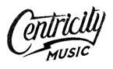

About AEG Presents
Combining the power of the live event with a focus on true artist development, AEG Presents is a world leader in the music and entertainment industries. Operating across five continents, the company has an unparalleled commitment to artistry, creativity, and community. Its tentpole festivals and multi-day music events — which include the iconic Coachella Valley Music & Arts Festival and the legendary New Orleans Jazz & Heritage Festival alongside British Summer Time at Hyde Park, Stagecoach, Hangout Festival, Electric Forest, Rock En Seine and All Points East — continue to set the bar for the live music experience. AEG Presents promotes global tours for artists such as Justin Bieber, Blackpink, Kenny Chesney, Celine Dion, Elton John, Karol G, Paul McCartney, Katy Perry, The Rolling Stones, Ed Sheeran, Taylor Swift, and Tyler, The Creator, in addition to — through its network of clubs, theatres, arenas, stadiums and renowned partner brands such as The Bowery Presents, Concerts West, Frontier Touring, Goldenvoice, Marshall Arts, Messina Touring Group, PromoWest Productions, and Zero Mile Presents — creating and developing an unmatched infrastructure for artist development and audience reach. More information can be found at www.aegpresents.com.

