2x GRAMMY® AWARD-WINNING MULTI-PLATINUM
SINGER AND SONGWRITER
LAUREN DAIGLE
RELEASES NEW SINGLE “THANK GOD I DO”

THE GLOBAL STAR ANNOUNCES SELF-TITLED ALBUM
SET FOR MAY 12, 2023 RELEASE
VIA ATLANTIC RECORDS/CENTRICITY MUSIC

PRE-SAVE LAUREN DAIGLE ALBUM HERE
LISTEN TO “THANK GOD I DO” SINGLE HERE

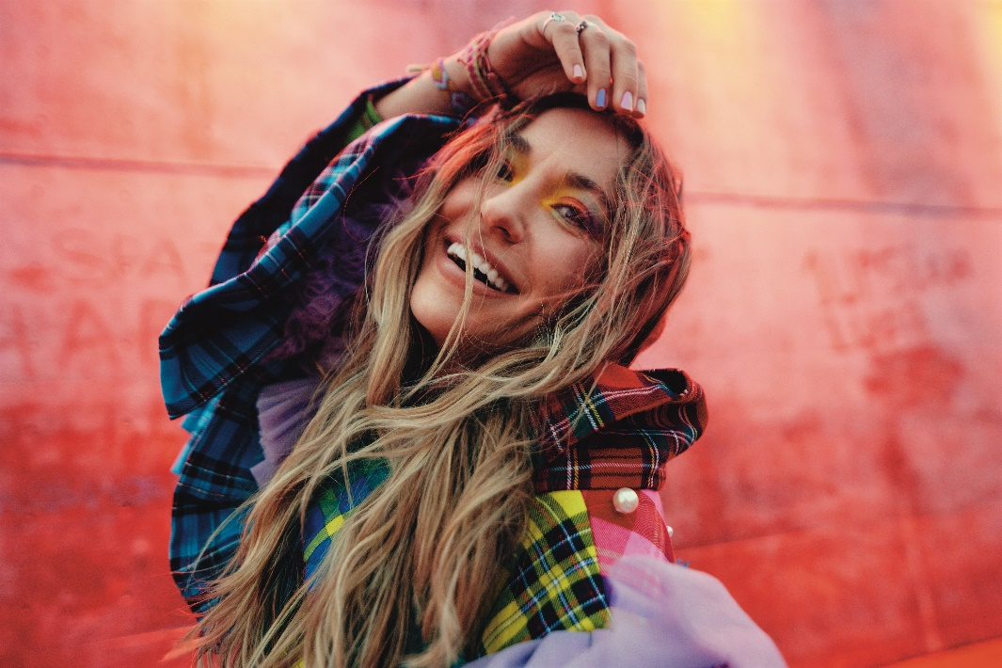
Photo Credit: Jeremy Cowart | Download Hi-Res Press Photo HERE

Today, two-time GRAMMY® Award-winning singer and songwriter Lauren Daigle debuts her new single, “Thank God I Do,” and announces her forthcoming self-titled album, Lauren Daigle, due out May 12, 2023.

“Thank God I Do” marks the launch of a new creative chapter for the multi-platinum selling, Louisiana-bred artist, who just last month announced the signing to Atlantic Records in partnership with longtime label home Centricity Music. The creative team behind Lauren Daigle is led by Grammy®-winning producer Mike Elizondo (Twenty One Pilots, Mary J. Blige, Fiona Apple, Carrie Underwood), and includes co-writes with Natalie Hemby, Shane McAnally, Amy Wadge, Lori McKenna, Jason Ingram and Jon Greene to name a few. Lauren Daigle comprises twenty soulful and uplifting songs to be released in two parts. The first ten songs arrive May 12, and the other ten release later this year.

Listen to “Thank God I Do” HERE– Daigle’s first release via Atlantic Records/Centricity Music – and pre-save Lauren Daigle album HERE.

“This is my most precious project,” Daigle shares, “It’s got fun moments, solemn moments, extrovert moments and introvert moments. And I’m just thrilled about taking my songwriting further on this record than anything I’ve done previously.”

Lauren Daigle taps into every side of the multi-faceted artist herself – showcasing her stunning and powerful voice, rich storytelling, and incredible musicality drawn from and inspired by her New Orleans roots.

Download Hi-Res Album Artwork HERE

With over a billion streams and years of sold-out US and international tours to her name, Lauren Daigle continues to cement her status as a modern vocal powerhouse with a global, ever-growing fanbase.

Since the release of her GRAMMY® Award-winning, platinum-certified 2018 album Look Up Child – which includes the breakthrough hit single “You Say” – Daigle has been a mainstay on the Billboard charts. When Look Up Child debuted at No. 3 on the Top 200 Albums chart, Daigle became the first female artist in history to simultaneously hit the Top 10 on both Billboard’s Pop and Christian Album charts. She went on to break another record when the LP reached 100 weeks at No. 1 on the Top Christian Albums chart, which is the greatest number of weeks that any artist has spent at the top of any individual album chart. Similarly, the 5x platinum-certified “You Say” is the longest-running No. 1 to appear on any weekly Billboard chart.

Born in Lake Charles, Louisiana, Lauren Daigle is a two-time Grammy®, seven-time Billboard Music Award, four-time American Music Award, and ten-time GMA Dove Music Award winner.

Off stage, Daigle remains committed to investing her time to promote music education, work with at-risk youth, and provide care for children, the elderly, and those in need through The Price Fund, an organization she founded in 2018. To date, she has distributed over $2.4 million to 40 nonprofits around the world.

CONNECT WITH LAUREN DAIGLE
Website | Facebook | Instagram | Twitter | TikTok | YouTube

For More Information, Please Contact:

Sheila Richman | Atlantic Records | Sheila.Richman@atlanticrecords.com
Katy Carmichael | Atlantic Records | Katy.Carmichael@atlanticrecords.com

Paul Freundlich | PFA Media | paulf@pfamedia.net
Alicia Krass | PFA Media | akrass@pfamedia.net
