NIKO RUBIO CELEBRATES 22ND BIRTHDAY WITH NEW SONG “SUNSHINE”

FORTHCOMING SOPHOMORE EP DUE OUT THIS SPRING

RISING SINGER/SONGWRITER NAMED “LATIN ACTS TO MAKE IT BIG IN 2023” BY ROLLING STONE AND “EMERGING ARTISTS TO WATCH” BY PEOPLE

DOWNLOAD/STREAM “SUNSHINE”

“This is the first song I’ve ever played guitar on and it feels super good to write and work on a song like this and put it out on my birthday it feels like a big moment for me as a writer and artist. It’s the most personal song I’ve ever shared, I cried writing it and just being really honest about how much I needed to heal my inner child. There is something very cathartic about crying in a session and being super honest. I love writing very happy songs that get me out of feeling so sad but this one came out of me at a time I needed it.”

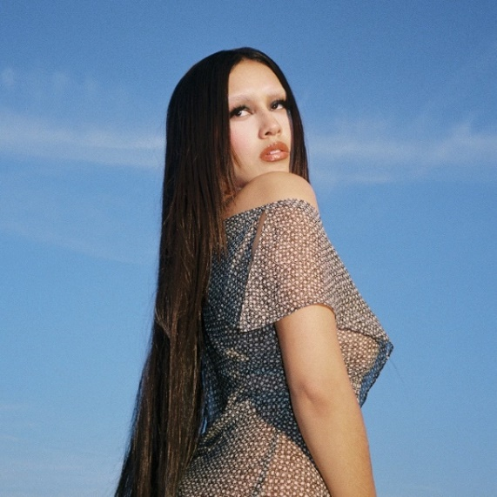
DOWNLOAD HI-RES PRESS PHOTO

New York, NY – March 16, 2023 – Rising singer-songwriter Niko Rubio releases angelic new song, “Sunshine,” available today via Sandlot Records/Atlantic Records – watch the lyric video here. “Sunshine” is the second track to come off Niko’s forthcoming sophomore EP due out this spring, following “Olividar De Ti.”

“Latin Acts to Make it Big in 2023” -ROLLING STONE

“Captivating showcase for the newcomer…“the kicky pop-rock track allows Rubio’s tone to sink down low and soar skyward.” – BILLBOARD

“Talented emerging artist to have on your playlist…” – PEOPLE

“Niko Rubio’s music feels like driving down PCH” – PAPER

“Her self-described “pop-indie-rock” music is at once ethereal and buoyant, yet grounded by a thrumming bassline. In other words, the perfect soundtrack for riding in a seafoam-green convertible, top down, along the familiar Pacific Coast Highway.” – LATINA

2022 saw Niko support 14 dates of Omar Apollo’s Desvelado Tour, a set at Lollapalooza in Chicago and a performance at BottleRock Music Festival in Napa, California and released the captivating singles “Over For Real,” and “Love Me Till U Hate Me,”

Niko made her major label debut in 2021 with debut EP, Wish You Were Here, which featured the standout singles “Bed,” “Saving Me” and “You Could Be The One.”

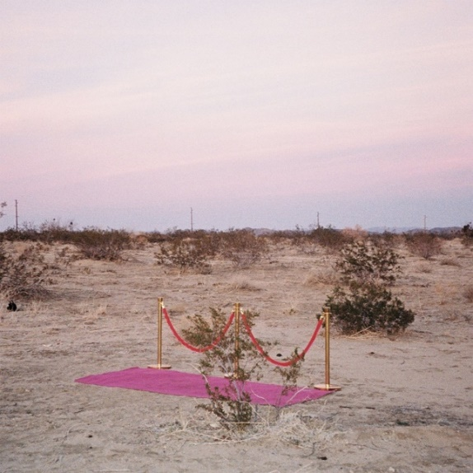
DOWNLOAD HI-RES ARTWORK

ABOUT NIKO RUBIO:
When creating her debut project, 22-year-old singer/songwriter Niko Rubio found a never-ending muse in the Pacific Coast Highway: the iconic stretch of road that runs along the ocean for nearly the entire length of California, including the Southern California South Bay area where she grew up. Expansive and euphoric, Niko’s radiant form of songwriting perfectly echoes the pure sense of possibility that accompanies driving down the PCH. Drawing inspiration from the collage of artists she’s come to admire throughout her life including Vampire Weekend, Lana Del Rey, Erykah Badu & twenty one pilots, as well as the mariachi & banda music her grandparents played at home, Niko’s music is an amalgamation of these influences, but unique in its effervescent melodies and unpredictable textures. Using cinematically detailed references and her effortlessly untamed vocals, Niko is ready to take those who listen to her debut EP Wish You Were Here and her subsequent releases on a sonic road trip along the highway where they became a possibility.

Press Contact: Jason Davis – jason.davis@atlanticrecords.com

